English
for
Engineers

For

I Year B.Tech

Department of English and Foreign Languages
Faculty of Engineering and Technology
SRM University

© Department of English and Foreign Languages, SRM University
First published 2013

Printed by
SRM Publications Pvt Ltd,
211 / 2, East Potheri Village St.,
Kattankulathur – 603 203

All rights reserved. No part of this publication may be reproduced, stored in a retrieval
system or transmitted in any form or by any means, electronic, mechanical, photocopying,
recording or otherwise, without prior written permission of the publisher.

Published by
Department of English and Foreign Languages
Faculty of Engineering and Technology
SRM University

PREFACE
In English for Engineers, the English text book based on the new curriculum, the authors have made their best efforts to harness user friendly materials that are at once interesting and relevant to the I year B. Tech. learners. The topic / theme based approach gives a meaningful context to the learning / teaching objectives and the disparate language items.
An effort has been made to combine materials to cater to the multiple intelligent learners of today. The Units are designed so as to develop the LSRW skills which are essential for the learner of this competitive, career oriented world.
We welcome your opinions and suggestions We also acknowledge with thanks a few publishers from whom some of the sources have been utilised.

Department of English and Foreign Languages
Faculty of Engineering and Technology
SRM University
SRM Nagar

Prof. N. Sethuraman, M.A., M.Phil., PhD
Registrar, SRM University
Formerly Prof. of English, Pachaiyappa’s College

FOREWORD

Language is a result of community-living and it is an essential means of bringing people
close to each other.

In the present-day ‘global village’, English has surfaced as the chief of languages for communication in various fields. Industry, business, academics, science and research, for that matter any field cannot do without the language of English. For the young thriving professionals like engineers and technologists, proficiency in the four language skills (Listening, Speaking, Reading and Writing) of English Language is ‘a must’.

I congratulate Prof. K. Anbazhagan, Head, Department of English and Foreign Languages who has initiated this project, and along with him the team who have contributed in bringing out the book successfully.

I am certain that the students will find this book An English Course Book for I year B. Tech interesting, and they will improve their English languages skills through the application-approach followed.

Wishing you all the best.

Prof. N. Sethuraman

DEPARTMENT OF ENGLISH AND FOREIGN LANGUAGES
LE 1001 – ENGLISH FOR ENGINEERS
SYLLABUS
UNIT I INVENTIONS
- Grammar and Vocabulary – Tense and Concord
- Listening and Speaking – Common errors in Pronunciation (Individual sounds);
Process description (Describing the working of a machine, and the manufacturing process)
- Writing – Interpretation of data (Flow chart, Bar chart)
- Reading – Reading Comprehension – Answering questions
UNIT II ECOLOGY
- Grammar and Vocabulary – Error Analysis – Synonyms and Antonyms, Parallelisms
- Listening and Speaking – Conducting Meetings
- Writing – Notice, Agenda, Minutes, Letters to the editor via email : Email etiquette
- Reading Comprehension – Summarizing and Note-making
UNIT III SPACE
- Grammar and Vocabulary – Word formation
- Listening and Speaking – Distinction between native and Indian English – accent, use of vocabulary and rendering
- Writing – Definitions and Essay writing
- Reading Comprehension – Predicting the content
UNIT IV CAREERS
- Grammar and Vocabulary – Homonyms and Homophones
- Listening and Speaking – Group Discussion
- Writing – Applying for job, cover letter and resume
- Reading, etymology (roots; idioms and phrases), Appreciation of creative writing
UNIT V RESEARCH
- Grammar and Vocabulary – Using technical terms, Analogies
- Listening and Speaking – Presentation techniques
- Writing – Project Proposal
- Reading Comprehension -- Referencing Skills for Academic Report Writing
Writing a report based on MLA Handbook
TEXT BOOK
- Department of English and Foreign Languages. English for Engineers. SRM University Publications, 2013

REFERENCE BOOKS
- Dhanavel, S.P. English and Communication Skills for Students of Science and Engineering. Units 1-5. Chennai: Orient Blackswan Ltd., 2009
- Meenakshi Raman and Sangeetha Sharama. Technical Communication - Principles and Practice. Oxford University Press, 2009
- Day, R A. Scientific English: A Guide for Scientists and Other Professionals. 2nd ed. Hyderabad: Universities Press, 2000

COMMUNICATION AND LANGUAGE SKILLS
Importance of Communication
Students need to understand the various types of communication involved in the globalised context, and the students of Engineering and Technology need a specific set of language skills for their success in education and career.
Industries are also voicing heir concern about the need for better communication skills among students of Engineering. Scientists and engineers in all positions should be able to communicate the purpose and relevance of their work, both orally and in writing. Good communication skills are often needed to get a good job. If one is clear in expressing one’s thoughts and articulating one’s accomplishments and attributes, an interviewer is more likely to form a favourable impression and gain an understanding of that person’s skills. The professional profile of a modern qualified engineer should include well-developed communication skills and high English language proficiency to help him achieve success in the modern, highly competitive global work arena.
Communication
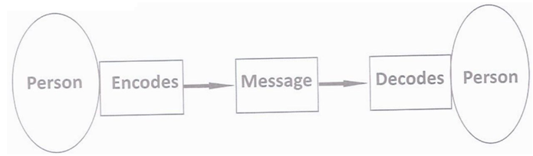

Communication is the transmission of information, ideas, emotions, skills, etc., by the use of symbols, words, pictures, figures, graphs, and other means.
These are a few definitions giving different approaches to communication:
It is the act or process of transmission that is usually called communication” (Berelson and Steiner, 1964).
Communication is the process by which we understand others and in turn endeavor to be understood by them. It is dynamic, constantly changing and shifting in response to the total situation (Anderson, 1959).
Communication is commonly defined as “the imparting or interchange of thoughts,
opinions, or information by speech, writing, or signs”. Communication can be perceived as a two-way process in which there is an exchange and progression of thoughts, feelings or ideas towards a mutually accepted goal or direction.
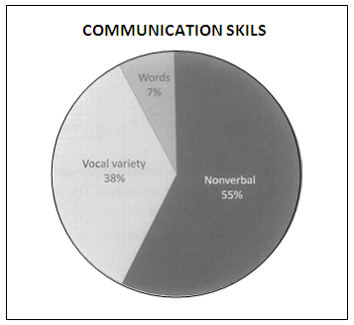
There are three major parts in human face-to-face communication. They are body language, voice tonality, and words. According to a research,
- 55% of impact is determined by body language—postures, gestures, and eye contact,
- 38% by the tone of voice, and
- 7% by the content or the words used in the communication process.

Types of Communication
Verbal communication
A dialogue is a reciprocal conversation between two or more entities under which the oral and written communication take place.
Nonverbal communication
Nonverbal communication is the process of communicating through sending and receiving wordless messages. Such messages can be communicated through gesture, body language or posture, facial expression and eye contact. Nonverbal communication plays a key role in every person’s day-to-day life, from employment to romantic engagements. It includes pictures, drawings, charts, signs, symbols, body language, sounds and visuals.
Process of Communication
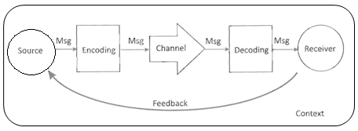

The process of communication involves ideation, encoding, channelising, decoding and feedback.
Channels of Communication
In any work place all forms of communication are routed through different types of channels according to the nature and purpose of communication. The following are the channels / directions of communication used in workplaces.)
- Upward
- Downward
- Horizontal
- Diagonal
- Downward communication follows the hierarchical order from the higher to the lower level.

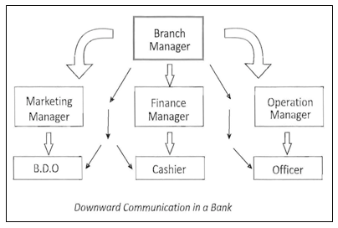

- Upward communication starts from the lower levels and goes up to the higher level.
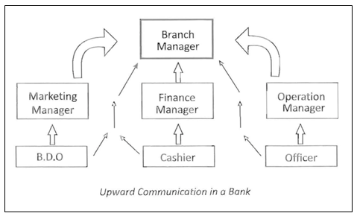

- Horizontal communication takes place between employees of equal ranks and sometimes among the peer groups.
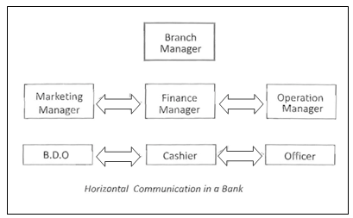

- Diagonal communication happens across all official cadres and no hierarchy is followed. This is also known as grapevine communication. This is a mode of informal, unofficial but effective way of communication.

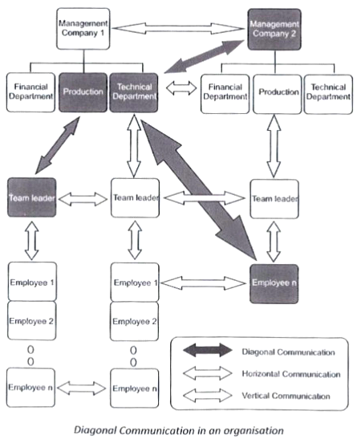

- External communication takes place with people outside the company. It helps to achieve organizational goals and customer satisfaction.
Technical Communication
It refers to the exchange of technical and scientific knowledge through writing, speech, and other mediums, addressed to a specific audience.
Language
It is the medium through which communication takes place. It is used to convey the thoughts and feelings through a system of arbitrary signals, such as voice, sounds, gestures, or written symbols.
Communication is not always successful and there are a few factors that barrier communication. Anything which acts as a threat or hinders communication is a communication barrier. Some of them are:
- Language Barriers
- Improper message
- Confusion resulting from homophones and spelling
- Wrong translation
- Assumptions
- Bombastic or ostentatious and technical jargon
- Accent
- Personal Barriers
- Physical inconvenience
- Passive listening (lack of attention) / Selective listening
- Individual perception
- Lack of confidence
- Improper time management
- Fear of superiors
- Malfunctioning of the aids
- Organisational Barriers
- Strict seniors / boss
- Status problem / ego
- One way communication
- Rigid rules
- Job pressure
- Poor working environment
How to overcome these barriers?
- Be clear and precise.
- Let the sentences be short and simple with easy words.
- Speak at a normal pace.
- Improve concentration and active listening skills.
- Plan your schedule and act accordingly.
- Avoid being egoistic and give way for suggestions.
- Know your audience / listener.
- Appreciate feedback.
LSRW
Language is never learnt. It is acquired. If one wants to acquire language, he / she should follow a natural way of learning things. As a child, we ‘listen to’ the language spoken around us for 3 years. At the second stage, we ‘speak’ in broken words and sentences for a couple of years. At the third stage, we ‘read’ some picture books. Even alphabets are remembered as pictures. It is only in the last and fourth stage that we learn to ‘write’. Thus, to say, L-S-R-W (L – Listening, S – Speaking , R – Reading, W – Writing) is the natural way of acquiring language.
We shall now have a detailed look at each of the communication skills.
Listening: Though 45% of our communication is listening, it is the most difficult one to practice. One should know the difference between Listening and Hearing. Listening is an active process wherein we concentrate and retain the information listened to, while hearing is a passive process wherein the listener does not want to retain any information.
Some of the barriers to listening are external noise, personal distraction, inappropriate place and time, information overload and selective listening. To avoid listening barriers one can practice active listening. Active listening involves uninterrupted listening, concentration, asking questions and observing the non verbal cues and the ability to restate the message.
Speaking: To be an effective speaker one should follow the following rules:
- Use appropriate vocabulary.
- Use words in correct order.
- Check the stress, rhythm and intonation accordingly.
- Use simple language and avoid ostentation.
- Avoid hanging thought, relate whatever you say.
- Know your listener / audience.
- Avoid slang and unparliamentary words.
- Synchronise the body language and words.
- Be slow, if you doubt your pronunciation.
Reading: Reading is the process of decoding the symbols on the page (print or electronic) for a meaningful comprehension. It is the interaction between the text and the reader. Reading is typically an individual activity, although on occasion a person will read out loud for the benefit of other listeners. It is not always necessary that we understand every word that we read. Reading is effective only when
- The reader can distinguish sounds of the language.
- The reader is fluent so as to remember what he has already read.
- The reader deduces the meaning of the vocabulary used in the text.
Reading is of four types:
- Skimming — It is to gather the most important information by running the eye over the text. One tends to read the title, sub titles and topic sentences. Skimmers will not look for minute details. Pictures, graphs and charts help in additional understanding of the text.
- Scanning — It is to find a particular piece of information. The scanner scans the text until he finds what he was looking for. For example, Sachin Tendulkar’s fans would scan the sports column to know how many runs he scored in how many overs. It is also like finding the phone number of Mr. Ramarao who belongs to Ranipet from the directory. We also scan for the expiry date when we buy a product.
- Reading for thorough comprehension — It is when the reader wants to gain the full knowledge or information in the text. The reader tries to understand the relationship between the ideas of the text including the author’s purpose. Vocabulary enhancement takes place unknowingly.
- Critical reading — Critical reading takes place when the reader tends to make judgment on the piece of work. The reader here comes up with various questions and arguments. It is done to understand the author’s purpose of writing the text and language used.
Writing
Writing is when we put our thoughts in words on a paper or computer screen. It is considered to be the most difficult skill and therefore is less preferred. Writing is usually more formal and therefore the writers have to be more careful about the grammatical rules, syntax and lexical items. If the writing is comprehensible and creative then the writer has achieved the purpose. Since nonverbal expressions are generally avoided in formal writing one should use proper punctuation so that the reader can arrive at what the author is trying to convey.
This book focuses on the Reading and Writing skills of the learner with a mention of the phonetic symbols on learning which the learners can refer to the dictionary to know the correct pronunciation of the words whenever they are in doubt. A few words are also given as examples to distinguish bewteen the British and American pronunciation
UNIT I
INVENTIONS

Pre reading Activities
Brainstorm: What is the difference between an invention and a discovery? Can you give three examples to show the difference?
Draw: A mind map illustrating how an invention or a discovery impacts any other aspect of our social life.
Find out and label: Pictures of two inventors and two discoverers and their main contributions
TEXT 1
Inventions and Innovations
Scientific discoveries include both inventions (the creation of new products or methods whose function is designed in from the start), as well as innovations (the discovery of new abstract concepts).
Three principal methodologies have led to "inventions and innovations" in the past: (1) the application of a technology or knowledge;
(2) mathematical calculation; and
(3) logical reasoning.
Most inventions and innovations can be distinguished on the bases of one or more of these three methodologies.
The methodology of the application of a technology or knowledge can further be divided into two sections, namely 1) application of a known knowledge; 2) making exploration with a known technology. Several historical examples also help us to distinguish these approaches. Consider, for example, a case that involved the application of known technology and that occurred in the Research and Development laboratory of a major American manufacturer of automobiles approximately twenty years ago. Management had asked its researchers to generate some new ideas for improving engine performance and they came up with the idea of an electronic fuel injection unit--a kind of mini-computer with the capacity to gauge and control the amount of fuel required by the engine under varying load and weather conditions. This device, however, was 'new' only in the sense that it was the first time that a principle of electronics had been applied to the operation of a car engine. As it turned out, any competitive edge that this invention might have given the West was offset by the fact that, researchers in the Japanese and Korean car industries had come up with pretty much the same idea at around the same time. Granted, it is not entirely fair to dismiss the importance of incremental technological improvements. After all, Chinese fire-crackers eventually evolved into rockets capable of reaching the moon.
The case of making exploration with technology was used in the discovery of DNA. After optical magnification techniques had advanced to the molecular level, scientists were able to see multiple protein molecules. DNA was discovered from these molecules by observing its four organic bases, its double helix structure, and its ability to duplicate itself. Other historical examples help to illustrate these methodologies as well. For example, mathematical calculation played a pivotal role both in Albert Einstein's Theory of Relativity and his equation of E=mc².
Logical reasoning can help one to come up with highly imaginative ideas. An early example involving logical reasoning concerns an event that occurred over two thousand years ago in Greece. In 530 B.C., Pythagoras witnessed a lunar eclipse. On the basis of his observation, he conjectured that the dark portion of the eclipse was the shadow of the earth when lit by the sun. Noting that the shadow was round, he reasoned that the earth must also be a sphere. Unfortunately, the technology available to Pythagoras at that time did not allow him to confirm his hypothesis. Furthermore, although some Chinese, Indian, and Mayan astronomers had also witnessed this eclipse, only Pythagoras had come up with a logical explanation to account for the eclipse. Finally, it was only in 1522, the year in which Magellan sailed around the world, that Pythagoras' hypothesis that the earth was a sphere was proven to be correct.
A second example of this type involves Thomas Edison, who had made many careful studies of sound characteristics. He had hypothesized that every sound (e.g., the phrase "good morning"), had its own unique vibration waveform. On this basis, he set about reproducing sound by creating an identical sound vibration waveform. This ultimately led him to the invention of a 'talking machine' or phonograph. Only later, with the invention of the oscilloscope, did it become technologically feasible to prove that his theory had been correct.
Some inventions and innovations are made by applying these methodologies in parallel. When Thomas Edison first tried to invent the light bulb, he placed the filament in a vacuum glass container so that the filament would not burn. This part of the process is an example of his logical reasoning. He then tried to find a filament material that would not melt at high temperature. He experimented more than a thousand times with different materials and over many months. Finally he discovered that carbon was the most suitable material. This part of the process involves exploration. In short, the invention of the light bulb involves both logical reasoning and exploration.
The purpose of science is to solve problems. Science can be divided into two parts. The first is the uncovering of new scientific knowledge. The second is the recording of uncovered scientific knowledge and the practical application of this knowledge. School teaches us already known scientific knowledge and how to apply this science to practical use. This is why we are taught not to say anything that has not been proven to be true. School has not taught us how to uncover new scientific knowledge. Please see the chart below.

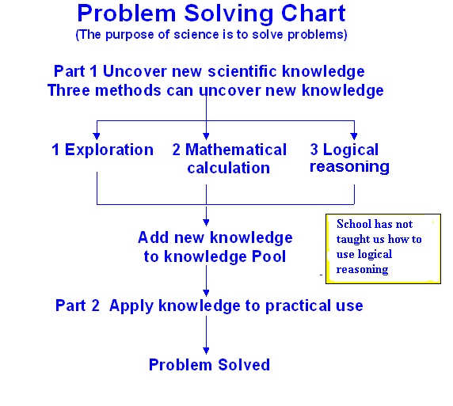
For example after our professors taught us E=mc² in Albert Einstein's theory of relativity, they then gave us an assignment to calculate the amount of uranium-235 needed to generate 1 million thermal kilowatts in a nuclear power plant. Students can easily accomplish this task by applying the above formula. However, in solving a problem in the practical world, we need to come up with the formula E=mc² by ourselves. By doing so, we uncover new knowledge by ourselves. That is the ideal way to apply science to solve problems. As mentioned above, there are three methods to uncovering new knowledge. These methods are exploration, mathematical calculation, and logical reasoning. Our teachers have not taught us how to use logical reasoning methodology in order to uncover new scientific knowledge.
When we use logical reasoning to uncover new scientific knowledge, we need to come up with the most suitable hypothesis and verify this idea with experiments. This is contrary to what we are taught in school. Schools teach students that in science "what you say must be proven to be true". This statement is true when we are applying science to practical use. However, the main purpose of science is to uncover new scientific knowledge to solve problems. In order to uncover new knowledge, we need to verify that our idea is true. Yet we cannot prove our idea is true before verification. This statement becomes an obstruction in our effort to uncover new knowledge. Schools should differentiate between uncovering new scientific knowledge and applying science to practical use. Since we were taught in school not to say anything that had not been proven to be true, logical reasoning has been neglected ever since the establishment of the modern education system. We need to re-introduce a logical reasoning methodology back into our schools and into our research environments. © 1998 SC Innovation.
A. Grammar & Vocabulary
- 1 Tense: Tense is the form or shape of the verb used in a sentence. Tense is the main indicator of the time of the happening / action described in the sentence.
Given below is the table with the basic format for various tenses that also comprise the principle of concord.
Tense | Verb Form | Meaning | Example sentence
Simple present | I, We, You, They sleep  He, She, It sleeps | To denote a regular / habitual action / general facts | We use logical reasoning to uncover new scientific knowledge.
Present continuous | I am sleeping; We, You, They are talking; He, She, It is sleeping | To denote an action in progress at the moment / an action done periodically | We are using logical reasoning to uncover new scientific knowledge.
Present perfect | I, We, You, They have slept; He, She, It has slept | To denote an action that happened in the past and continues till the present | We have used scientific knowledge to uncover new scientific knowledge.
Present perfect continuous | I, We, You, They have been sleeping; He, She, It has been sleeping | To denote an action that began in the past and continues into the present | We have been using scientific
Simple past | I, We, You, They, He, She, It slept | To denote an action that is over in the past | We used logical reasoning to uncover new scientific knowledge.
Past continuous | I, We, You, They were sleeping; He, She, It was sleeping | To denote an action that was going on at a particular time in the past | We were using scientific knowledge to uncover new scientific knowledge.
Past perfect | I, We, You, They, He, She, It had slept | To denote an action that happened before some other action in the past | We had used logical reasoning to uncover new scientific knowledge.
Past perfect continuous | I, We, You, They, He, She, It had been sleeping | To denote an action that began in the past and continued up to a particular time in the past | We had been using logical reasoning to uncover new scientific knowledge.
Simple Future | I, We, You, They, He, She, It will sleep | To denote an action that will happen in future | We will use logical reasoning to uncover new scientific knowledge.
Future continuous | I, We, You, They, He, She, It will be sleeping | To denote an action that will be going on at a particular time in future | We will be using logical reasoning to uncover new scientific knowledge.
Future perfect | I, We, You, They, He, She, It will have slept by 10 tomorrow night | To denote an action that will be over at a particular time in future | We will have used logical reasoning to uncover new scientific knowledge.
Future perfect continuous | I, We, You, They, He, She, It will have been sleeping for eight hours by one this afternoon | To denote an action that begins in future and continues into a particular time in future | We will have been using logical reasoning to uncover new scientific knowledge.
- 1. 1 For Practice
- Read the following sentences from the text. Note down the tense in which they are in and rewrite the same in other appropriate tense forms.
- We were taught in school not to say anything that had not been proven to be true.
- He discovered that carbon was the most suitable material.
- Only Pythagoras had come up with a logical explanation to account for the eclipse.
- Chinese fire-crackers eventually evolved into rockets capable of reaching the moon.
- Optical magnification techniques had advanced to the molecular level.
- Read the following sentences and correct the errors in the use of tense forms
wherever necessary and explain the changes made.
- After our professors taught us E=mc² in Albert Einstein's theory of relativity, they then give us an assignment to calculate the amount of uranium-235 needed to generate 1 million thermal kilowatts in a nuclear power plant.
- When Thomas Edison first is trying to invent the light bulb, he had placed the
filament in a vacuum glass container so that the filament would not burn.
- Management had asked its researchers to generate some new ideas for improving engine performance and they came up with the idea of an electronic fuel injection unit.
- An early example involving logical reasoning concerned an event that occurs over two thousand years ago in Greece.
- When we use logical reasoning to uncover new scientific knowledge, we need to come up the most suitable hypothesis and had verified this idea with experiments.

- Read the following paragraph and fill in the blanks with the correct form of the verbs given in brackets.
An inventor from a Japanese company called Blest, _______ (manage) to create a machine able to transform plastic back into oil, thus proving hope that it _______ (be) possible to reduce plastic waste that not only ________ (pollute) the ground but also _______ (form) huge islands in the oceans.
Akinori Ito ________ (invent) a machine that can be of different sizes, and which can be used at home and industrial plants.
Ito's latest invention can turn a kilogram of plastic waste into a liter of oil. Though such process _______ (use) 1 kilowatt of electricity, the machine (be, not emit) carbon dioxide.
It _______ (be) worth mentioning that instead of using flames, the machine _____ (make) use of a temperature controlling electric heater. It can process almost anything, including polyethylene, polystyrene and polypropylene. However, it ______ (be) unable to process PET bottles, reports Akihabara News.
The oil obtained during the process can be then used to create gasoline, diesel and kerosene.
- Look at the following pictures of life-changing inventions given below. Write a paragraph having a minimum of 6 sentences on each of them using the appropriate form of tense. Writing answers to questions beginning with ‘Who’, ‘When’, ‘How’, ‘What’, ‘What improvements’, and ‘What impact on life style’ will help you to write a coherent paragraph.
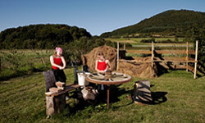


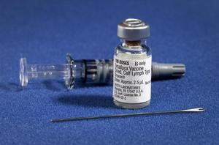


- 2 Concord : Concord denotes the use of the appropriate verb that agrees in case (I person / II person / III Person) and no (singular or plural) with the subject of the sentence.
For example, the following sentence
Scientific discoveries include both inventions … as well as innovations is in simple present tense. We note that the verb ‘include’ agrees in no and case with the plural subject ‘Scientific discoveries’.
Concord can be of three types. They are:
Grammatical Concord: Concord based on the grammatical rules of English Language
Example: Both logical reasoning and exploration are necessary to make inventions.
Notional Concord: Concord based on our understanding of whether the subject functions as a collective noun or disparate constituents in a group.
Example: If one million kilowatts is to be generated, how much uranium-235 is required?
Neither of the methods is good enough.
Concord by Proximity: The verb agrees with its nearest noun or pronoun that occurs after the conjunction. This is so with regard to correlative conjunctions such as “either … or”, “neither … nor”, “not only … but also”
Example: Not only logical reasoning but also exploration and mathematical calculation are necessary to uncover scientific knowledge.
Anyway, while correcting sentences or choosing the correct form of verb, we need to first identify the subject of a sentence from among all the nouns or pronouns that have been used.
We also need to distinguish the countable from the uncountable noun before deciding on the verb to be used. Let us remember that “a prepositional phrase” never has the subject.
- 2 .1 For Practice
a. Identify and underline the subject in the following sentences and fill up the blank choosing the appropriate verb from the options given in brackets.
Example: There is a difference between uncovering new scientific knowledge and applying science to practical use.
“There” in the above sentence is an empty subject and “a difference” is the actual subject.
- The creation of new products as well as innovations ____ (is/are) a part of scientific discoveries.
- Three principal methodologies ____ (have led/has led) to "inventions and innovations" in the past.
- An electronic fuel injection unit with the capacity to gauge and control the amount of fuel required by the engine under varying load and weather conditions ______ (was developed/were developed) by a leading American automobile manufacturer.
- The advancements in optical magnification techniques _____ (have made it/has made) possible for the scientists to see multiple protein molecules.
- No other scientist except Pythagoras _____ (was able to explain/were able to) the phenomenon of lunar eclipse.
- Every sound _____ (has/have) its own unique vibration waveform.
- Each sound ____ (has/have) its own unique vibration waveform.
- Our schools and research environments (need/needs) to reintroduce a logical reasoning methodology.
- The Time Machine _____ (is/are) an interesting science fiction.
- The Japanese _____ (have /has) also made important contribution to the automobile industry.

- Match the following.
- A team each of Japanese and Korean engineers were able to prove that
the earth is a sphere.
- Logical reasoning as well as mathematical were not able to account
calculation and exploration for lunar eclipse.
- Many an astronomer was one of the materials
Edison experimented with.
- A great many astronomers has decreased.

- Carbon is necessary for progress
in science.
- A number of experiments has come up with the
same idea.

- The number of schools and colleges were conducted before
teaching logical reasoning carbon was discovered to
be the most suitable material.
- Neither Pythagoras nor the Chinese and were not able to account
Mayan scientists for lunar eclipse.
- Read the following passage and complete the given sentences using appropriate verb forms.

ABOUT CANCER STEM CELLS
The cancer stem cell (CSC) concept postulates that the growth of tumors is driven by a rare population of dedicated cells that have stem cell-like properties, including self-renewal. While the bulk of a tumor consists of rapidly proliferating cells and post-mitotic, differentiated cells, neither of which is capable of self-renewal, a small population of CSCs provides for long-term maintenance of the cancer. Although the CSC concept was first postulated in the 1960s, it wasn’t until 1994 that proof of their existence was demonstrated, when John Dick and colleagues in Toronto isolated CSCs (known as leukemic stem cells, or LSCs) from bulk acute myeloid leukemia (AML) cells. This and subsequent work clearly established that AML is organized as a cellular hierarchy, sustained by a population of LSCs. More recently, CSCs have been identified in many other human malignancies, including solid tumors such as bladder, brain, breast, colon, ovarian and prostate cancers.
There is accumulating evidence that CSCs are resistant to conventional chemotherapies and radiation. Thus, CSCs are thought to be responsible for a phenomenon well known to oncologists: most patients will experience an initial response to conventional chemotherapies but will ultimately relapse. To cure cancer, CSCs need to be destroyed, but the current armament of therapies is poorly equipped to do so. Hence the need to develop new, innovative therapies that kill CSCs. Stem Cell Therapeutics is pursuing two unique approaches: a repurposed antibiotic (tigecycline) that kills CSCs by targeting their energy supply, and SIRPαFc, a novel therapeutic that activates the immune system to destroy CSCs.

- A population of dedicated cells that have stem cell-like properties, including self-renewal _______ the growth of tumours.
- Neither the rapidly proliferating cells nor the post-mitotic differentiated cells __________ capable of self-renewal.
- The existence of Cancer Stem Cell ___________ demonstrated till 1994.
- AML _______ as a cellular hierarchy.
- Recently solid tumors such as bladder, brain, breast, colon, ovarian and prostate cancers __________ as having CSCs.
- Accumulating evidence _______ that CSCs are resistant to conventional chemotherapies and radiation.
- CSCs _______ destroyed to cure cancer.
- The current armament of therapies _________ to destroy CSCs.
- New, innovative therapies that kill CSCs __________.
- One of the two unique approaches of Stem Cell Therapeutics ________ a repurposed antibiotic.
- The immune system that ___ by SIRPαFc _____ CSCs.
B. Listening and Speaking
B. 1 Listening
In the current world of incessant changes and booming development, communication needs to be fast and effective. Graphics, namely, charts and tables are the tools that transform extended information into succinct codes. Let us learn how to draw a basic flow chart from listening to speeches / presentations on the descriptions of various processes.
Drawing a Flow Chart
Flow chart is a diagrammatic sequential representation of a process. Any complicated process can be explained in a series of steps which makes it easy for us to understand the process. Engineers like you would be dealing with various processes, and representing them as flow charts is an integral part of your profession.
The process of laying plastic roads as described by Dr. Vasudevan, Thiagaraya College of Engineering, Madurai is given in the passage below. Read it and then listen to the process of laying plastic roads while watching the video on http : // www.youtube.com /watch?v=OVLNiufjXss. After that, look at the flow chart given at the end of the passage.
TEXT 2
Plastic Roads
Plastics are always common man’s friend. It finds its use in every field and the consumption of plastics increases day-by-day. Nearly 50% of the plastic consumed is used for packing. The most used plastic material[s] are carry bags, cups, thermocoles and foams. These materials are made from polymers like polyethylene, polypropylene and polystyrene. (The tubes and wires are made out of poly vinyl chloride).
Plastics as a Binder
These plastic materials when heated at around 120⁰C to 150⁰ C… melt and in [the] molten state they can be used as a binder. Only if they are heated to [a] temperature more than 250⁰C they may decompose producing gaseous products [that cause] air pollution. Coating molten plastic over granite stone can be done around 150º C and the coating helps to bind with bitumen strongly resulting in better mix for road construction and the quality of the stone also improves by closing the voids. PVC is not used due to its toxic nature.
Waste Plastics for Road Construction
First of all, plastic waste is shredded into small pieces (between 1.6mm – 2.5mm). The granite stone in the meanwhile is heated to around 170⁰C. After that, the shredded plastics waste is added to the stone where it gets melted and coated over stone in just 30 seconds. Then the bitumen is added and mixed. The resulting mix is used for road construction. From rural roads to National High ways all types of roads can be laid using this technique.

Flow Chart
Constructing Roads Using Plastic Waste
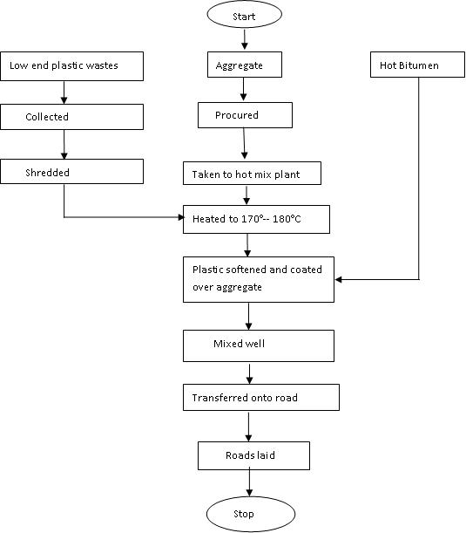

Once you have gone through the above flow chart, remember the following points when you draw a flow chart.
Points to Remember
- Get to know what the different kinds of boxes used in a flow chart stand for. For example: The Start and Stop terminal steps are inside an oval shape; The action or process steps are written inside a rectangular shape; The decision or branches in the sequence are written inside a diamond shape; A link to another chart in another page is indicated as an alphabet inside a small circle.
- Sift the relevant information from the irrelevant one. Pick out and include only the main steps that are directly involved in the process.
- Understand the correct sequence of actions. Indicate the flow of actions by arrows. Identify the parallel procedures, if any that make up the process. Enclose the steps in the process within rectangular boxes.
- Drawing diagrams is also a way of taking down notes. Hence do not use complete sentences within the boxes. Use the past participle forms of verbs in fragments of sentences.
- Explain any symbols or abbreviations you have used in the flow chart.
- Give a suitable title.
B. 1. 1 For Practice
- Watch the video in http://www.youtube.com/watch?v=-6UHfRXLwGI and draw a flow chart to represent the process of ceramic tile making in CERATEC.
- Listen to the report on “Water-run car” on http://ww.youtube.com/ watch?v=0awHUhVj0Ec and answer the following questions.
- Watch the video on “The Tunnel Boring Machine” in the YouTube (http://www.youtube.com/watch?v=qx_EjMlLgqY) and complete the flow chart on the working of EPB machine.
Working of an EPB Machine
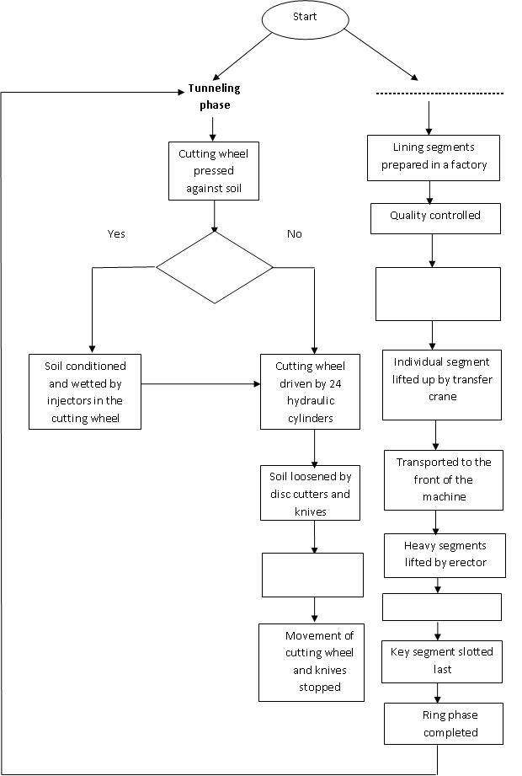
- Fill in the blanks with appropriate answers.
    - The water-run has been invented by a ________ company in the _____ _____ _____ of ______.
    - The car can run if it has a ____ of _____ ____of ____ .
    - The water-run car is _____ and saves the use of _____ _____.
    - The _____ ______ takes out _____ from _____ ___ _____ and releases _____.
    - One litre of water can give a mileage of ___ ___ or ___ ___ per ____.

B. 2 Speaking
In our era of globalization and cultural interchange, it has become imperative to get trained in and equipped with the use of foreign languages, especially English which still has a sway over the world. The business outsourcing companies, the research institutes, and almost all the professional organizations demand proficient speakers of English. Hence to survive and excel in our chosen careers and in the world, we need to speak English intelligibly. Fluency and facility can be achieved with frequent exposure and repeated practice. Prior to that we need to have knowledge of the basic sounds of English language and be aware of the common errors we commit in our pronunciation. English has 12 pure vowels, 24 consonants and 8 diphthongs (combination of two vowel sounds second one gliding from the first), altogether a total of 44 sounds. Following is the list of the sounds in English language with examples:

VOWELS

Short Vowels
ɪ - kin, ink
ɛ - send, wreck
æ - fat, stand
ɒ - bog, topple
ʌ - rut, undo
ʊ - full, soot
ə - alarm, lever

Long Vowels
i: - sea, feel
ɜː - turn, learn (also shown as əː)
ɑː - father, car
ɔː - torn, flaunt
uː - mood, blue
CONSONANTS
p - pick, pat
b - ball, but
t - tall, touch
d - dine, dip
k - cut, keep
g - gap, give
f - fig, photo
v - vain, vet
θ - thin, thug, both
ð - them, those, loathed (?)
s - sift, sick
z - zinc, zip
ʃ - brush, shell
ʒ - pleasure, leisure
h - hat, how
tʃ - chip, chocos
dʒ - fridge, judge
m - mind, muck
n - tan, nudge
ŋ - ring, clang
l - lick, pail
r - run, fur
w - wail, want
j - yam, prayer

Diphthongs
aɪ - lie, cry
ɛɪ - gait, prate
ɔɪ - boy, choice
əʊ - rose, note
aʊ - ground, bow
ɔə - bored, poured (?)
ɪə - cheer, fear
ɛə - lair, care
ʊə - pure, poor
We need to be sure of the way the sounds are to be articulated. Otherwise, it results in the misinterpretation of the message. Often the errors occur in the following ways. A few examples are given below:
Addition of sounds:
Correct Incorrect
install yinstall,
effort yeffort,
school ischool,
enter yenter,
honour (Initial ‘h’ silent) honour (initial ‘h’ pronounced)
iron (Medial ‘r’ silent) irun (medial ‘r’ pronounced)
Omission of sounds:
laughed laugh (‘-ed’ omitted)
fold fol (‘d’ omitted)
government government (‘n’ omitted)
geography gography (the sound for ‘eo’ omitted)
general genral (‘e’ omitted)
Replacement of sounds:
ship sip
bear beer
zip dzip
folder bolder
pore bore
pleets fleets
enjoys and brushes (‘s’ and enjoys and brushes (final ‘z’ and ‘iz’
‘es’ to be pronounced pronounced as ‘s’ and ‘is’)
as ‘z’ and ‘iz’)
hatched (‘ed’ to be hatched (‘ed’ pronounced as ‘d’)
pronounced as ‘t’

- 2. 1 For Practice
a. Listen carefully to the working of “The Tunnel Boring Machine” as described in the YouTube (http://www.youtube.com/watch?v=qx_EjMlLgqY). Pay attention to how the following words, especially the underlined parts, are pronounced and practice saying them aloud.
populated, cost, machine, phase, protection, completed, means, knives, water, support, this, conditions, material, picked up, positioning, cylinders, personnel, can in ‘can start, interior, exterior, constructed, grows, thousand, accommodates, things, systems, located, parameters, conveyers, shaft, distance, releases, stabilise, cutters, subsequently, automated, containers.
b. Listen to the presentation on http://www.youtube.com/watch?v=-6UHfRXLwGI and fill in the blanks choosing the appropriate words from the given options.
- We have been involved in the _____ (sales/sells) of ceramic ______ (tiles/tails)
- Raw materials such as white_____ (clays/plays), sand are _____ (quarried/queried).
- The conveyer belt _____ (dumps/dumbs) the mixture into a _____ _____ (storage tank/historic gang).
- The tiles are fired in _____ (kins/kilns).
- The tiles are inspected for _____ (imperfections/ in professions).
- The CERATAC’s ______ (spanned/expand) 60 years of business.
- The vat releases the atomized powder into the ____ (tray/spray).
- Roller screens are used to apply design and colour to the ____ (disc/bisque) of the tiles.
- The final formulation is inspected and ____ (excepted/accepted).
- Glazing and screening serve ______ (autistic/artistic) purpose.

c. Identify and write down at least five words ending in ‘z’, ‘iz’, ‘t’, ‘d’, ‘id’ sounds. Write down 3 examples each for words with different sound realizations for the following alphabets: a, e, i, o, u from listening to the process on “Manufacturing Ceramic Tiles”.
d. Listen to the report on “Water-run car” on http : // www.youtube.com / watch? v=0awHUhVj0Ec and write down at least 10 words that you pronounced incorrectly till now and which you have now learned to pronounce correctly.
e. Summarise in your own words any one process out of the three given above in their respective websites.
C. Writing
Communication through writing occupies the centre stage even in the age of proliferating technological tools such as note books, iPads and mobile phones. Writing helps to clarify our thinking, and persons who write precisely and effectively enhance their rate of personal and career success. Using the correct vocabulary and appropriate syntax and having a feel for the natural rhythm and flow of the language make for easy reading and a thorough comprehension of the written text.
In the technical scenario, it is not only essential to equip yourselves with the knowledge of capturing the information and data in a nutshell in the form of graphs, bar charts, flow charts, pie charts and tables, but it is also important to develop the skill of elaborating on the information represented in figures and charts. This is especially so when one has to explain, compare and contrast and summarise sales, marketing trends, companies’ turnovers and achievements, and public opinions whether it be oral or written presentations.
Extended Writing Based on Bar Chart:
The main steps involved in writing this are:
- Introducing the topic
- Describing numerical data
- Identifying differences and similarities
- Comparing and contrasting
- Identifying and describing trends / Drawing inference
For example, after analyzing the data represented in the bar chart, and forming an opinion on them, answering the questions that follow the given bar chart will help the learners to write a passage based on it.
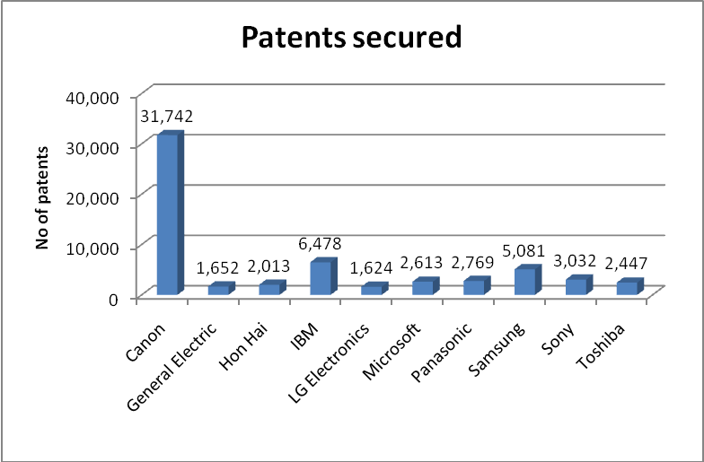
data provided by ifi claims patent services

      - Which company has secured the highest number of patents?
      - Which company has secured the second largest number of patents and how many?
      - What are the companies that have got more than 2,000 patents and by how many are they less or more than each other?
      - Do you find any company that has almost as many numbers of patents as the other? Name the two.
      - Which company has secured the least number of patents?
      - What is your inference from the given figures in the bar chart?
Description
The above bar chart describes the number of patents secured by various companies in the year 2012.
Let us begin with the names of the various companies that have won the patents. They are: Canon, General Electric, Hon Hai, IBM, LG Electronics, Microsoft, Panasonic, Samsung, Sony and Toshiba. And following are the number of patents obtained by them: 31,742; 1,652; 2,013; 6,478; 1,624; 2,613; 2,769; 5,081; 3,032; 2,447.
We note that Canon has obtained 31,742 patents by far the highest of all other companies. When we have a look at the performance of IBM, it has got 6, 478 patents the second highest of all the companies represented in the chart. Hon Hai, Microsoft, Panasonic and Toshiba have each acquired more than 2,000 patents. Microsoft has received 2,613 whereas Hon Hai has procured only 2,013 patents. This is lesser by 500 than that received by Microsoft. Turning to Panasonic, it has got only 166 more patents than that of Toshiba. Similarly, though we cannot say that Panasonic has won as many number of patents as that of Microsoft, we can say that the difference if not negligible is comparatively less, the difference being 156. IBM and Samsung have crossed the 5,000 mark, but only Canon tops all the companies with 31, 742 patents.
On the whole, we may deduce that Canon spends the most on its R & D and has a stronger team of research personnel who come out with more and more innovations and an alert legal department who ensure that their company win all the patents that they are eligible for.
Some of the useful expressions for writing this are:
- For introducing the topic – The chart represents, The table shows ,The graph depicts etc.
- Describing the data – To begin with, Let us begin with, Beginning with, We note that, Turning to etc.
- Comparing and Contrasting – Similarly, However, Despite, Though, Whereas etc.
- Concluding – To sum up, On the whole, To conclude, Overall etc.
- Degrees of comparison – the … -est / most ,… -er / more than, as / so (not) … as
C. 1 For Practice
- Look at the following bar chart and write a passage based on the statistical details given in that.
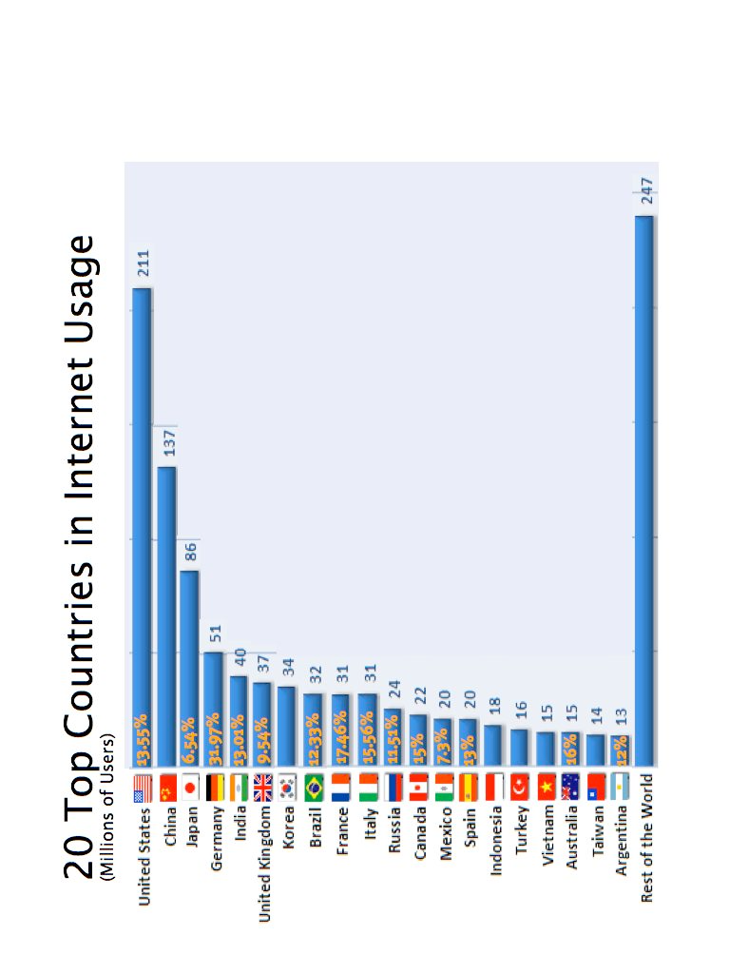
- Write a passage based on the data represented in the following bar chart using degrees of comparison and expressions of comparison and contrast.
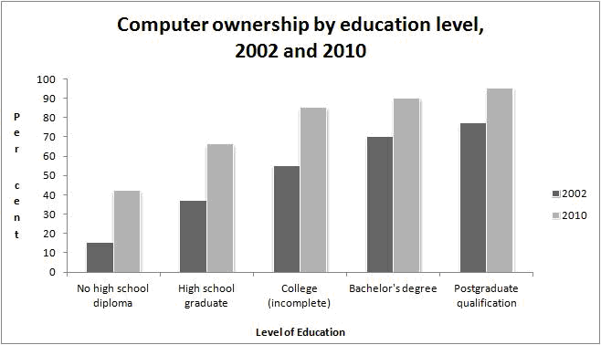

C. 2 Extended Writing Based on a flow chart
Describing a process by converting the details of the flow chart into a continuous writing is also a requisite skill that is expected of an engineering student before he enters the job market. We already have practice in drawing a flow chart. Now let us learn the steps involved when we write a passage based on a flow chart.

Steps involved in process description based on a flow chart
Step I | Read the flow chart carefully and understand the process depicted in the codes correctly.
Step II | Open the paragraph with introduction of the codes. E –g “The given flow chart is about the process of preparing lime juice”
Step III | Use simple present tense throughout and whenever necessary use impersonal passive in present tense form. Avoid using any other tense form.
Step IV | Use connectives like, then, now, initially, finally and consequently to establish continuity.
Step V | If any inference could be drawn from the flow diagram use it in the conclusion.
http://www.scoop.it/t/ielts-writing-task-1-practice
Example: Given below is a passage on the functioning of a fingerprint biometry detector based on the flowchart that follows it. Note how the different phases are distinguished and how the sequential connectives are used.


AUTOMATED FINGERPRINT RECOGNITION
The passage outlines a typical automated fingerprint recognition system. Initially, during the enrollment phase, the sensor scans the user’s fingerprint and converts it into a digital image. Then, the minutiae extractor processes the fingerprint image to identify specific details known as minutia points that are used to distinguish different users. Minutiae points represent locations where friction ridges end abruptly or where a ridge branches into two or more ridges. A typical good-quality fingerprint image contains about 20-70 minutiae points; the actual number depends on the size of the sensor surface and how the user places his or her finger on the sensor.
Next, the system stores the minutiae information—location and direction—along with the user’s demographic information as a template in the enrollment database. During the identification phase, the user touches the same sensor, generating a new fingerprint image called a query print. Once the minutiae points are extracted from the query print, the matcher module compares the query minutia set with the stored minutia templates in the enrollment database to find the number of common minutia points. Due to variations in finger placement and pressure applied on the sensor, the minutiae points extracted from the template and query fingerprints must be aligned, or registered, before matching.
After the fingerprints are aligned, the matcher determines the number of pairs of matching minutiae—two minutiae points that have similar location and directions. Finally, the system determines the user’s identity by comparing the match score to a threshold set by the administrator.
Functioning of Automated Fingerprint Biometric System
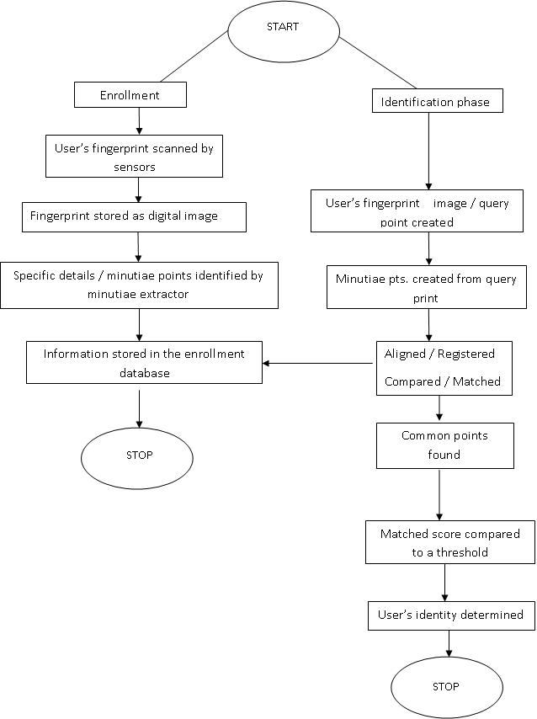
Abbreviation used: pts. – points
C. 2. 1 For practice
- Write a passage on how AIML functions to produce a programmed reply.
How AIML Works with SR, TTS and Avatar to Give a Programmed Reply

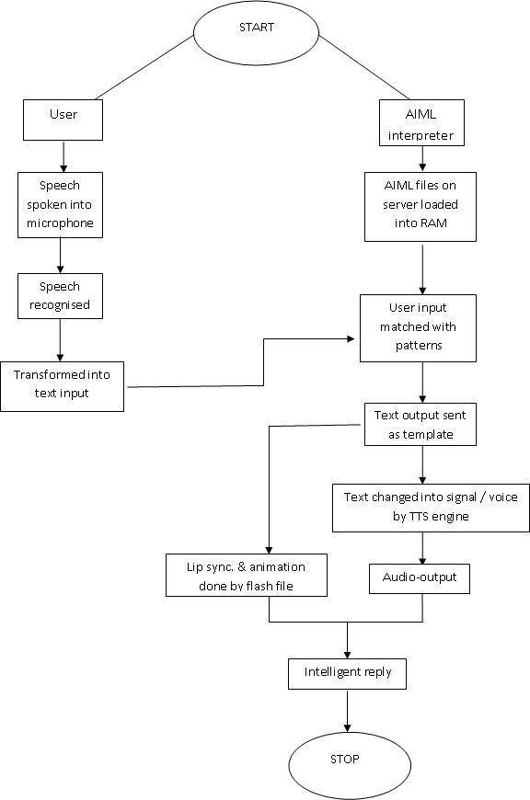

- Write a passage on how conveyer belts are manufactured based on the following flow chart.

Manufacturing Rubber Conveyer Belts

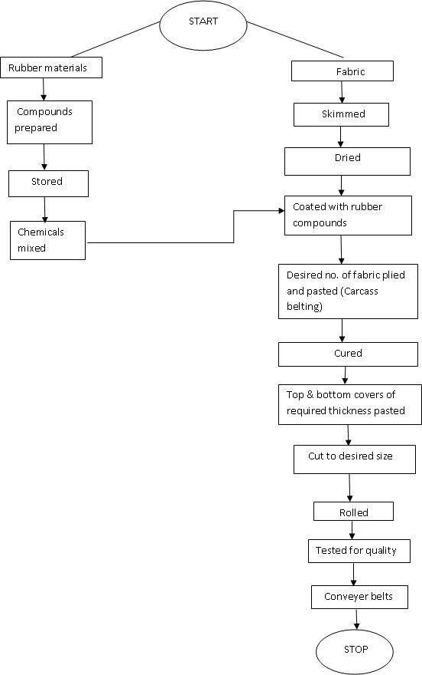

D. Reading
Reading is one of the essential learning skills that should be developed by the engineering students to update their knowledge of the subject as well as to express themselves fluently while speaking and writing. Efficient reading equips the learners with a wide range of necessary vocabulary; unconsciously lets the appropriate syntax get embedded so that the learner is able to have a good command over the language whether it is spoken or written.
But the kind of reading that you choose to employ depends on the purpose on hand. Thus ‘Reading’ can be of four types. They are: Skimming, Scanning, Critical Reading and Reading for Comprehension.
Skimming: You skim a passage when you give a quick reading of a text to get an overview or gist of it without going deep into the details of the passage.
Scanning: You scan a passage when you span over the text to get only the main ideas of the passage or to look for a particular idea.
Reading for Comprehension: You read a text to know and understand the facts, details and ideas presented in the passage. This requires a thorough study of the text with the precise understanding of the vocabulary, syntax, the tone used and the various shades of implied meanings.
Critical Reading: You critically read a text when you know and assimilate the ideas in a text, evaluate them to form your own opinions and conclusions.
An average American reader reads approximately 250 words per minute as per the information given in a website. But that is not the ultimate speed. If you have to become an efficient reader, you need to first improve your speed of reading. But
How to improve the reading speed?
- Read silently. Do not move your lips while reading.
- Do not read word by word. Use larger eye-span to take in phrases.
- Guess the meaning of an unfamiliar word from the context. If the meaning is still not clear, refer to a dictionary.
- Read with an open mind, without any bias or prejudice.
- Set time for reading a passage. Reduce time for subsequent readings.
Following are a few suggestions that can be followed if you want to benefit to the maximum from your reading.
Pre-reading
- Brainstorm if in a group; otherwise, jot down your ideas on the topic.
- Write down the words that you expect to find in the passage.
While reading
- Note down the main ideas.
- Note down the difficult words.
Post-reading
- Check whether the ideas expressed in the passage are similar to your own.
- Find out the meanings of totally unfamiliar words.
- Answer the given questions.
D. 1 Reading Comprehension
Pre Reading Activity
Before reading the given passage work in pairs and answer the following questions.
- What are skyscrapers?
- Why do you think they are named so?
- Can you name two famous skyscrapers that you have seen?
- Write down a few words that come to your mind as soon as you hear the word ‘skyscrapers’ and while / after reading the passage check how many of them have been used in the text.
- Do you think skyscrapers are a threat to ecology? Discuss with your friend and jot down points.
Note the time before you begin to read the passage. Read the passage silently and at the end of it check how many minutes it has taken for reading the whole of it. Repeat the same a second time and see whether the time taken this time is lesser than previous one.
Now read the passage again and answer the following questions.
D. 1. 1 The History of Skyscrapers by Karen Barss

A race to the top



The Chrysler Building, The John Hancock Tower,
New York Boston, Massachusetts
The desire to build big is nothing new. Big buildings have been used to show off power and wealth; to honor leaders or religious beliefs; to stretch the limits of what's possible; and even as simple competition among owners, families, architects, and builders. Some of the most dramatic buildings of the past include the pyramids in Egypt, the skinny towers stretching towards the sky in Italian hill towns, and the gothic cathedrals of France. While these types of buildings may look very different from each other, they all have one thing in common. They were built with masonry or stone walls supporting most of the weight (so-called load-bearing walls), including that of the floors, the people, and everything the rooms contained. Because of this, the height of these buildings was limited by how massive and heavy they had to be at the base.

Removing the Obstacles
Two developments in the 19th century paved the way for a whole new type of building: the skyscraper. The first was the development of a safe elevator. Primitive elevators of various designs had been used for centuries, and starting in the mid 19th century, steam-operated elevators were used to move materials in factories, mines, and warehouses. But these elevators were not considered safe for people; if the cable broke, they would plummet to the bottom of the elevator shaft. Then in 1853, an American inventor named Elisha Graves Otis developed a safety device that kept elevators from falling if a cable should break. This new development had an enormous impact on public confidence. And later in the century, the switch to an electric motor made the elevator a practical solution to the problem of getting up and down tall buildings.
The second development took place in Chicago. In 1871, Chicago suffered a devastating fire. In the years that followed, however, instead of recovering slowly, the city experienced explosive growth, and it quickly began to strain against its natural boundaries. By the 1880s, the available land for new buildings in this area could not keep up with demand; the only alternative was to build up. But in order to achieve the desired height, construction techniques had to change. A new method of building was developed that used a grid of steel beams and columns that were strong enough to support any stresses or forces a building might experience, including both the weight of the floor and the building contents, as well as the force of wind or even, in some areas, earthquakes. And with this new building method, the skyscraper was born and the race for the tallest building began.

Modern Materials
Since the birth of the skyscraper, builders and engineers have continuously looked for ways to improve building methods and materials, in order to make structures stronger, taller, and lighter. Skyscrapers are built to last, so they must be made of materials that are strong; durable; resistant to the sun, wind, rain, frost, and snow; and affordable. Concrete is one of the most common materials, beyond the steel supports, because it is enormously versatile. Its composition can be changed depending on the needs of the building. It can be reinforced to make it stiffer and stronger by setting steel mesh or bars into the concrete. And additives can make it set or harden faster or slower depending on the needs of the design.
Another very important material is glass. Because the steel skeleton now supports the main loads of the building, the outer skin only serves to keep the weather out and let light in, the more light the better. So glass walls became very popular beginning after World War II, because they are weatherproof while providing ample natural light and also because they are so much lighter-and cheaper-than masonry or concrete.

The Forces of Nature
But as buildings became taller and lighter, particularly the modern glass boxes that are so popular, skyscrapers began having trouble with the wind and they began to sway, some more than two feet in any direction! Engineers came up with new solutions for this problem, first installing diagonally braced steel trusses between central elevator shafts to create a stronger core, and then moving most of the beams and columns to the outside edge of the walls in order to make a stiff tube. A more unusual solution was devised to control sway in the 1970s called a tuned mass damper. This is a giant concrete block or weight, mounted with springs and shock absorbers on a lubricated plate, designed like a pendulum to move in one direction when a computer senses the structure has begun to move in the other, in order to counterbalance the motion.

Building Badly
Of course, with new technological developments, problems can occur. One dramatic and very visible example was the John Hancock Tower in Boston, now considered the city's most spectacular building. The structure is a tower of mirrored glass. But almost from the beginning, the glass panes failed. The problem started during a winter gale in January 1973 while the tower was still under construction, when huge panels of glass, each weighing 500 pounds, shattered and fell to the street below.
The streets and sidewalks were roped off as engineers tried to figure out what was going wrong. By April at least 65 panels had fallen and been replaced by plywood. Theories and rumors persisted, including that the tower was swaying too much, causing the windows to pop out, or that the tower's foundation was settling so significantly that it broke the windows. The truth was that the material itself failed. The window units had been manufactured using a fairly new process and the design was fatally flawed. Ultimately, all 10,344 windows had to be replaced and the building has been safe ever since.

The Race for the Sky
In the early 20th century, corporations built skyscrapers for the promotional value to increase name recognition. Among the early skyscrapers in Manhattan were the Metropolitan Life Insurance Tower (700 feet, 50 stories), the Woolworth Building (the world's tallest from 1913-1930 at 792 feet, 60 stories), the Bank of Manhattan (927 feet, 71 stories), and the heavily decorated Chrysler Building (briefly the world's tallest in 1930 at 1046 feet, 77 stories). The Chrysler Building soon lost its crown to the Empire State Building, built during the Depression by a real estate developer, which reached a stunning 1,250 feet and 102 stories. The Empire State Building would reign supreme among skyscrapers for 41 years until 1972, when it was surpassed by the World Trade Center (1,368 feet, 110 stories). Two years later, New York City lost the distinction of housing the tallest building when the Sears Tower was constructed in Chicago (1450 feet, 110 stories). And twenty-four years after that, for the first time the tallest skyscraper was no longer in the United States at all, but in Kuala Lumpur, Malaysia, where the Petronas Towers were built in 1998 (1483 feet, 88 stories).
Taipei 101, completed in Taiwan in 2004, which tops out at 1,670 feet and 101 stories, held the title as the tallest building in world until January 2010, when the Burj Khalifa (formerly called the Burj Dubai), in Dubai, United Arab Emirates, became the world's tallest building at 2,716 feet (828 meters) and 160 stories. The Burj Khalifa contains the world's fastest elevators, 20.7 acres of glass, and is expected to use about 250,000 gallons of water per day.
http://www.infoplease.com/spot/skyscraperhistory.html#ixzz2SgHjEVQ8

- Answer the following questions in not more than three sentences.
- Why do people desire to build big?
- Name two well-known structures of the past.
- What bore the weight of the building in olden days and what was its disadvantage?
- What were the two developments made in the nineteenth century that paved the way for building skyscrapers?
- Mention the two new construction materials that contributed to the building of stronger and lighter skyscrapers.
- Give a brief account of the innovations made in erecting buildings which can balance against forces of nature.
- What is the motive behind building tall structures by corporations? Mention the name of the tallest building in the world, where is it situated and when was it built?
- Find the expressions beginning with ‘stretch…’ from the passage. Write three more expressions of the same kind and use them in sentences of your own.
Example (out of the text): stretch one’s leg – After working on the computer for more than five hours, I wanted to stretch my legs.
- Write the meanings of the following expressions and use them in sentences of your own.
paved the way, switch to, strain against … natural boundaries, roped off, figure out, lost its crown
d. Choose the correct meanings of the following words as used in the text from the options given.
- skinny
  - made of skin, very thin or lean, skeletal, covered with skin, shiny
- massive
  - huge and heavy, attraction of a large number of people, made of the same material, massaging, appeal to people
- base
  - foundation, fundamental, menial, mean, primary
- primitive
  - primeval, uncivilized, crude and one at the early stage of development, instinctual, significant
- plummet
  - plum, fall straight down, plume, a sudden decline, burden
- enormous
  - great, large, caught amidst, monstrous, out of proportion
- devastating
  - causing great destruction, vast, invoking, stun, rude
- explosive
  - profound, violent, likely to catch fire easily, intense
- versatile
  - well versed, adjustable, inconstant, freely moving, adaptable to various uses
- braced
  - made stronger by support, dental appliance, burnt down, encountered, broadened
- Find out the antonyms of the following words.
including, practical, followed, harden, flawed, surpassed
- State whether the following statements are true or false.
- Impressive buildings of ancient times were built for promotional value.
- Elevators operated by electric motors are not considered safe.
- The use of reinforced concrete made the building weak.
- Mass damper is a weight used to counterbalance the swaying motion of the skyscrapers.
- Burj Khalifa has the world’s fastest elevators.
- World Trade Center is the tallest building in the whole world.
g. Summarize the main ideas of the given passage.
D.1.2. Read the following passage and answer the questions below
Casting a wide Net
SOCIETY From booking train tickets to saving rare species of animals, do it all through websites
It’s a wonderful to watch the excitement on Pushpa, our house help’s face, when I click open the University of Manchester, UK website on my laptop, to show her where our son has gone to study. “Foreign” is no more a nebulous world in her mind, as I have actually opened out not only the University website to show her where she is studying, but I can also show her where he is staying. That is the power of a website, which immediately not only shrinks the world, but offers a plethora of possibilities.
On the other side of the spectrum is Ramakrishna Karuturi, owner of Karuturi Global Ltd. Within a few years of starting a floriculture unit in Doddaballapur, his company has become the largest producer of roses. The site, www.karuturi.com, presents the company attractively online. Ramakrishna says the website opens up for him, ‘an interactive information brochure for business development. My customers feel cofident reading about our disciplined approach. The website offers stakeholder / investor communication, and it is also a prospective employee magnet.”
“I found the PETA India website very educative since I am fond of animals,” says Indumathi, a student of Mass Communication. www.petaindia.com is laid out attractively with large pictures. Celebrities such as Angelica Huston and Celina Jaitley speak about issues relating to the great apes and elphants.
Hritik Bagade says the Akshaya Patra scheme (www.akshayapatra.org) website impresses him, as it’s the world’s school meal programme. “One million children are fed by this scheme, and it has even entered the Limca Book of Records. One can volunteer, contribute, raise funds and spread the word through this interactive website.”
Saves time and effort
And, student Pradeep books all his train tickets online through www.irctc.co.in, the Indian Railways’ reservation site. “I find it so much easier to book online than stand in a long queue at the station. It may cost around Rs. 25 extra for the use of the credit card, but it’s worth it. You save all the extra effort and time wasted.”
“In fact, with Easy Jet (www.easyjet.com), a foreign student in the U.K. like me can get off-season cheap flights to visit Europe,” says Sulabh Jain, who studies in University of Wales, Swansea. “I have recently been to Geneva for les than 30 pounds for the round trip. You have to look for their lowest fares and book in advance.”
“The world’s newspapers are all online and, no matter which part of the world one is in, logging onto the e-paper is just a click away,” says Swati Nair, who is presently in the U.S. E-bay (www.ebay.in) and Craigslist http://bangalore.craigslist.co.in, are commercial sites which work on the lines of the old auction houses. Check them out if you are looking for a deal in anything from antiques to mobile phones. It’s a borderless online world out there.
MARIANNE DE NAZARETH,
The Hindu, Metroplus, 11 August 2009, p.5
- Find the meanings of the following words as used in the passage by referring to a dictionary.
- shrinks
- plethora
- spectrum
- borderless
- nebulous
- “Culture” means “cultivating.” “Floriculture” is “cultivating flowers”. Write similar words ending in “culture” and give their meanings.

1. ………………… 6…………………….
2. …………………… 7…………………….
3. …………………… 8…………………….
4. ………………….. 9…………………….
5. ………………….. 10………………….

- Give the other degrees of comparison for the following words.

Positive Comparative Superlative
- _______________ _______________ largest
- _______________ easier/ more easy _____________
- confident _______________ _____________
- ______________ less _____________
- attractive _______________ _____________

- Answer the following questions based on your reading of the passage.
- What are the different specific fields / areas mentioned in the passage that benefit the public through their websites?
- How does an interactive website help in furthering the business prospect?
- Why does the writer say a website “not only shrinks the world, but offers a plethora of possibilities”?
- How does booking tickets online benefit a traveller?
- Do you think “casting a wide Net” is a suitable title? Justify four answer.
D.1. 3 Read the following passage and answer the questions given below
Artificial intelligence systems may run amok
Criminals could exploit artificial intelligence
A robot that can open doors and find electrical outlets to recharge itself. Computer viruses that no one can stop. Predator drones, which, though still controlled remotely by humans, come close to a machine that can kill autonomously.
Impressed and alarmed by advances in artificial intelligence, a group of computer scientists is debating whether there should be limits on research that might lead to loss of human control over computer-based systems that carry a growing share of society’s workload, from waging war to chatting with customers on the phone.
Their concern is that further advances could create profound social disruptions and even have dangerous consequences.
As examples, the scientists pointed to a number of technologies as diverse as experimental medical systems that interact with patients to simulate empathy, and computer worms and viruses that defy extermination and could thus be said to have reached a “cockroach” stage of machine intelligence.
While the computer scientists agreed that we are along way from HAL, the computer that took over the spaceship in “2001: A Space Odyssey,” they said there was legitimate concern that technological progress would transform the work force by destroying a widening range of jobs, as well as force humans to learn to live with machines that increasingly copy human behaviour.
The researchers – leading computer scientists, artificial intelligence researchers and roboticists who met at the Asilomar Conference Grounds on Monterey Bay in California – generally discounted the possibility of highly centralized super-intelligences and the idea that intelligence might spring spontaneously from the intrnet. But they agreed that robots that can kill autonomously are either already here or will be soon.They focused particular attention on the spectre that criminals could exploit artificial intelligence systems as soon as they were developed. What could a criminal do with a speech synthesis system that could masquerade as a human being. What happens if artificial intelligence technology is used to mine personal information from smart phones?
The researchers also discussed possible threats to human jobs, like self-driving cars, software-based personal assistants and service robots in the home. Just last month, a service robot developed by Willow Garage in Silicon Valley proved it could navigate the real world.
A report from the conference, which took place in private on February 25, is to be issued later this year. Some attendees discussed the meeting for the first time with other scientists this month and in interviews.
The conference was organised by the Association for the Advancement of Artificial Intelligence, and in choosing Asilomar for the discussions the group purposefully evoked a landmark event in the history of science. In 1975, the world’s leading biologists also met at Asilomar to discuss the new ability to reshape life by swapping genetic material among organisms. Concerned about possible biohazards and ethical questions, scientists had halted certain experiments. The conference led to guidelines to recombinant DNA research, enabling experimentation to continue.
The meeting on the future of artificial intelligence was organised by Eric Horvitz, a Microsoft researcher who is now president of the association.
Mr. Horvitz said he believed computer scientists must respond to the notions of super-intelligence machines and artificial intelligence systems run amok.
The idea of an “intelligence explosion” in which smart machines would design even more intelligent machines was proposed by the mathematician I. J. Good in 1965. Later, in lectures and science fiction novels, the computer scientist Vernor Vinge popularized the notion of a moment when humans will create smarter-than human machines, causing such rapid change that the “human era will be ended.” He called this shift the Singularity.
John Markoff, The Hindu, 27 July 2009.

a. Read the following questions and answer them in not more than three or four sentences.
- Define “artificial intetlligence.”
- What are some of the “social disruptions” and “dangerous consequences” of further advancements in artificial intelligence?
- Find out and give details about what “HAL” and “2001: A Space Odyssey” are.
- Why was Asilomar chosen as the venue for the 25 February 2009 Conference on artificial intelligence?
- Explain the terms “singularity”, and “intelligence explosion”. Who are the proponents of these terms?

  - Find out the following words by filling in the blanks correctly and give their meanings.
- ---- ----- o ---- ------s (paragraph 1)
- ---- e ----- ------- ------- i ------- ------ ----- e (paragraph 5)
- c ---- ---- ----- ----- a ----- ----- z ------ (paragraph 6)
- m ------- ------ q ------ ------ r ------ ------- e (paragraph 7)
- ----- ------- ------ e ------ ----- e ------s (paragraph 9)
c. The prefix “re-------- means “again”. For example “recombinant” -- the element that combines again. Give a minium of five words of your own with the following prefixes.
- re -- 2. bio – 3.dis -- 4. auto – 5.sy –

d. The word “progress” can act both as a noun and a verb.
Example : The progress was slow
The research does not progress fast
Give a minimum of five examples of your own for words acting in different
parts and use them in sentences of your own.
D.1.4. Read the following passage and answer the following questions
Milestone in stem cell research
Research on reprogramming adult cells to make them behave like embryonic stem cells crossed a milestone recently when two Chinese teams succeeded in producing mouse pups using such cells. Ever since induced pluripotent stem (iPS) cells were produced in 2006 by reprogramming adult cells, researchers across the world have been wotking feverishly to replicate and refine the technique. Though many scientists have succeeded in producing iPS cells, unassailable evidence of their pluripotency – ability of the cells to behave like embryonic stem cells and form all of the two-hundred odd specialised cells – was lacking. The latest success in producing mouse pups using reprogrammed adult cells has taken research one step closer to proving the pluripotency of iPS cells. One team, headed by Qi Zhous of the Chinese Academy of Science, and the other, led by Shao Rong Gao from the National Institute of Biological Sciences in Beijing, were able to produce mouse pups using iPS cells injected into early-embryos that can only become the placenta and not develop into animals. While Qi Zhous’ team was able to produce 27 pups, including ‘tiny,’ using three iPS cell lines, the other team could create only four. If growing to adulthood is considered significant, the pups created by Qi Zhous passed the fundamental test of health – they sired over two second-generation pups. More than hundred third-generation pups have also been produced.
Many scientists are turning to iPS cell technique to side step the ethical controversy of embryo destruction when somatic cell nuclear transfer (SCNT) technique is used. Also, unlike in the case of SCNT, human eggs are not required when iPS cells are used for making embryos. But this technique is fraught with scientific hurdles. For instance, the Qi Zhous’ team used retroviral vectors to introduce four genes to reprogramme adult cells. Retroviruses are known to induce cancer in mammals. Though some studies have succeeded in inducing pluripotency without usint these viruses, more research remains to be done. Similarly, oncogenes were used for reprogramming adult cells. This again raises the possibility of cancer formation when the pluripotent cells are introduced into an animal. Skin cells are routinely used for making iPS cells. Though available in plenty, turning back their clocks to make them pluripotent is big challenge. Both the teams had hence used more pliable cells taken from late-stage embryos. This approach will not be useful if the iPS technique is used for patient-matched therapeutic applications. However, the technique is nearing maturity and may pave the way for creating cell lines to study genetic diseases.
The Editorial, The Hindu, 1 August 2009.
a. Note the following phrases.
  - mouse pups, 2. adult cells
When countable nouns are used as adjectives they take the singular form and not plural. Similarly, when a numerical phrase is used as adjective, it is in the singular form.
Example: a two-year research.
Write five examples for each of the above category.
b. ‘IPS’ and SCNT’ are abbreviations used in the passage given above. Give their expansions and write down five abbreviations and expansions of your own from any one technical field of your choice.
c. Find out the sentences from the passage using the connectives “though”, “however” and “if”. Indicate their functions. Write your own sentences using those connectives.
d. Use the following phrases in sentences of your own.
- cross a milestone
- take one step closer
- sidestep
- fraught with
- pave the way
UNIT II
ECOLOGY
Ecology is defined as the branch of biology that deals with the relations of organisms to one another and to their physical surroundings.
It is also defined as the study of the interaction of people with their environment.
Recent newspaper headlines In India

Heavy rains claim seven lives in Chamoli
Heavy rains continued to wreak havoc in Uttarakhand where seven persons of a family were killed when the ceiling of their house collapsed in Chamoli district on Wednesday. The house collapse... »
(Dehradun, Wednesday, July 10, 2013, The Hindu)
& Worldwide

China floods trigger landslide that buries 30 people
Hundreds trapped in road tunnel and earthquake memorial , destroyed amid heavy rain and high winds in Sichuan province …
(guardian.co.uk, Wednesday 10 July 2013)

Australian heatwaves 'five times more likely due to global warming'
Human activities will account for at least half of extreme summer temperatures likely to hit Australia in the future, say scientists…
(guardian.co.uk, Monday 8 July 2013)

Crew of 19 elite firefighters killed in Arizona wildfire
Only one survivor from hotshot unit trained to venture into remot eareas, which was overtaken by rapidly moving blaze…
(guardian.co.uk, Monday 1 July 2013)
This earth we live in has been our home, sustaining life and providing us with the environment to work and play.
The recent catastrophes reveal the power of nature and its fury at being taken for granted. Will we learn ever?

Read the text given:
TEXT 1
EARTH
Our planet is simply amazing.
Viewed by someone not from our world, it could be seen as one big, finely tuned and ultimately incredible machine.
Lots of cogs, pullies and wheels (animals, plants and environments) working together. Depending on each other in so many ways. Creating a green, blue healthy world that you, us, everyone depends on.
For food, fuel, medicine and other essentials that we simply cannot live without.
Sure this machine can take some knocks and bruises.
It can bounce back.
Stretch. Adapt. Mend.
It is part of what makes it so marvelous.
But we're beginning to pull and stretch it further than it has ever been stretched before.We're entering unknown territory where some of the extinctions we are causing may have deep and profound effects on how we live our lives.
In the grand time scale of our planet, these effects may be currently seen as the equivalent of storm clouds gathering on the horizon.
But rest assured, the storm is coming.
Unless we learn to start loving and caring for what our planet already gives us.
( http://wwf.panda.org/about_our_earth/biodiversity/)
A. Grammar and Vocabulary
A.1 Synonyms and Antonyms
Synonyms are words that have the same meaning as the given word
e.g. Start – commence, begin
Antonyms are words which are opposites of the given word.
e.g . Gather – disperse
Very often the addition of a prefix to a base word gives us the antonym of that word
e.g . known - un + known = unknown, non + violence=Non-violence
A.1.1 Exercises based on given text
- Provide synonyms for the following from the text above
- Mechanism
- Earth
- Intense
- Acclimatize
- Squall
- Provide antonyms for the following from the text above
- believable
- Antidote
- Compress
- Initially
- Depart
A. 1. 3 Tips for cracking antonym tests in competitive exams
- If the word is known to you, choosing an antonym is easy. Very often a synonym of the word is added to the list given. Bear in mind that you are looking for a word with the opposite meaning. You may also have two words which is close but remember, marks are given for the perfect answer only. e.g. BRAVADO – valour, brevity, audacity, cowardice, chauvinism
- If you do not know the meaning of a word, try to infer its meaning by looking at the prefixes or roots of the words.
OVERBEARING – Sly, industrious, servile, subterranean, hortatory.
- One way to guess the answer is to see if the given word has positive connotations, if it has, then the answer will be a word with negative connotation. Addition of prefixes such as dis-, ir-,
e.g - CURB – bridle , ameliorate, encourage, reproach, perjure
‘Curb’ means ‘to restrict’ which has a negative meaning and the only positive word among the given words is ‘encourage’
- At times when the word you are looking for is not among the answers then look for the secondary meaning of the word, which might reveal the answer.
e.g. RENT – reserved, razed, restore, kinetic, busy
‘Rent’ here does not refer to the charge paid for occupying a place, a tenancy but to the act of tearing something. The answer is ‘restore’.

A.1.2. Additional exercises for Competitive exams
A.1.2.a Choose the perfect synonym

1. PALTRY
a) insignificant
b) unfair
c) average
d) slovenly
e) party

2. DISPARAGE
a) to scatter
b) discriminate
c) belittle
d) waste
e) parable
3. OVERTURE
a) disclosure
b) apology
c) request
d) proposal
e) vulture

4. LETHARGY
a) serenity
b) listlessness
c) impassivity
d) laxity
e) zeal
5. TRACTABLE
a) tillable
b) easily followed
c) understandable
d) docile
e) adamant

6. NURTURE
a) to ripen
b) pamper
c) nourish
d ) relieve
e) doctor

7. INCHOATE
a) loose
b) implicit
c) chaotic
d) incomplete
e) beginner

8. SATIATE
a) to glut
b) comfort
c) desire
d) water down
e) craven
9. OBSESSION
a) dejection
b) preoccupation
c) frustration
d) suspicion
e) gaiety

10. APPEASE
a) to yield
b) give pleasure
c) placate
d) compromise
e)small
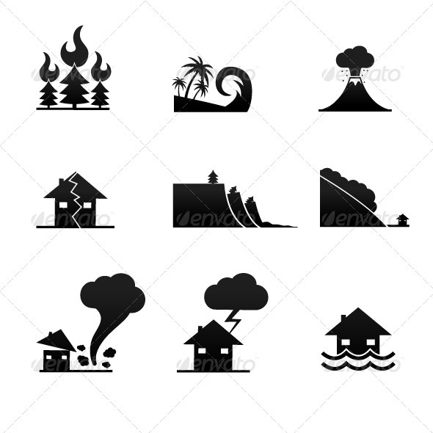

A.1.2.b. Choose the most suitable antonyms

1. INORDINATE
A. moderate
B. excessive
C. venal
D. mundane
E. preternatural
2. CONTENTIOUS
A. irascible
B. jaundiced
C. placatory
D. unrequited
E. antipathetic
3. BUOYANT
A. ebullient
B. morose
C. prescient
D. feral
E. bland
4. COALESCE
A. disperse
B. agglomerate
C. bamboozle
D. canalize
E. moderate
5. MODERN
A. moribund
B. antediluvian
C. salutary
D. hidebound
E. burgeoning
6. OVERBEARING
A. sly
B. industrious
C. hortatory
D. servile
E. subterranean
7. TRANSPARENT
A. noisome
B. preponderant
C. ineluctable
D. esoteric
E. diurnal
8. INQUIETUDE
A. temerity
B. punctiliousness
C. decency
D. serenity
E. excision


9. STOLID
A. tractable
B. refractory
C. ineligible
D. diaphanous
E. volatile
10. NONCOMBATANT
A. Correspondent
B. stalwart
C. warrior
D. proletarian
E.jester

A.2 . Parallellisms
Parallelism is the arrangement of similarly constructed clauses, sentences, or verse lines in a pairing or other sequence suggesting some correspondence between them. The effect of parallelism is usually one of balanced arrangement achieved through repetition of the same syntactic forms. In classical rhetoric, this device is called parison or isocolon. These lines from Shakespeare's Richard II show parallelism:I'll give my jewels for a set of beads, My gorgeous palace for a hermitage, My gay apparel for an almsman's gown, My figured goblets for a dish of wood …Parallelism is an important device of 18th‐century English prose, as in Edward Gibbon's sentence from his Memoirs (1796): ‘I was neither elated by the ambition of fame, nor depressed by the apprehension of contempt.’ where the elements arranged in parallel are sharply opposed, the effect is one of antithesis.
Learn through Error Analysis:
Faulty: Cramming for exams is hard, boring, and it doesn't pay. Correct: Cramming for exams is hard, boring and pointless. [3 adjectives] Faulty: The sisters bought shoes, bags and then went to lunch.
Correct: The sisters bought shoes, bags and lunch. [3 nouns]
Faulty: Sylvain travelled by plane, boat and by train.
Correct: Sylvain travelled by plane, by boat and by train. [3 phrases]
Correct: Sylvain travelled by plane, boat and train. [3 nouns]
Faulty: Formerly, science was taught by the textbook method, while now the laboratory method is employed.
Correct : Formerly, science was taught by the textbook method; now it is taught by the laboratory method
The faulty version gives the impression that the writer is undecided or timid; he seems unable or afraid to choose one form of expression and hold to it. The correct version shows that the writer has at least made his choice and abided by it.
By this principle, an article or a preposition applying to all the members of a series must either be used only before the first term or else be repeated before each term.
Faulty – The French, the Italians, the Spanish, and the Portuguese
Correct- The French, the Italians, Spanish, and Portuguese
Faulty - In spring, summer, or in winter
Correct - In spring, summer, or winter (In spring, in summer, or in winter)
Correlative expressions (both, and; not, but; not only, but also; either, or; first, second, third; and the like) should be followed by the same grammatical construction. Many violations of this rule can be corrected by rearranging the sentence.
Faulty
- It was both a long ceremony and very tedious.
- A time not for words, but action
- Either you must grant his request or incur his ill will.
- My objections are, first, the injustice of the measure; second, that it is unconstitutional.-
Correct
- The ceremony was both long and tedious
- A time not for words, but for action
- You must either grant his request or incur his ill will.
- objections are, first, that the measure is unjust; second, that it is unconstitutional When making comparisons, the things you compare should be couched in parallel structures whenever that is possible and appropriate.
A.2.1. For Practice
Select the sentence which displays use of proper parallel constructions:
- Rani has wit, charm and she has an extremely pleasant personality.
- Rani has wit, charm and an extremely pleasant personality

- In English class, Nayan learned to read poems critically and to appreciate good prose
- In English class, Nayan learned to read poems critically and she appreciated good prose

- Kalpana’s CGPA is higher than Pooja.
- Kalpana’s CGPA is higher than Pooja’s.

- He wanted three things out of college: to learn a skill, to make good friends and to learn about life
- He wanted three things out of college: to learn a skill, to make good friends and learning about life.

- Coach Rodriguez was a brilliant strategist, a caring mentor and a wise friend.
- Coach Rodriguez was a brilliant strategist, a caring mentor and friend.

- We found the film repulsive, offensive and we thought it was embarrassing
- We found the film repulsive, offensive and embarrassing.

- Mr. Subramani kept his store clean, neat and he made it conveniently arranged.
- Mr. Subramani kept his store clean, neat and conveniently arranged.

- Professor Ali rewarded his students for working hard on the final project and going
beyond the call of duty.
- Professor Ali rewarded his students for their hard work hard on the final project and going beyond the call of duty.

TEXT 2
17th Century -- Status of the Environment
In 1854, "The Great White Chief" in Washington made an offer for a large area of Indian land and promised a "reservation" for the Indian people.
Chief Seattle's reply, published here in full, to mark World Environment Day has been described as one of the most beautiful and profound statements on the environment ever made:

In 1851, Seattle, chief of the Suquamish and other Indian tribes around Washington's Puget Sound, delivered what is considered to be one of the most beautiful and profound environmental statements ever made. The city of Seattle is named for the chief, whose speech was in response to a proposed treaty under which the Indians were persuaded to sell two million acres of land for $150,000." -- Buckminster Fuller in Critical Path.
Chief Seattle's Thoughts
How can you buy or sell the sky, the warmth of the land? The idea is strange to us. If we do not own the freshness of the air and the sparkle of the water, how can you buy them?
Every part of this earth is sacred to my people. Every shining pine needle, every sandy shore, every mist in the dark woods, every clearing and humming insect is holy in the memory and experience of my people. The sap which courses through the trees carries the memories of the red man.

The white man's dead forget the country of their birth when they go to walk among the stars. Our dead never forget this beautiful earth, for it is the mother of the red man. We are part of the earth and it is part of us. The perfumed flowers are our sisters; the deer, the horse, the great eagle, these are our brothers. The rocky crests, the juices in the meadows, the body heat of the pony, and man --- all belong to the same family.
So, when the Great Chief in Washington sends word that he wishes to buy our land, he asks much of us. The Great Chief sends word he will reserve us a place so that we can live comfortably to ourselves. He will be our father and we will be his children.
So, we will consider your offer to buy our land. But it will not be easy. For this land is sacred to us. This shining water that moves in the streams and rivers is not just water but the blood of our ancestors. If we sell you the land, you must remember that it is sacred, and you must teach your children that it is sacred and that each ghostly reflection in the clear water of the lakes tells of events and memories in the life of my people. The water's murmur is the voice of my father's father.
The rivers are our brothers, they quench our thirst. The rivers carry our canoes, and feed our children. If we sell you our land, you must remember, and teach your children, that the rivers are our brothers and yours, and you must henceforth give the rivers the kindness you would give any brother.
We know that the white man does not understand our ways. One portion of land is the same to him as the next, for he is a stranger who comes in the night and takes from the land whatever he needs. The earth is not his brother, but his enemy, and when he has conquered it, he moves on. He leaves his father's grave behind, and he does not care. He kidnaps the earth from his children, and he does not care. His father's grave, and his children's birthright are forgotten. He treats his mother, the earth, and his brother, the sky, as things to be bought, plundered, sold like sheep or bright beads. His appetite will devour the earth and leave behind only a desert.
I do not know. Our ways are different than your ways. The sight of your cities pains the eyes of the red man. There is no quiet place in the white man's cities. No place to hear the unfurling of leaves in spring or the rustle of the insect's wings. The clatter only seems to insult the ears. And what is there to life if a man cannot hear the lonely cry of the whippoorwill or the arguments of the frogs around the pond at night? I am a red man and do not understand. The Indian prefers the soft sound of the wind darting over the face of a pond and the smell of the wind itself, cleaned by a midday rain, or scented with pinon pine.
The air is precious to the red man for all things share the same breath, the beast, the tree, the man, they all share the same breath. The white man does not seem to notice the air he breathes. Like a man dying for many days he is numb to the stench. But if we sell you our land, you must remember that the air is precious to us, that the air shares its spirit with all the life it supports.
The wind that gave our grandfather his first breath also receives his last sigh. And if we sell you our land, you must keep it apart and sacred as a place where even the white man can go to taste the wind that is sweetened by the meadow's flowers. So we will consider your offer to buy our land. If we decide to accept, I will make one condition - the white man must treat the beasts of this land as his brothers. I am a savage and do not understand any other way. I have seen a thousand rotting buffaloes on the prairie, left by the white man who shot them from a passing train. I am a savage and do not understand how the smoking iron horse can be made more important than the buffalo that we kill only to stay alive. What is man without the beasts? If all the beasts were gone, man would die from a great loneliness of the spirit. For whatever happens to the beasts, soon happens to man. All things are connected.
You must teach your children that the ground beneath their feet is the ashes of our grandfathers. So that they will respect the land, tell your children that the earth is rich with the lives of our kin. Teach your children that we have taught our children that the earth is our mother. Whatever befalls the earth befalls the sons of earth. If men spit upon the ground, they spit upon themselves.
This we know; the earth does not belong to man; man belongs to the earth. This we know. All things are connected like the blood which unites one family. All things are connected.
Even the white man, whose God walks and talks with him as friend to friend, cannot be exempt from the common destiny. We may be brothers after all. We shall see. One thing we know which the white man may one day discover; our God is the same God.
You may think now that you own Him as you wish to own our land; but you cannot. He is the God of man, and His compassion is equal for the red man and the white. The earth is precious to Him, and to harm the earth is to heap contempt on its creator. The whites too shall pass; perhaps sooner than all other tribes. Contaminate your bed and you will one night suffocate in your own waste.
But in your perishing you will shine brightly fired by the strength of the God who brought you to this land and for some special purpose gave you dominion over this land and over the red man. That destiny is a mystery to us, for we do not understand when the buffalo are all slaughtered, the wild horses are tamed, the secret corners of the forest heavy with the scent of many men and the view of the ripe hills blotted by talking wires.
Where is the thicket? Gone. Where is the eagle? Gone. The end of living and the beginning of survival.
A.2.2 For Practice
- Note and underline the use of parallelisms in the above speech.
- Observe how efficient use of parallelisms and repetition heightens the effect of the speech!
TEXT III
21st Century – Status of the Environment
It’s 2013 and it appears that we have not learnt our lessons. Global warming, extinction of species including the human race looms large, in front of us.
The report on the convention on Global Biodiversity states:

“We can no longer see the continued loss of biodiversity as an issue separate from the core concerns of society: to tackle poverty, to improve the health, prosperity and security of present and future generations, and to deal with climate change. Each of those objectives is undermined by current trends in the state of our ecosystems, and each will be greatly strengthened if we finally give biodiversity the priority it deserves.” (http://wwf.panda.org/about_our_earth/biodiversity/)

Is there something that we can do?
The good news is that it is still not too late!! There is still a lot that can be done. Why not start right now? Let’s have a meeting to decide –
B. LISTENING & SPEAKING
Conducting Meetings –
Any organization requires to gather its workforce together from time to time and discuss plans, happenings and other matters related to the organization. Thus meetings play an important part in the effective functioning of an organization. It is imperative that a professional understands the process of conducting meetings.


B.1 Preparation for the meeting – Classroom Activity
A meeting has to be conducted to discuss and tackle environmental issues with students taking on roles of members of the Nature Club drawn up to tackle the problem of environmental degradation.
Venue - The Nature Club / The NCC unit at the University/………………………………….
Step 1: Communicating the information regarding the meeting
  - Discuss and Decide : What is the Agenda? Who are the Participants?
(Agenda –Issues to be discussed. Participants - Designated representatives of different areas)
  - Methods of Communicating - Notice and email
(Who sends? Suggestions: President of the Nature Club? Secretary ?
Or ……….....................)
Step 2: Organising the meeting
Discuss and Decide: Who will conduct? Who are the participants? Who takes notes? (Suggestions : President of the Nature Club? Secretary of NCC ? or…………………………)
Step 3: Conducting the meeting
(one convener , 6-8 members and one member to take notes)
The convener is in charge, he welcomes the other members and the meeting begins.
(Suggestions – Take three problems at least and discuss the causes, effects and solutions In addition, other tips on helping to conserve the environment and its implementation can be discussed. The other students in the class can be allowed to add any points on a particular issue before the next issue is taken up. All the students can be asked to make notes which could make sure that no points are omitted)
Step 4: The Minutes of the Meeting is prepared based on the recorded notes
One student writes on the blackboard board with inputs from all the others using the example provided in the text.
C. Writing
- Prepare a notice with agenda to be circulated as a. circular b. email for the meeting .
- Prepare the minutes of the aforesaid meeting (See examples provided on the following pages)
C.1. Notice, Agenda & Minutes of Meeting
NOTICE
What is it?
When a meeting is to be held by an organization, a notification is sent to all members of the particular team or committee. This notice is either put up on bulletin boards or circulated personally or via email. Some tips to remember include:
Drafting a Notice – How?
- Use the organisation letterhead
- Clearly state the date, time and venue of the meeting.
- Specify the reason (agenda) for the meeting
- Mention the name and designation of the issuing authority
- Mention the authorities to whom the copies are sent as Cc at the right/left bottom of the page
AGENDA
What is it?
The points to be discussed at the meeting are put down and appended along with the notice to ensure that the participants are well prepared for the meeting
Drafting the Agenda – How?
- Normally the agenda is drafted in two methods- one way of doing this is using serial numbers starting from 1 and continuing till the end of the last point
- The other way is placing the serial number of the meeting as the first digit (e.g and continuing from that number one for the points for eg. 3.1, 3.2, 3.3 so the first digit in all the numbers denoting meeting number if there is a sequence or conduct of any meeting of the same type with the same group.
Tips for preparing Agenda
- All agenda normally starts with the first point as the review of the previous meeting so that what has been discussed in the previous meeting and status of the work completed or pending can be viewed.
- This will be followed by a sequence of points according to the importance of the issue and the last point will be “any other matter” which probably cropped up after the notification or is new but related.
MINUTES OF MEETING
Definition
The MoM is a document where the proceedings of the meeting is recorded, usually by a secretary or another member. It carries the names of the organizer, the participants and details of issues discussed.
TIPS
  - The meeting usually begins with a reading of the minutes of the earlier meeting. The decisions taken and the follow up are looked into.
  - The issues of the current meeting are then taken up and discussed one by one in the same sequence as given in the agenda.
  - The person who records is a silent participant who observes the proceedings and makes notes regarding who says what and what decisions are taken.
  - Notes are made in the right hand corner with the names of people who have been delegated various tasks.
C.2. Examples of a
- Notice with an Agenda and
- A document carrying the Minutes of Meeting of the Board of Directors Of Narmadha Rubber Industries ,New Delhi, are provided on the next page. Study the format and style of presentation.
C.2.1 Prepare similar ones for the meeting conducted in class.
Sample: NOTICE WITH AGENDA
Narmadha Rubber Industries Ltd
27, Palace Road, Noida, New Delhi – 110 098
NOTICE
20 June 2013
The fourth meeting of the Board of Directors of the company will be held at the registered office of the company at 36, Mothilal Street, Shimla at 5.00 p.m. on Monday, 12July 2013.
The agenda for the meeting is given below.
AGENDA
4.1. Review of previous meeting
4.2. Proposal to start a new unit
4.3. Salary Revision
4.4. Conduct of the next meeting
4.5. Any other matter

Signature

S. R. Raghavan
(The Secretary)

Cc : The Chairman
Members of Board of Directors
More Practice
- Consider yourself as the Secretary of Fusion India Limited, 23 Sajjan Road, New Delhi. Draft a notice and agenda of a Director’s meeting.
- As the Secretary of the Organising Committee of the National Science Congress, present a copy of the notice and agenda for the first meeting held at No 11, Lake View Apartments, Lodi Road, Kolkatta.
Sample –MINUTES OF MEETING
Narmadha Rubber Industries Ltd
27, Palace Road, Noida, New Delhi – 110 098
Minutes of the Board of Director’s held on 12 July 2009 at 5.00 p.m.in the company’s conference hall.
The meeting chaired by Mr.G.Bhasha Managing Director Narmadha Rubber Industries commenced at 5.00 p.m.
The following members were present.
- Mr.G.Bhasha Managing Director
- Mr. K.Guptha Director, Planning and Development
- Mr.N. Naresh Director Finance
- Mr. G.Gogul Krishnan Director Marketing and sales
- Mr.R. Rajevan Director Purchase
- Mrs.s.Helen Director Human Resource
- Mrs Pamella Manager Office
Agenda 2.1 Review of the Minutes of the Previous meeting
The Managing Director discussed in details about the content of the previous meeting held on 12 March 2013 and all members showed their satisfaction and appreciated the efforts taken by the people concerned who had completed all the assigned work.
Agenda 2.2 Starting of new Unit
All the members agreed to the proposal submitted by the director to start a new unit in Kerala, considering the congenial atmosphere. The work was assigned to Director, Planning and Development to proceed further and to submit the project proposal before August 2013.

Agenda 2.3 Salary Revision
The Human Resource Director submitted the proposal for enhancing the salary of all employees from August 2013, upto 25% of the previous salary. All members welcomed the suggestion, quoting the profit of the company.
2.4 Conduct of the General Body Meeting
The office manager informed the members that the previous General body meeting was conducted five years earlier, in September 2008, hence it would be appropriate to conduct the next meeting by October 2013. All the members agreed and instructions were given to the manager to send the invitation to all members.
2.5. Any other matter
- The Managing director informed all the members about the market situation and asked them to deal carefully because the global recession has affected most of the industries.
- The Director Purchase pointed out that the procurement of raw materials’ was becoming a difficult task. The members advised that the company should also look for new suppliers from other countries.
With this the Director thanked all members and the meeting ended at 7.00 p.m.
Director

The person who records is a silent participant who observes the proceedings and makes notes regarding who says what and what decisions are taken.
Notes are made in the right hand corner with the names of people who have been delegated various tasks.
MINUTES OF MEETING
Definition: The MoM is a document where the proceedings of the meeting is recorded, usually by a secretary or another member. It carries the names of the organizer, the participants and details of issues discussed.
TIPS
- The meeting usually begins with a reading of the minutes of the earlier meeting. The decisions taken and the follow up are looked into.
- The issues of the current meeting are then taken up and discussed one by one in the same sequence as given in the agenda.
C.3 ELECTRONIC MAIL (EMAIL)
C.3. Electronic mail, most commonly referred to as email or e-mail since approximately 1993 [2], is a method of exchanging digital messages from an author to one or more recipients. Modern email operates across the Internet or other computer networks.
Electronic email is a method of exchanging digital messages from an author to one or more recipients. Modern email operates across the Internet or other computer networks. An Internet email message consists of three components, the message envelope, the message header, and the message body. The message header contains control information, including, minimally, an originator's email address and one or more recipient addresses. Usually descriptive information is also added, such as a subject header field and a message submission date/time stamp
Email etiquette
Tips
- Have separate email ids for personal and professional use.
- See that you mention the issue on the subject line –in order that the reader can prioritise and decide whether he wants to read the email then or whether he would like to come back to it later.
- It is very important to be brief and concise. Pleasantries can be avoided but the tone must be respectful.
- Do not use capitals unnecessarily as it is considered to be the equivalent of shouting in spoken language.
- Bullet points aids in better focus on points .
- While replying it is better to use the reply mode so that the all the points raised in the letter can be looked into and addressed.


Sample: Email
To : all boardmembers@narmadha.co
Cc: ceo@narmadha.com
Subject : Board Meeting
Dear Sir/Madam
This is to inform you that the fourth meeting of the Board of Directors of the company will be held at the registered office of the company at 36, Mothilal Street, Gurgaon at 5.00 p.m. on Monday, 12July 2013.
The agenda is as follows:
AGENDA
4.1. Review of previous meeting
4.2. Proposal to start a new unit
4.3. Salary Revision
4.4. Conduct of the next meeting
4.5. Any other matter

S. R. Raghavan
(The Secretary)

Exercise:
C.4. Write an email to the editor of a popular newspaper about the meeting.
Be sure to include:
The decisions taken at the college nature club meeting to conserve the environment
- Requesting the public to cooperate and help the students in their endeavour.
- Request to publish in order to spread awareness.

D. Reading Comprehension
It is not just the environmentalists who are worried about the state of the environment. The Inconvenient Truth is a hard hitting documentary created by AlGore, ex-Vice President of USA and is worth watching.
Michael Jackson, the erstwhile King of pop has done his bit too .His Earth Song was accompanied by a lavish music video shot on four geographical regions. It centered on the destruction and rebirth of Earth and went on to receive a Grammy nomination in 1997.
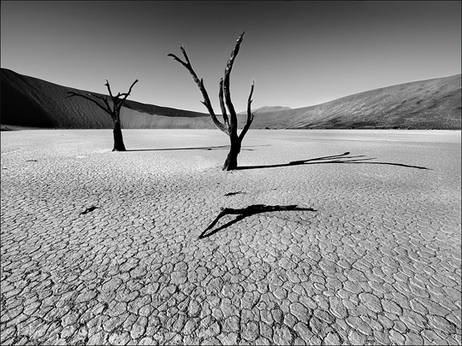
TEXT 3
Earth Song
Read the lyrics of the popular song by pop singer Michael Jackson.
Then, Watch the video or listen to the song.
Earth Song Michael Jackson
What about sunrise / What about rain
What about all the things / That you said we were to gain...
What about killing fields / Is there a time
What about all the things / That you said was yours and mine...
Did you ever stop to notice / All the blood we've shed before
Did you ever stop to notice / The crying Earth the weeping shores?
Aaaaaaaaah Oooooooooh / Aaaaaaaaah Oooooooooh
What have we done to the world / Look what we've done
What about all the peace / That you pledge your only son...
What about flowering fields / Is there a time
What about all the dreams / That you said was yours and mine...
Did you ever stop to notice / All the children dead from war
Did you ever stop to notice / The crying Earth the weeping shores
Aaaaaaaaah Oooooooooh / Aaaaaaaaah Oooooooooh
I used to dream / I used to glance beyond the stars
Now I don't know where we are / Although I know we've drifted far

Aaaaaaaaah Oooooooooh / Aaaaaaaaah Oooooooooh
Aaaaaaaaah Oooooooooh / Aaaaaaaaah Oooooooooh
Hey, what about yesterday (What about us)
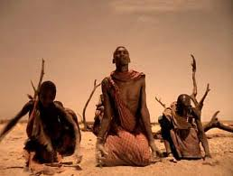
What about the seas (What about us)
The heavens are falling down(What about us)
I can't even breathe(What about us)
What about apathy(What about us)
I need you(What about us)
What about nature's worth(ooo, ooo)
It's our planet's womb(What about us)
What about animals(What about it)
We've turned kingdoms to dust(What about us)
What about elephants(What about us)
Have we lost their trust(What about us)
What about crying whales(What about us)
We're ravaging the seas(What about us)
What about forest trails (ooo, ooo)
Burnt despite our pleas(What about us)
What about the holy land (What about it)
Torn apart by creed (What about us)
What about the common man (What about us)
Can't we set him free (What about us)

What about children dying (What about us)
Can't you hear them cry (What about us)
Where did we go wrong (ooo, ooo)
Someone tell me why (What about us)
What about babies (What about it)
What about the days (What about us)
What about all their joy(What about us)
What about the man (What about us)
What about the crying man (What about us)
What about Abraham (What about us)
What about death again (ooo, ooo)\
Do we give a damn / Aaaaaaaaah Oooooooooh
D. 1 For Practice
a. What is the tone of the song? Joyous? Sad? Desperate?..................? Why do you say so?
What words or lines make you feel that way?
b. Prepare a write- up on the contents of the poem.
c. Summarize the main points of environment destruction that MJ sings of.
d. Add a paragraph on how it affects you.
D.2 Note making
Explosion of knowledge in today’s world manifests itself in many forms. As engineers, architects and technologists of future one has to deduct knowledge from varied sources like media, books and computers. Note taking and note making are essential tools that felicitate easy absorption of information from a lecture or text.
What is to be noted?
A general understanding of the text aids to form the focus of the reading. Read the text twice slowly and carefully. Understand the crux and proceed on to the next vital step of sifting out the wanted information from the unwanted.
Frame out a definite idea of the way the essence of the text to be understood and registered in the form of notes. Identifying the relevant and significant information from a wide range of information is the most integral and indelible part of note making
Steps involved in a note making
Note making involves identification and representation of major ideas and supporting in the following format:
- Major Idea
  - Supporting Idea
    - Supporting Idea

- Major Idea
2.1 Supporting Idea
2.1.1 Supporting Idea
- Major Idea
3.1 Supporting Idea
3.1.1 Supporting Idea
Steps involved in note making
Step I | Identify the important striking points from the given passage and list them separately.
Step II | Formulate MAJOR IDEAS from the spotted striking points.  If you have identified the sentence, “ There are various types of pollution” as one of the striking points then the major idea could be framed like this:  Types of Pollution
Step III | Identify the supporting ideas, the ideas that elaborate and support the major idea.  The sentence patterns of the supporting ideas should not be complete and be in the form of hints. For instance, you should not write the complete sentence, “air pollution is one of the types of the pollution” as a supporting idea. Instead you should write like this:  - Types of Pollution  - air pollution  Supporting ideas could further be supported by sub- supporting ideas like the following  1 Types of Pollution  1.1 air pollution  1.1.1 causes respiratory diseases
Step IV | Use abbreviations in writing the supporting ideas and it should be mentioned at the end of the note making with the proper explanation.  Abbreviations: Eng. - English Spl. - special
Step V | Check if all the relevant information are represented in the notes

D.2.1 For Practice
Make notes of the text given in a proper format
Energy lights our cities, powers our vehicles, and runs machinery in factories. It warms and cools our homes, cooks our food, plays our music, and gives us pictures on television.
Energy is defined as the ability or the capacity to do work. We use energy to do work and make all movements. When we eat, our bodies transform the food into energy to do work. When we run or walk or do some work, we ‘burn’ energy in our bodies. Cars, planes, trolleys, boats, and machinery also transform energy into work. Work means moving or lifting something, warming or lighting something. There are many sources of energy that help to run the various machines invented by man.

The discovery of fire by man led to the possibility of burning wood for cooking and heating thereby using energy. For several thousand years human energy demands were met only by renewable energy sources—sun, biomass (wood, leaves, twigs), hydel (water) and wind power.
As early as 4000–3500 BC, the first sailing ships and windmills were developed harnessing wind energy. With the use of hydropower through water mills or irrigation systems, things began to move faster. Fuelwood and dung cakes are even today a major source of energy in rural India. Solar energy is used for drying and heating.
With the advent of the Industrial Revolution, the use of energy in the form of fossil fuels began growing as more and more industries were set up. This occurred in stages, from the exploitation of coal deposits to the exploitation of oil and natural gas fields. It has been only half a century since nuclear power began being used as an energy source. In the past century, it became evident that the consumption of non-renewable sources of energy had caused more environmental damage than any other human activity. Electricity generated from fossil fuels such as coal and crude oil has led to high concentrations of harmful gases in the atmosphere. This has in turn led to problems such as ozone depletion and global warming. Vehicular pollution is also a grave problem.
There has been an enormous increase in the demand for energy since the middle of the last century as a result of industrial development and population growth. World population grew 3.2 times between 1850 and 1970, per capita use of industrial energy increased about twentyfold, and total world use of industrial and traditional energy
Due to the problems associated with the use of fossil fuels, alternative sources of energy have become important and relevant in today’s world. These sources, such as the sun and wind, can never be exhausted and are therefore called renewable. Also known as non-conventional sources of energy, they cause less emission and are available locally. Their use can significantly reduce chemical, radioactive, and thermal pollution. They are viable sources of clean and limitless energy. Most of the renewable sources of energy are fairly non-polluting and considered clean. However, biomass is a major polluter indoors.
Renewable energy sources include the sun, wind, water, agricultural residue, fuel wood, and animal dung. Fossil fuels are non-renewable sources. Energy generated from the sun is known as solar energy. Hydel is the energy derived from water. Biomass – firewood, animal dung, and biodegradable waste from cities and crop residues – is a source of energy when it is burnt. Geothermal energy is derived from hot dry rocks, magma, hot water springs, natural geysers, etc. Ocean thermal is energy derived from waves and also from tidal waves.
UNIT III
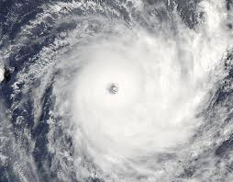
SPACE
A. Grammar and Vocabulary
A.1 Word Formation
AFFIXES
Affixes are often added to root words to form new words.
Addition of a prefix often results in the creation of an antonym however the addition or removal of a suffix creates a new word where the part of speech of the given word changes.
Thus, words in the English Language undergo transition take on different forms,. for example the word ‘electric’ is an adjective, however with the addition of the suffix ‘city’ or ‘-cation’ it becomes a noun and you get electricity or electrification.

A.1.1 For Practice
a. Find the nouns, adjectives, verbs and adverbs in the text provided and give the other forms.
One example is provided:
Nouns | Verbs | Adjectives | Adverbs
existence | exist | existential | existentially
TEXT 1
Life in a Space Station
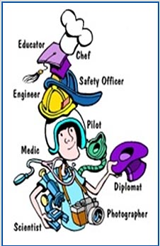

Roles of an Astronaut
Have you ever wondered how astronauts spend many years in outer space?
Yes! You are right! They live on space stations where they live and work. These space stations are usually as big as a three bedroom house and have a volume of 15000 cubic feet. Gravity, which is an intrinsic part of our existence is virtually non-existent.
The space station is absolutely essential for space exploration. It is the place where the astronauts learn how to deal with the physiological effects of spending a long time in space.
In addition to their work in the laboratory they follow certain daily routines.
Morning Routine in Space
Astronauts living and working in space have the same hygiene needs as people on earth. They wash their hair,brush their teeth, shave and go to the bathroom. However because of the microgravity environment ,astronauts take care of themselves in some different ways.
Astronauts wash their hair with a rinseless shampoo that was originaly developed for hospital patients who were unable to take a shower.
Many astronauts have a personal hygiene that is attached to the wall. The kit contains the personal hygiene items each astronaut has chosen to take. Personal preferences, such as the brand of toothpaste, are accommodated if possible. Dental hygiene is basically the same as on earth.
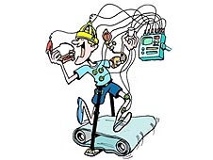
Exercise in Space
Exercise equipment is specially designed so that astronauts can use them in their daily routine. The absence of gravity rules out weight lifting because what may be too heavy on earth may turn out to be very light in space. On an average, astronauts exercise for about two hours per day.

Eating in Space
A balanced supply of vitamins and minerals are required by astronauts who take three meals a day –breakfast, lunch and dinner. While In space astronauts require lesser calories than they would need on earth. A woman would need 1900 calories
Illustration : Fred Myers only whereas a large man would need 3200 calories.
Fruits ,nuts, peanut butter, chicken ,beef, candy and brownies are made available as well as fruit juices and coffee and tea. Ketchup , mustard and mayonnaise too are provided. However salt and pepper are provided in liquid form because they might float away and attack the unsuspecting astronaut in his eyes, ears or nose. There is also the probability of contamination of equipment by clogging vents and so on.
The disposable packages used by the astronauts are probably part of the accumulating space debris which is turning out to be a major problem.
Sleeping in Space
There is nothing like sleep to rest your body and mind but imagine attaching or tying yourself down to something and then trying to sleep! Weird!! Not at all for the astronauts, as they sleep in their sleeping bags in small crew cabins ,so that they do not float around and bump into things! Wonder what they dream of then? Definitely not of the stars and the moon but probably of solid earth beneath their feet!
(http://www.nasa.gov)
A. 1.2 For Practice
a. Note down the suffixes you added in order to create the other parts of speech
To make nouns you added or deleted–………………………………………………………
To make adjectives you added or deleted - …………………………………………………..
To make verbs you added or deleted-…………………………………………………………
To make adverbs you added -……………………………………………………………….
A. 2. PREFIXES
A List of prefixes and examples of words with the prefixes:
Prefixes | Examples | Prefixes | Examples
a | Amoral | micro | Micrometer
ambi | Ambivalence | mis | Mismatch
anti | Anti-Christ | mono | Monologue
ante | Antedate | multi | Multifunctional
auto | Autograph | mal | Malnutrition
be | Befriend | neo | Neoclassical
bi | Bilingual | non | Non-Alliance
by | Bygone | over | Overcome
centi | Centigrade | post | Postmodernism
co | Coexist | pre | Predetermination
de | Demystify | pro | Proactive
demi | Demi-God | quasi | Quasimodo
dis | Disproportionate | re | Rehabilitation
en | Enlarge | sub | Substandard
extra | Extramarital | super | Supernatural
fore | Foreshadow | trans | Transcending
hyper | Hyperactive | un | Unauthorized
macro | Macroeconomics | vice | Vice-Chancellor

A.3. SUFFIXES
Suffixes | Examples | Suffixes | Examples
able | Accountable | ist | Environmentalist
acy | Intricacy | less | Flawless
al | Phenomenal | ful | Powerful
ance | Countenance | ly | Technically
ence | Ambivalence | ment | Armament
cracy | Aristocracy | ness | Harmfulness
cy | Poignancy | some | Troublesome
en | Proven | ship | Courtship
ency | Tendency | sion | Conclusion
dom | Martyrdom | tion | Intonation
ed | Collaborated | ward | Upward
d | Noted | worthy | Noteworthy
fy | Amplify | ish | Sluggish
hood | Manhood | ism | Escapism
ic | diplomatic | ive | Generative
A.1.2. For Practice
a. Add either prefix or suffix
- Place 6) hope
- Tense 7) coward
- Automatic 8) king
- Graduate 9) doubt
- Brown 10) new

b. Forming adjectives from nouns
- Authority 6) Japan
- Gold 7) Practice
- Peru 8) Frequency
- Type 9) System
- Disaster 10) Attitude
- Convert the following words into verbs using suffixes:
Fluctuation vital simple eulogy
Legal maximum beauty revision
Legislation national ample improve
Meditation energy justice neutral defence equal sedation polar

More prefixes and their meanings
Prefix | Meaning | Example
Contra | Against/opposite | Contradiction
Counter | Contrary/opposite | Counteract
Dia | Passing through/across/between | Dialogue/diameter
Fore | Before | Foretell/forecast
Pan | Pertaining to all | Pan American/Pan Indian
Un | Not/to reverse an action | Untidy, unfold
Pre | Before | Prepaid, premature
Post | After | Postdate, postmortem
Inter | Between | International
Sub | Below | submarine
B. Listening and Speaking
Differences between Native and American English
TEXT 2
Carl Sagan: Pale Blue Dot: A Vision of the Human Future in Space
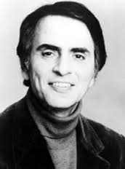
Carl Sagan is the reason behind the revival of interest in science .His television series titled Comos reached millions of people presenting them with a fascinating view of outer space, galaxies. At his request a photograph of the earth as seen closest to the sun was clicked from Voyager 1 on February 14, 1990. As the spacecraft left our planetary neighborhood for the fringes of the solar system, engineers turned it around for one last look at its home planet. Voyager 1 was about 6.4 billion kilometers (4 billion miles) away, and approximately 32 degrees above the ecliptic plane, when it captured this portrait of our world. Caught in the center of scattered light rays (a result of taking the picture so close to the Sun), Earth appears as a tiny point of light, a crescent only 0.12 pixel in size. It is seen as a pale blue dot and this was the title given to a work by Sagan
B.1. Watch the talk on You-tube. Watch twice.
The first time –just listen
The next time follow it using the text provided below:
- Attempt an analysis on the differences between the native tongue (Indian English) and the American.
- Prepare a table as given. Pick out problem areas and classify under the different headings
Lexis (Words) | Pronunciation | Syntax (Sentence construction) | Delivery (Accent,  Intonation etc.)
This excerpt from A Pale Blue Dot was inspired by an image taken, at Sagan's suggestion.

Look again at that dot. That's here. That's home. That's us. On it everyone you love, everyone you know, everyone you ever heard of, every human being who ever was, lived out their lives. The aggregate of our joy and suffering, thousands of confident religions, ideologies, and economic doctrines, every hunter and forager, every hero and coward, every creator and destroyer of civilization, every king and peasant, every young couple in love, every mother and father, hopeful child, inventor and explorer, every teacher of morals, every corrupt politician, every "superstar," every "supreme leader," every saint and sinner in the history of our species lived there--on a mote of dust suspended in a sunbeam.

The Earth is a very small stage in a vast cosmic arena. Think of the rivers of blood spilled by all those generals and emperors so that, in glory and triumph, they could become the momentary masters of a fraction of a dot. Think of the endless cruelties visited by the inhabitants of one corner of this pixel on the scarcely distinguishable inhabitants of some other corner, how frequent their misunderstandings, how eager they are to kill one another, how fervent their hatreds

Our posturings, our imagined self-importance, the delusion that we have some privileged position in the Universe, are challenged by this point of pale light. Our planet is a lonely speck in the great enveloping cosmic dark. In our obscurity, in all this vastness, there is no hint that help will come from elsewhere to save us from ourselves.

The Earth is the only world known so far to harbor life. There is nowhere else, at least in the near future, to which our species could migrate. Visit, yes. Settle, not yet. Like it or not, for the moment the Earth is where we make our stand.

It has been said that astronomy is a humbling and character-building experience. There is perhaps no better demonstration of the folly of human conceits than this distant image of our tiny world. To me, it underscores our responsibility to deal more kindly with one another, and to preserve and cherish the pale blue dot, the only home we've ever known.
http://www.goodreads.com

Graphic novels are the rage today when illustrations or comic strips carry the story. Young people find it easier to read when compared to a lengthy prose text. Manga, the Japanese form is very popular too. In order to see the excerpt in comic form take a look at:
http://zenpencils.com/comic/100-carl-sagan-pale-blue-dot

B. 2. The differences between British & American English – A tutorial
England and America are two countries separated by a common language.
George Bernard Shaw Irish dramatist & socialist (1856 - 1950)
  - Look at the two paragraphs and underline the words that make differences between the two varieties of English
We stock an amazing selection of styles and colours, all at a price that you will find hard to beat. We’re sure to have your favourite. On our ground floor you’ll find a wide range of favourite for your home. On our first floor we have our special deals on office furniture. Visit Brown’s furniture shop near the Hindustan Petrol Station, in the city centre. Send us your name address and postcode for our new catalogue, free.
We stock an amazing selection of styles and colors, all at a price that you will find hard to beat. We’re sure to have your favorite. On our first floor you’ll find a wide range of favorite for your home. On our second floor we have our special deals on office furniture. Visit Excel’s furniture shop near the Hindustan gas station, in the downtown. Send us your name address and zip code for our new catalog, free.
b. Note the main differences in spelling:
British English American English
--our --or
Colour Color
Honour Honor
Vigour Vigor

--re --er
Theatre Theater
Metre Meter
Centre Center

--ll --l
Wollen Wolen
Councillor Councilor
Chilli Chili

–l --ll
Skilful Skilfull
Fulfill Fulfill
Instill Instill

–c --s
Licence License
Offence Offense
Defence Defense

–gue --g
Analogue Analog
Catalogue Catalog

–mm --m
Programme Program

– s --z
Analyse Analyze
Paralyse Paralyze

- Sometimes there is a total variation in the word itself. Examples of such words are:
BRITISH ENGLISH AMERICAN ENGLISH
Autumn Fall
Amber Yellow
Biscuit Cookie
CV Resume
Cooker Stove
Dustbin Garbage can
Engine driver Engineer
Flat Apartment
Essay Paper
Full stop Period
Hand bag Purse
Ground floor First floor
From Monday to Friday Monday through Friday
Lorry Truck
Notice board Bulletin board
Number plate License plate
Time-table Schedule
Term Semester
Torch Flash light
Value Appraise
Wagon Freight car
Waist coat Vest
Flask Thermos
Frost Ice
Grill Broil
Cutting Clipping
About - turn About - face
Anti-clock wise Counter-clock wise
Aerial Antenna
Fire engine Fire truck
Apart from the lexical differences, there are also grammatical and phonological differences between the British and American English. We will have a look at some of them below
Differences in grammar
Verb agreement with collective nouns
In British English collective nouns, (i.e. nouns referring to particular groups of people or things), (e.g. staff , government, class, team) can be followed by a singular or plural verb depending on whether the group is thought of as one unit, or as many individuals.
For example:
My team is winning.
The other team are all sitting down.
In American English collective nouns are always followed by a singular verb, so an
American would usually say:
Which team is losing?
Use of verbs such as ‘have’ and ‘take’
British English
I’d like to have a bath.
She’s having a little nap.
I’ll just have a quick shower before we go out.
American English, the verb takes, rather than have, is used in these contexts. For example:
Joe’s taking a shower.
I’d like to take a bath.
Let’s take a short vacation.
Why don’t you take a rest now?
American and British English may also use a base verb in different manners.
For example: For the verb ‘to dream’, Americans would use the past tense dreamed while the British would use dreamt in past tense.
The same applies to ‘learned’ and ‘learnt’.
Another example of differing past tense spellings for verbs in American and British English is ‘forecast’. Americans use forecast while the British would say ‘forecasted’ in simple past tense.
Use of auxiliaries and modals
In British English, the auxiliary do is often used as a substitute for a verb when replying to a question.
For example:
AE: Are you coming with us?
BE: I might do.
In American English, ‘do’ is not used in place of verbs. For example:
AE: Are you coming with us?
BE: I might.
In British English ‘needn’t’ is often used instead of ‘don’t need to’. For example:
They needn’t come to school today.
They don’t need to come to school today.
In British English, ‘shall’ is sometimes used as an alternative to ‘will’ to talk about the Future.
For example:
I shall / will be there later.
In American English, ‘shall’ is unusual and ‘will’ is normally used.
In British English shall I / we is often used to ask for advice or an opinion.
For example:
Shall we ask him to come with us?

Use of prepositions
There are also a few differences in the use of prepositions.
on the weekend (AE)
at the weekend (BE)
on a team (AE)
in a team (BE)
Please write me soon (AE)
Please write to me soon (BE)
Note that ‘have got’ is possible in American English, but is used with the meaning ‘have’,
‘gotten’ is the usual past participle of ‘get’.
For example:
You’ve gotten taller this year (AE)
you’ve got taller this year (BE)
B.2.1 For Practice
a. Fill in using the British Equivalent
American English | British English
a druggist
an eraser
a flight attendant
French fries
Glue
Department
Notebook
Oven
telephone booth
toll free (phone)
C.Writing
C.1 DEFINITIONS
Science writing and Technical writing are areas offering many job opportunities for people with a good command over the English language and a basic knowledge of science. It is essential that professionals working in such fields understand the importance of defining things. Students have been learning definitions in order to pass exams …but how does one write them?
For example, The term Big Bang Theory is well-known today, thanks to the popular TV serial but do we know what the Big Bang Theory actually is ?
It is not enough to say that it is a scientific term and has to do with the origin of life.
Being professionals we have to be more specific and say that:
Big Bang theory is the theory that the universe was once clustered and at the 'beginning' it exploded out, as shown by the fact that objects are still moving out from the center.
During interviews too, the interviewer often starts with very simple questions related to the field such as What is …?. Students should be very careful in their reading and should understand the minute details of any concept they come across in simple terms so that it can be retained in memory for future use. Though it may seem very simple but only by constant practice can one define any term in an easier way.
C.1.1.Single Sentence Definition:
Step I |  | Step II |  | Step III
thing to be defined | = | what is it /group to which the thing belongs/ | + | specific details that separate it from other things in its group
Technology | is | the application(the study and use ) of scientific knowledge | to | practical purpose.
Laboratory | is | a place | to | conduct experiments
Transformer | is | an electrical equipment | to | change ( to step up or step down)the voltage of current.
Calculator | is | an electronic device | for | making arithmetical operations
Mortar | is | the mixture | of | cement, sand, bluemetel and water inthe right proportion used for construction.

Following are a few examples for single sentence definition:

Dynamo: Dynamo is an instrument for generating electricity by transforming mechanical energy into electrical energy.

Icon: Icon is a small symbol on a computer screen representing a programme that a user may choose.

Airbag: Airbag is a safety device which will cause an air filled pillow to prevent one from hitting the dashboard.

Scanner: Scanner is a device which analyses an image and then captures and processes it so that it can be saved to a file on a computer.

Road roller: Road roller is a machine with heavy wide smooth rollers used in road making to make the surface smooth.

Shock absorber: Shock absorber is an oil filled device used to control the movement of the springs in the suspension system.
Turbine: Turbine is an engine or motor in which the pressure of liquid or a gas turns a wheel, usually to produce energy.

Radar: Radar is a system for finding out the position and movement of solid bjects, especially aircraft and ships, when they can not be seen, by sending out short radio waves which the objects reflect.
C.1.1 For Practice
Define the following terms in a sentence each.
Engineering,

science,

ballast,

rheostat,

cloning,

word processor,

seismograph,

gobar gas

plant,

compiler,

machine code.

Chamfer

kerf
C.2 Extended Definition:
Sometimes definitions might be much longer than one sentence, in which case one is still trying to answer "what is it?" but will be using most other patterns to help answer it: and can be defined by describing, classifying, comparing, etc.
Laser Technology: is a kind of modern technology using sophisticated equipments, involving high cost, designed and operated by highly skilled professionals used in various areas particularly in the medical field to diagnose, operate and provide laser treatment to complicated and serious diseases.
Appropriate Technology: is a kind of technology that is used within the resources available. It is otherwise called as low cost technology. For example, Gobar gas is produced using the local resource cow dung that is easily available. In practice, this technology uses the simplest form of technology to achieve the intended purpose in a suitable location.
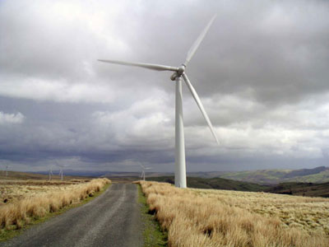
Wind mill, an appropriate Technology.

Nanotechnology: is the study of the control of matter on an atomic and molecular scale. Generally nanotechnology deals with structures of the size 100 nanometers or smaller, and involves developing materials or devices within that size. Nanotechnology is very diverse, ranging from novel extensions of conventional device physics, to completely new approaches based upon molecular self-assembly, to developing new materials with dimensions on the nanoscale, even to speculation on whether we can directly control matter on the atomic scale.
Nanotechnology has the potential to create many new materials and devices with wide-ranging applications, such as in medicine, electronics, and energy production.
Here is a lay out of an extended definition for your understanding.
Extended Definition
identify distinguishing characteristics(low cost, easily available local resources)
give examples(gobar gas)

pr(applied in rural and urban areas) provide extra facts/information
say what cannot be included in this definition
definition

C.2.1 FOR PRACTICE
a. Identify the pictures and define the objects in a sentence each.



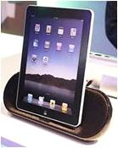

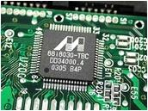

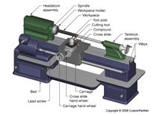



b. Attempt to write extended definitions for the following ; if required, refer to the dictionary or the internet.
Artificial Intelligence
Virtual Reality
Junk food
Bio-technology
Wi fi,
Satellite communication,
Bluetooth
Cloning
Aeronautical Engineering
Information technology
e-learning
Podcast
Dragnet
Matrix
cloud computing
antibiotic
c. Read the following poem, jot down the technical words found there and write single sentence definitions of the same.
Remember When
A computer was something on TV
From a sci fi show of note.

A window was something you hated to clean
And ram was the cousin of goat.
Meg was the name of my girlfriend.
And gig was a job for the nights.
Now they all mean different things
And that really mega bytes.
An application was for employment.
A program was a TV show.
A curser used profanity.
A keyboard was a piano.
Memory was something that you lost with age.
A CD was a bank account.
And if you had a 3 1/2” floppy
You hoped nobody found out.
Compress was something you did to the garbage
Not something you did to a file.
And if you unzipped anything in public
You’d be in jail for a while.
Log on was adding wood to the fire.
Hard drive was a long trip on the road.
A mouse pad was where a mouse lived.
And a backup happened to your commode.
Cut you did with a pocket knife.
Paste you did with glue.
A web was a spider’s home.
And a virus was the flu.
I guess I’ll stick to my pad and paper
And the memory in my head.
I hear nobody’s been killed in a computer crash,
But when it happens they wish they were dead.
d. Look at the picture given below and write an extended definition of the same.
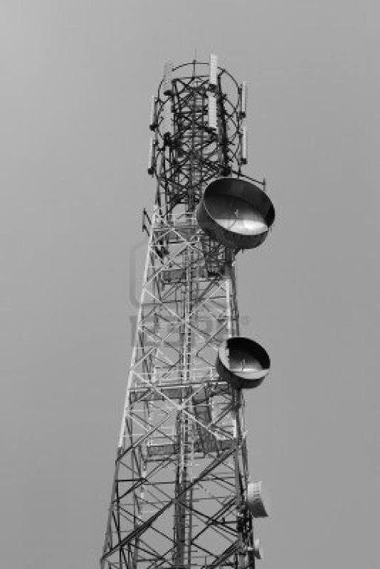

- Read the description and write the name of the product / item in the blank provided.
Battery, biotechnology, patent, aerodynamics
- __________ is a device that converts chemical energy into electrical energy

- __________ is a field of applied biology that involves the use of living organisms and bioprocesses in engineering, technology, medicine, and other fields requiring bioproducts.

- A __________ is an exclusive right granted for an invention, which is a product or a process that provides, in general, a new way of doing something, or offers a new technical solution to a problem.

- __________ is a branch of dynamics concerned with studying the motion of air particularly when it interacts with a solid object.

C.3 Essay Writing
How to start writing an essay
An essay is normally written to discuss, describe or analyse any topic of interest or requirement. It may discuss the topic directly or indirectly, seriously or humorously depending upon nature of the essay. Sometimes it presents personal opinion, or some times just reports information. Essays are written for different purposes and for different occasions.
An essay should contain the following sections:
Introductory paragraph
The introductory paragraph should include the thesis statement, a kind of mini-outline of the essay. This is where the writer grabs the reader’s attention. It tells the reader what the essay is about. The last sentence of this paragraph must also include a transitional “hook” which moves the reader to the first paragraph of the body of the essay.
Body of the essay
The next paragraph of the essay includes the strongest argument, most significant example, cleverest illustration, or an obvious beginning point. This subject should relate to the thesis statement in the introductory paragraph. The last sentence in this paragraph again has a transitional hook leading to the second paragraph of the body.
The next paragraph of the body should include the counter arguments, and supporting examples and illustrations, or an obvious follow up to the previous paragraph in the body.
Concluding paragraph
The final paragraph is the summary paragraph. It is important to restate the thesis and the supporting ideas in an original and powerful way, as this is the last chance the writer has to convince the reader of the validity of the information presented.
In general, an essay should be planned as follows:
- Introducing the topic
Presenting the main ideas (thesis statement)
- Defining the purpose
Establishing the central ideas with the supporting points
- Organising the ideas
Elaborating each supporting point by describing, analysing and providing
Explanation
- Writing the paragraphs in the body of the text
The introductory and the concluding paragraphs should be of great interest; hence utmost care should be taken while writing these two paragraphs. The concluding paragraph: This rounds off the topic and provides a final perspective on the topic.
After finishing the work, check the essay on all aspects such as margins, title, spelling, the logical sequence and the smooth flow of paragraphs from one point to another.
Samples of Good Essays

There has been a lot of controversy regarding the expenditure on space exploration.

Two essays one arguing for the need to spend more and the other decrying the “unnecessary” outflow towards space research are provided below:
TEXT 3
Space Exploration
Since human beings first appearance on Earth, curiosity has always acted as a force of human nature which is the predominant factor that today’s knowledge of science and technology has its grounds on. Accordingly, space exploration is one of this curiosity’s outcomes that some people claim that more money should be allocated in this field of science in order to understand more about space, the universe and its system, trigger new inventions in science and find alternative planet to live on.
The first reason for space exploration concerns understanding more about space, the universe and its system. Due to the fact that the widespread belief amongst people about alien’s existence has stirred a lot of controversy, research in science is accelerated in order to find certain answers to intriguing questions about aliens.
The second reason for space exploration concerns the possibility of triggering new inventions in science. Because of the fact that there are still thousands of unanswered questions among scientists, learning more about space and the universe has caught immense attention. Since human beings are lacking in knowledge of space presently, there are still thousands of facts to be discovered which subsequently will trigger new inventions in science.
The third reason for space exploration concerns the search for an alternative planet to live on. Since the Earth’s population is constantly growing and the climatic changes on this planet are causing unbearable sufferings among people, the search for a new planet which should be similar to Earth in terms of temperature, gravitation and air concentration, etc. has become one of the most desired feature in most people’s lives.
In conclusion, the idea of allocating more money on space exploration and its research is highly supported by its proponents based on its possible outcomes like understanding space and the universe, new inventions in science and finding an alternative planet to live on. Hence, many governments expect to gain interest and cooperation among others in order to carry out this research for a better future.
(http://www.usingenglish.com/forum/editing-writing-topics/73917-space-exploration.html)
On the other hand…..

TEXT 4

(Sample IELTS essay) Space Exploration
Q: Space exploration requires vast sums of money. Is the amount of money spent on space research justifiable? Could the money be better spent?
There has always been considerable discussion about whether governments should spend tax payers’ money on space research. In my view it is impossible to justify the amount of money spent on such projects. Generally speaking, the main reason for this position is that there are several areas in which the money could be invested better.
The first point to make is that politicians have a responsibility to spend public money on projects that bring a benefit to the general public. This has not been the case with space research as most developments have been limited to helping astronauts in space or have been very specialised. For example, it is not of great value to the general public that we now have pens and biros that can write upside down. This does not merit the huge amount of money spent.
The second point to make is that there are many much more urgent projects on Earth that require investment. If governments spent less money on space research, then they would be able to help solve some of these problems such as population control, elimination of diseases like cholera, global warming and food shortages. It seems to me that all of these issues are more important because they affect the lives of millions of ordinary people. An illustration of this is that the US government could provide food for all the starving people in the world if they did not spend so much on NASA.
My conclusion is that politicians should not fund space research. The grounds for saying this are that it is very costly and provides few real benefits. Furthermore, there are several more urgent issues that need to be funded.
http://www.dcielts.com/ielts-essays/sample-essay-space-exploration/#ixzz2YWgQUtW5
C. 3.1 For Practice
Write essays on the following topics.
- Research and write an essay - SRM Space Research
- Merits and demerits of going abroad for higher education.
- Space Debris: A Major Threat to the World
D. Reading Comprehension
D.1. Predicting the Content
Pre-reading
TEXT 4
Pre reading Activities
Brainstorm: what do you understand from the word ‘Space’. What are the different kinds of ‘Spaces’ you have heard of?
Find and label: Pictures of two astronauts and their space shuttles.
Begin reading…
1971: Man plays Golf on the Moon is the title of the text that follows.
What do you think the text is about?
Do you think it is a story? If so, try telling it to the class.
While reading
The first manned mission to the Moon since the near-disastrous Apollo 13 is on its way home after two successful moon walks.
Answers the questions
What is the name of this spacecraft and were there people on it?
The term ‘moonwalk’ is related not only to space studies but also to…………………? Why?
Continue reading……
There was just one moment of serious concern: as Apollo 14 left its orbit around the Earth for the Moon, a docking probe failed to work, putting the mission's ability to return in jeopardy.

Were you right in your predictions so far?
What do you think happens next?
New Vocabulary
Docking Probe
Jeopardy
Continue reading…
In the event, a manual docking went perfectly.
There were also light-hearted moments. At the end of today's moonwalk, Alan Shepard became the first man to hit a golfball on the Moon, using a ball and golf club head he had smuggled on board inside his space suit.
He hit two balls just before lift-off, and drove them, as he put it, "miles and miles and miles".
For more information on the Apollo 14 mission continue reading…
Overall, the mission was pronounced a major success.
The lunar module, known as Antares, landed within 87 feet (26 metres) of its target point just north of the rim of the Fra Mauro crater - the site originally planned for the aborted Apollo 13 mission.
It was chosen for its exposed rock formations, part of a geological feature covering much of the near side of the Moon.
Shepard and his colleague, Edgar Mitchell, were able to go further from the lunar module than before with their "modularised equipment transporter" - a cart which allowed them to carry equipment and store lunar samples.
The cart also meant they could bring back more moon rock than ever before - about 100 lbs (45 kg) compared to the 75lbs (34 kg) brought back by Apollo 12.
They included samples of very old, crystalline "continental" rocks, almost white, which may be up to 4,500 million years old.
In all the pair spent more than nine hours exploring the Moon - longer than in any other mission.
One of their main scientific aims - a climb to the rim of the 400-foot (120 meters) high Cone Crater - had to be called off after Shepard registered a heartbeat of 150.
Mitchell also found the climb difficult, saying it was "a darn hard climb to try rapidly. The soil is a bit thin and mushy and these suits are bulky".
The next mission, Apollo 15, is scheduled for launch in July. Nasa plans to send a lunar rover car with the astronauts to send them even further away from base in exploring the Moon.
BBC on this Day, 6 February ,1971
D.1.1 For Practice
Assignment
Do research on the following missions to the moon and prepare an assignment accompanied by pictures.
Predict what follows the given text
TEXT 5
Read the passage below and predict what follows:
On 24 October 1944, Planet Earth was following its orbit about the sun as it has obediently done for nearly five billion years. It moved at the stunning speed of sixty six thousand miles an hour ,and in doing so, created the seasons. In the Northern hemisphere it was a burnished autumn; in the southern, a burgeoning spring.
What do you think this text is all about? Discuss and present your view.
At the same time, the Earth revolved on its axis at a speed of more than a thousand miles an hour at the equator, turning from west to east, and this produced day and night.
As a new day broke over the Philippine islands, two navy men, one Japanese, one American, were about to perform acts of such valor that they would be remembered whenever the historic battles of the sea were compared and evaluated.
Later, when then the ceaseless turning of the Earth brought high noon to the island town of Peenemunde on Germany’s Baltic coast, a small quiet mechanical genius working for Adolf Hitler would find himself in the middle of an ordinary day which would have a most extraordinary conclusion.
A few hours following, when mid afternoon reached London, a youthful American engineer, not in uniform, would see for himself the power of Hitler’s vengeance weapon, the A4, and would take steps to destroy it but not its makers, because even then the American government could foresee that when the war ended, they would need these German scientists.
And toward the close of that long day, when the earth had revolved the western region of America into the hours of sunset, in a small city in the city of Fremont a boy of seventeen would realize as they were happening that they were special in a way that might never be exceeded.
James. A. Michener “Space”
Predict what follows
What do you think follows? Discuss.
D.1.1 Start with a discussion on
- The main characters
- The situations they are in
D.1.2 Speculate on the possible progression and conclusion.
After the brainstorming session with your team mates, arrive at the best possibilities and present the team’s view to the class.
D.1.3. Prepare a written assignment in an essay form comparing your predictions with Michener’s plot
UNIT IV
CAREERS

Pre reading Activities
Brainstorm: What is the difference between a job, profession and career? Can you give three examples to show the difference?
Draw: A table showing five not popularly opted for careers, their specific names, the specific primary knowledge / skills required, and the challenges involved in them.
Find and label: Pictures of two Indian and Foreign persons who switched careers and achieved success in their fields.



TEXT 1

Career vs Job
 | Career | Job
What is it? | A career is the pursuit of a lifelong ambition or the general course of progression towards lifelong goals. | Job is an activity through which an individual can earn money. It is a regular activity in exchange of payment.
Requirements: | Usually requires special learning that includes individualized components that develop abilities beyond that which training is capable of. | Education or Special training may or may not be required
Risk taking: | A career may not mean stability of work as it encourages one to take risks. The risks are often internal and therefore planned. | A job is “safe”, as stability of work and income is there. However shifting priorities, especially in resource jobs, can abruptly change the demand and require relocation which is an unstable factor. Risks may be completely external.
Time: | Long term | Short term
Income: | Varies depending on value to society or to some other entity. Non-monetary benefits may be higher. Salary is more common. | Varies by demand. More likely to be wage.
Contribution to society: | May have high value as social change/progress may be possible. | May actually have a negative impact when counterproductive social practices are continued in the name of protecting jobs.
http://www.diffen.com/difference/Career_vs_Job
“Job” is defined as
- a piece of work, esp. a specific task done as part of the routine of one's occupation or for an agreed price.
- a post of employment; full-time or part-time position.
- anything a person is expected or obliged to do; duty; responsibility. It usually is considered to pertain to remunerative work (and sometimes also formal education).
A job is defined as anything a person is expected or obliged to do; a piece of work, especially a specific activity done as part of the routine of one's occupation or for an agreed price. Through a job a person can earn to support her basic needs and family or friends. A job can also be viewed as a contract between the employer and the employee. In commercial enterprises, the basic purpose of a job is to create profits for the employer, and the employee contributes labor to the enterprise, in return for payment of wages, or stock options etc.
"Career" is defined as
- an occupation or profession, esp. one requiring special training, followed as one's lifework.
- a person's progress or general course of action through life or through a phase of life, as in some profession or undertaking

Example of career vs. job
In Ayn Rand’s Fountainhead, the main protagonist, Howard Roark seeks a career and his best friend Peter Keating was only looking for a job. That’s why in the end Roark built some of the finest buildings using his skills, experience and imagination. On the other hand, his friend Peter Keating worked only on old architecture. He worked on it only to support his basic needs.

History of professional employment
In the earlier era, before modernism, many workers took up a single lifelong position (a place or role) in the workforce, and the concept of an evolving career had little or no meaning. But with the increasing use of technology and the Internet, this mindset has changed. By the late 20th century, choices of different streams of education allowed planning a career from a very early stage in life.

Time horizon of a job vs. career
“Career” by definition refers to a string of work performed over the long term , whereas a job is for short term. One may take up a job to fulfill his daily needs but it may not be the course of action he wants for his life. So a job is short term.

Multiple Careers and Jobs
Today, having multiple careers is the growing trend. These multiple careers can either be concurrent (where a worker has two simultaneous career options) or sequential (where a worker adopts a new career after having worked for some time in another career). Workers can adopt concurrent multiple careers for a host of reasons including: economic (such as poverty or striving for additional wealth), educational (such as multiple degrees in multiple fields), or personal (such as interest or lack of fulfillment in one career).
Multiple jobs are also an option for many individuals, but for many organizations, this is an illegal practice, for their full time employees. So many individuals today work for one organization for a few years and then again change to another job, which may or may not be in the same industry. This may be due to lack of job satisfaction, increasing salary and for better position.
A. Grammar & Vocabulary

Homophones
Homonyms

Homographs

A.1 Homonyms
Homonyms are two or more words that have the same spelling and pronunciation but have different meanings. The word has its origin in 17th century Greek ‘homonumon’. ‘Homos’ means the ‘same’, and ‘onuma’ means ‘name’.
Examples:
Job (employment / a piece of wood used in carpentry work)
general (overall / a position in military)
shift (change / restless)
term (semester / word)
A.2 Homophones
Homophones are words that have the same pronunciation but different meanings with a different spelling.
Examples:
Earn (to get something with your effort) and urn (the decorated vase where ashes after cremation is kept) through (in at one end and out at the other) and threw (fling)
piece (a little bit of) and peace (non warring condition)
needs (wants) and kneads (make dough or clay into uniform mixture by mixing, stretching and folding)
A.3 Homographs
Homographs are words that have the same spelling but a different pronunciation and meaning.
Examples
Contract – With the stress on the first syllable it means ‘agreement’.
With the stress on the second syllable it means ‘to shorten’ or ‘to draw the parts together’.
Content – With the stress on the first syllable it means ‘significance’.
With the stress on the second syllable it means ‘to be satisfied with what one has’.
For Practice
A. 1. 1 Choose six words from the passage above give their homophones and use them in your own sentences.
A. 2. 1 Choose six words from the passage above give their homonyms and use them in your own sentences.
A. 2. 2 Choose the correct word.
- The needs / kneads of customer are of prime importance in a consumerist society.
- A job applicant has to prepare himself for each face / phase of the recruitment process.
- Short / shot term projects help you in gaining experience.
- Problems in your career should not tie you in nots / knots.
- Some / Sum jobs require specialised skills.
- You should take due / dew care to check whether you have enclosed all the necessary documents before sending in a n application.
A. 3.1 Write six sets of homographs and use them in your own sentences.
A. 4 More practice exercises
a. Choose i or ii to suit the given context.
- The contents of this letter are not to be disclosed to anyone.
- She contents herself with memories of her past achievements.
- be satisfied with
- What is enclosed
- The employees demand a hike in their pay.
- The demand and supply chain is not stable these days.
- the quantity of goods that the buyer will take at a particular price
- claim as a right
- America’s adoption of new immigrant policy has made it more difficult for American companies to recruit foreigners for specialized jobs.
- Adoption of children has to be allowed after a thorough counseling to the concerned couple.
- Accept after putting to vote
- To bring up others’ children as one’s own by legal act

- He will resume duty this Wednesday after a long leave.
- Writing a good resume takes time and patience.
i. A brief written account of personal, academic and professional qualifications with experience details prepared by a job applicant
ii. To come back and take up the responsibilities and duties again
- My mother was a woman of great resource
- The resources of our nation are getting depleted rapidly.
- The collective wealth of a country
- Source of support
b. Fill in the blanks with the correct homonyms.
- _____ analysis is relatively a new line career in finance.
- You should be prepared to _____ your life if you decide to trek alone through a forest.
- The vegetable _____ can be used in many culinary preparations.
- The company’s _____-taking is not yet over.
- There are various ______ of disciplines in this University.
- The sight of the various ______ running through the valley was enchanting.
- The _____ of your agreement are unacceptable.
- She is not on good _____ with her in-laws.
- The _____ was not advertised for.
- Don’t forget to _____your reply.
- An unknown fear _____ through me.
- The _____ offered are many.
c. Find a word (homonym / homophone / homograph) that connect these two things or beings or actions and mention which ones are homonyms, which ones homophones and which ones homographs.
Eating and proposal
boss and tree
thermometer and graduation
many problems and entertaining guests
politely asking for permission and a month in summer
bell and agreement
a speeding vehicle and profession taken up for a considerable period of time
time measured in this unit and official record of the proceedings of a meeting
formal introduction of someone and what is happening now

B. Listening and Speaking
B. 1 Group Discussion
Group discussions are useful while we as a group attempt to discuss problems and arrive at solutions or come to a consensus regarding a controversy in our daily or official life. They may even be attempts at clarifying certain issues. In the employment scenario, group discussions are used as a means to evaluate and recruit candidates. Purposeful group discussions help us to
- Widen and deepen our knowledge base
- Sharpen our analytical ability
- Hone our Communication skills, especially Listening and speaking
- Improve our team playing or interpersonal skills – Willingness to share, confidence, presence of mind, integrity and time management, crisis management, taking hold of the situation and politeness
How are Group discussions held?
The participants are divided into groups of seven or eight. A specific topic is given to them for a discussion of 15 to 20 minutes. A few minutes , three to five minutes is allotted for their preparation during which they can jot down brief notes or points for discussion. In most of the job selection process, no leader or moderator for the group is nominated. The person in-charge or recruiter goes around while the group discussion is going on, and observes who emerges as the one whose ideas the majority of the group members naturally agree with. If a controversial topic is given, the person conducting the group discussion can judge the participants’ strength of ideas and how far they were able to arrive at an agreement on the topic.
Dos and Don’ts for the participants
- Learn to listen attentively. Note down the views of others carefully as this will let you prepare complementary points or counter arguments.
- Put forth your views politely. Even if you disagree, do so courteously.
- Get thorough with the fundamentals of your subject and familiarize yourself with the current happenings.
- Be assertive without sounding arrogant.
- Interrupt others only when appropriate and only when you have something meaningful to contribute.
- Don’t digress from the given topic and bring in irrelevant content.
- Don’t mumble to yourself. Be loud enough to be clearly heard by others.
- Have proper body language. Don’t lose yourself in the heat of the argument and lose objectivity. Remember it is not a debate but a discussion.
- Don’t drag personal affairs or call anyone by personal / nicknames if some of the participants are already known to you.
- Quote sufficient examples and statistics to establish your view.
- Be conscious of the stipulated time and remind the others to round off the discussion at the proper time.
TEXT 2
Sample - “Multinational Companies – Boon or Bane?”
JUDGE: Good morning. You can choose any topic you like or take a slip from that box. You are given one minute to think to start with the discussion. The observers will not interfere in your discussion. If no conclusion is reached, we may ask each of you to speak for a minute on the topic at the end of the discussion. The topic on the slip is "Multinationals: Bane or Boon". I suggest you should start the discussion.
Mr A : This is a good topic. I am against multinationals. We have Coke and Pepsi. Do we need them? We can manufacture our own soft drinks. Multinationals destroy the local industry and sell non-essential products.
Mr B: I agree with you. What is the fun of having Coke and Pepsi? We have our own Campa Cola.
Mr C: I think water is good enough.
Mr D : We are not here to discuss soft drinks. The topic given to us is a much larger one. First, let us define multinational companies. They are merely large companies which operate in a number of countries. There could be some Indian multinationals also. So there is nothing wrong with them. The point is whether they have a good or bad impact on the host countries. We have to discuss their business practices and find out whether they are desirable or not.
Mr E: That is a very good introduction to the topic. Multinational companies do serve an important function that they bring new products and technologies in countries which do not have them. And it is not just Coke and Pepsi. They set up power plants and build roads and bridges, which really help in the development of host countries.
Mr F: But are they all that good? We have seen that they destroy local industry. In India they just took over existing companies. They came in areas of low technology. Moreover, we have to see why they come at all. They come for earning profits and often remit more money abroad than they bring in.
Mr A: I agree with you. I am against multinationals. We can produce everything ourselves. We should be swadeshi in our approach. Why do we need multinational companies?
Mr E: We may not need multinational companies but then it also means that our companies should not do business abroad. Can we live in an isolated world? The fact is that we are moving towards becoming a global village. The world is interconnected. Then we have also seen that foreign companies bring in business practices that we are impressed with. Look at foreign banks. They are so efficient and friendly that the nationalized banks look pathetic in comparison. I think we can learn a lot from multinationals if we keep our eyes and mind open.
Mr B: Take a look at McDonald's. They are providing quality meals at affordable prices. One does not have to wait at their restaurants.
Mr C: How do you account for the fact that they take out more than they put in and thus lead to impoverishing the country?
Mr D: The fact is that every poor country needs foreign investment. Poor countries often lack resources of their own. That is why they have to invite foreign companies in. There is nothing wrong in this because then products like cars, air conditioners and so on can be made in poor countries. Often multinationals source products from different countries which helps boost their export earnings.
Mr E: We have been talking about Coke and Pepsi. It is well known that Pepsi is in the foods business also and has helped farmers in Punjab by setting up modern farms to grow potatoes and tomatoes. Modern practices have helped the people in that area.
Mr A : I still feel that multinationals are harmful for the country.
Mr D: Well, there could be negative things associated with such companies. They may not be very good in their practices. But can we do without them? I think the best way is to invite them but also impose some controls so that they follow the laws of the country and do not indulge in unfair practices.
Mr E: I think laws are applicable to everyone. Very often officials in poor countries take bribes. The fault lies not with the company which gives a bribe but the person who actually demands one. Why blame the companies for our own ills?
Mr A: What about the money they take out?
Mr D: We have had a good discussion and I think it is time to sum up. Multinationals may have good points and some bad ones too, but competition is never harmful for anyone. We cannot live in a protected economy any longer. We have been protected for many years and the results are there for everyone to see. Rather than be close about multinationals, let us invite them in selected areas so that we get foreign investment in areas which we are lacking. Laws can be strictly enforced that companies operate within limits and do not start meddling in political affairs.
Analysis :
Though Mr A started the discussion, he could not make any good points. Later, he could not give any points about why multinationals are bad. It is also a bad strategy to say at the outset whether you are for or against the topic. Remember, it is not a debate but a discussion. The first step should always be to introduce the topic without taking sides. See the way in which the discussion is proceeding and give arguments for or against. The observer is not interested in your beliefs but in what you are saying. The participation of Mr B and C is below average. A candidate must make 3-4 interventions. Their arguments are also not well thought out and add nothing to the argument. It is important to say relevant things which make an impact rather than speak for the sake of speaking. The arguments of Mr D and E are better. They seem to be aware of the role of multinational companies. Mr E's approach is better as he intervenes a number of times. He has also taken initiative in the beginning and brought order to the group. If selection has to be made from the above six candidates, the obvious choice would be Mr E and thereafter, Mr D.
http://www.freshersworld.com/interview/gd_mock.htm
B. 1. 1 For Practice
a. Read the group discussion given below and answer the following questions.
Popularity, Passion or Money – the Deciding Factor in the Career Choice of Today’s Youth?
Mr. A: Amidst the mass flocking of engineering and medical colleges, this is an interesting topic to discuss.
Mr. B: Yes, I agree. I think it’s money that propels today’s society. In the present world, even to have a minimum standard of life, we need to earn in lakhs if not in crores. We must remember that inflation rises every day. To cope we need to choose careers which profit us.
Mr. C: Oo… oo, it means all the professions can be turned into money spinning means! Mr. B, now don’t tell me you’ve taken up medicine because you can mint money in crores once you become a private practitioner.
Mr. D: I’m sorry. I’m at a loss to understand why passion for a career and earning should always be viewed to be at loggerheads. We have many personalities like Bill Gates and A. R. Rahman who pursue their dream career. They have hit their fortune as well.
Mr. E : I beg to differ with you, Mr. D. I’m sure all of us remember what trials and tribulations they underwent before hitting their jackpots.
Mr. D: Can I say that they did not hit their jackpots but earned their fortunes? Because they followed their heart they could put in all their efforts and work hard to reach the heights.
Mr. A: Yes, very much true.
Mr. B: Think of middle class youth who pursue their studies with bank loans. Isn’t it natural that they want to get back all the money they have paid through their nose? If they follow their hearts, won’t they become liabilities for their parents later on? Think of all the great people like Vincent Van Gough and our own mathematical genius Ramanujam. What happened to them at the end?
Mr. C: Ha…Ha… Died of poverty and disease!
Mr. A: Like the multitudes of Indians living in dismal conditions!
Mr. D: May I remind you gentlemen that we are going away from the topic? To come back, I think all of you would have noticed that of late there’s a renewed demand for courses in arts and related fields. There are an equal if not more number of admissions this year in Humanities as reported in the leading newspapers like The Hindu and Indian Express. This is proof enough that our youth hold their interest in their careers above money or popularity. The number of vacant seats in engineering colleges also testifies this.
Mr. B: But this can also be due to the decline in job opportunities in the engineering fields. How many do you think get placed at the end of their course? Because they can’t make money they switch over to other courses.
Mr. D: No, please. Even now people who are high achievers and have the required specialized skills are placed with high pay packages and they could also pursue their dreamed of careers though working in organizations. What is required is the passion for your subject, a strong desire to develop yourself and creating and making use of opportunities. About 70 per cent of our college graduates are placed in top notch companies and most of them are engaged in R & D too. So shall we conclude saying that popularity is not the deciding factor of the career choice of our youth. As we already saw money may be one of the factors but not the only factor. Money can bring comforts and success but not the fulfillment they are looking for. The youngsters of today know where their hearts lie, what they have to do to achieve excellence and success as well.
  - Who do you think would be the selected candidate from among all the five participants? Who would the next one eligible for selection? Give reasons.
  - Whom do you think has made the least contribution to the discussion?
  - Do you think any of the participants were impolite and intruded into the discussion inappropriately?
  - Give some examples for the polite expressions from the above given discussion.
  - Do you think the participants were able to arrive at a consensus over the topic of discussion? Why and why not?
b. Listen to the group discussion on www.youtube.com/watch?v=eyWxjNECRBE and answer the following questions.
- What is the topic of discussion?
- What are the roles assumed by the moderator during the course of the discussion? Give examples.
- How does the third participant politely disagree with the previous speaker? Quote her words.
- What is the disadvantage pointed out by the fourth participant regarding doing homework in groups?
- Mention the point made by the first participant regarding lower class families? Do you think that is a valid argument?
- Do the participants arrive at a conclusion? If so, what is it?

B. 2 Speaking
- Write down three polite and impolite ways of disagreeing as a participant in a group discussion.
- Listen to the group discussion on www.youtube.com/watch?v=actCNoxrvHo and hold a group discussion with five of your friends highlighting four other problems that you face in your locality other than the ones discussed in the provided model.
- Read the following exchanges of a group discussion on the “Environmental Responsibility of Local Companies” with reference to a specific company, and fill in appropriate responses in your own words with regard to a fast food outlet in your locality.
Initiator:
"Let's take a local perspective on environmental responsibility. Maybe a fast-food outlet?"
Information seeker:
__________________________________________. Does it recycle?"
Information giver:
"They won a local government award last year for running an environmentally friendly operation."
Procedure facilitator:
"I'll write this down to keep track of our discussion."

Opinion seeker:
__________________________________or is it just a bit of good PR?"
Opinion giver:
"I think it's a combination of the two, but at least they're taking the issue seriously."
Clarifier:
"We need to get hold of
_______________________________________________”.
Summariser:
"O.K. We're taking a local perspective, using
__________________________________
_____________________________________________________.
learningcentre.curtin.edu.au › The Learning Centre‎
d. Have group discussions on the following topics.

- Foreign Universities in India
- Higher Education and Research
- Look at the following mind map and recall a situation in your life where a group discussion / dialogue in your school life has led to realize or experience one of the values that are mentioned in it.

C. Writing
C. 1 Applying for a job
C. 1. 1 Cover Letter
There are many websites with ready to use formats for writing cover letters / application letters for jobs and for writing resumes. Yet, it is better for us to put in some effort to customize those to our requirements. Remember the following tips for writing a good cover letter.
Before applying,
- Read and reread the advertisement to know whether the post to be applied for suits your interest and qualifications.
- Collect information about the company and its requirements in the department you are applying for.
- Think of some specific ways through which you can make a positive contribution to the growth of the company.
In the cover letter,
- Be brief but take care to provide the important information.
- Your cover letter can be personalized but make sure to adopt a courteous but not a familiar or tone.
- Be direct and use a simple comprehensible language. In other words, do not be verbose to impress others.
- Highlight your past achievements and future career goals.
- You can close the letter expressing your desire for an interview. You can also state how and when you will follow it up.
- Edit your letter before sending.
Basic Format for a cover letter
1. Heading (Post applied for.)
2. Address of the Applicant
a. Do not use any comma or full stop
b. Mention only the flat or door numbers (E.g. Do not write NO. 47)
- Date
Write as DD/M/Y or M/DD/Y (E.g. 30 August 2009 or August 20, 2009 (Do not write 30/08/09)
- Recipient’s Address
Take care of the spelling while you write words like for Personnel Manager
- Salutation
Start as Sir or Dear Sir
- Subject
Mention clearly the post applied for.
- Reference
Mention the source (the advertisement, date.)
- Content
It should contain six or seven sentences.
- First sentence about the reference
- Two sentences on your highest qualification and the merits (Rank) if any
- In what way you are suitable and competent to hold the post and reason for applying (Experience)
- Some remarks about your expectations (Work ambience, your contribution to the growth of the company)
- Appealing closing remarks.
9. Subscription
10. Enclosures
Sample Cover Letter

Application for the Post of Senior Engineer
Naveen Karthik
A 15, Vivek Apartments
27, Gandhi Road
Kilpauk
Chennai 600 030.

20 August 2009

The Personnel Manager
Wheels India Ltd.
330, Avadi Road
Chennai 600 321
Dear Sir,
Sub : Application for the Post of Senior Manager – reg.
Ref : The Daily Times dated 20 August 2009
With reference to the above cited advertisement, I wish to apply for the position of the senior engineer in your industry. Having graduated from BITS, Pilani, I completed my Master’s Degree in Production Engineering from IIT Karagpur with a I rank. During my 5-year tenure as Manager in Tata Motors, I gained the talents and techniques that are most required in any industry. I am known for meticulous planning, execution and team work which have brought so many laurels in my present assignment.
Considering the future prospects and scope to make the best use of my expertise, I wish to associate myself with your industry.
Looking forward to an early reply,

Thanking you,
Yours sincerely,

Naveen Karthik
Encls.
Resume 1
Certificates 8
Testimonials 4
C. 1. 2 Resume
Before going into the details of writing a resume, let us first know the difference between a bio data, resume and curriculum vitae.
Bio data is the information that is stored in a data base regarding a person’s name, gender, blood group and other details about his education, profession and financial condition being used in banking, marketing and other service industries. This form of document is no more preferred by the employers nowadays.
Resume having its origin from French means summary. It’s a short account of one’s educational qualifications, work experience prepared to be sent to an employer. Generally, it is not more than a page.
Curriculum vitae means course of life and is similar to a resume. The difference is this is a more detailed document and is hence longer than a resume.
Points to remember
- Use the best type of resume (there are many types) that suits the kind of job you are applying for. Highlight your experience, skills you have gained and the qualifications you have particularly related to that.
- Write an effective statement of ‘Objective’ presenting in concrete terms your short term goals and your long term achievable vision.
- Use the key words from the advertisement to fit in with your experience and qualifications so that your resume looks tailor made for the post applied for.
- Give a convincing account for the years of gap in studies and / or service if any.
- Double check the data such as years of experience, study, date of birth etc before finalizing the Resume. Make sure you are sending in your updated your resume.
- Before giving references, get the consent of the referees and verify whether they possess the relevant information about you and discuss with them what kind of remarks will they offer regarding you.
- When you are applying for more than one post, make sure you are sending them to the correct employers or companies.
- As your application is the first step to impress the recruiter and get an interview, put in careful efforts while writing and designing it.

Sample Resume

Naveen Karthik
A 15, Vivek Apartments
27, Gandhi Road
Kilpauk E.mail. nveen_56@ yahoo.co.in
Chennai 600 030 Mobile: 9999444422

Objective
Aspiring for a challenging career that paves way to get in touch with the latest trends in the field, to attain a position of excellence and to become a good professional and selflessly contribute towards the growth of the organization.
Educational Details
S. No. | Course | Institution | Period | Class/ Percentage | Remarks
1 | M.Tech (Mechanical) | SRM University | 2005─07 | 8.7 CGPA | University Gold Medalist
2. | B.Tech (Mechanical) | BITS | 2001─05 | 92% | Department First
3. | HSC | Montford (Patna) | 1999 ─2001 | 97% | Class  First
4 | SSLC | Victor school | 1998─99 | 96% | School First

Experience Details
S. No. | Designation | Company | Period | Remarks
1 | Team Manager | Mahindra Trucks | June 08 to till date | Won the best team award in 2009
2 | Asst. Production Manager | Allwyn Nissan | June 2007─ May 08 | Known for meticulous planning

Training Details
Underwent one year training in TVS Automotive as Graduate Engineer Trainee from June 2006 to May 2007
Co-curricular Activities
- Won the best project award in M. Tech. for designing the working model “Driverless car” in 2007
- Presented a paper on “Latest Tools in Machine Designing – A Study” in the International Conference at Allahabad University, Lucknow, December 2007.
- Presented a paper on “Total Quality Management” in the National Conference at the University of Hyderabad in March 2005.
Extra Curricular activities
- Member of NCC, NSS, Scout and Rotaract Club
- Participated in a ten-day NSS camp in May 2000
Computer Skills
Have worked on projects using C, C++, Java, J2EE, and Computer Architecture
Personal Details
Date of Birth /Age : 14.02.81, 27 yrs
Permanent Address : No 14/3/A, Himalaya Avenue,
Chameli, UP – 98.

Languages Known : English, French, Hindi, Tamil and Telugu.
Sports : National level athlete 200m
South India Karate Champion

Hobbies : Singing, Gardening, Cooking, Stamp Collecting

References : 1. Mr. George D’Souza
Director
Vertin India Ltd.
Chennai – 48
Mobile no: 9190008282

2. Dr. Vandana Srinivasan
Head of the Department
Mechanical Engineering
XEC College of Engineering
Chennai – 46
Mobile no: 90913244547
Declaration
The above stated details are true to the best of my knowledge and belief.
(Signature)
Naveen Karthik
Place: Chennai – 600323
Date: 20 August 2009
C. 2. 1 For Practice
a. Given below are the sub headings of the details given in a Resume. Reorder them in the correctly.
Other interests
References
Computer Skills
Educational qualifications
Co curricular activities
Date of birth
Extracurricular activities
Permanent address
Name
Experience details
Training details
Objective
Languages known
- Find two different advertisements from two different newspapers that are related to your subject / area of specialization and respond to them.

D. Reading
Reading skills can be improved by equipping yourself with a wide range of vocabulary. One of the ways of doing this is by knowing the meanings of the common roots of various words as this will help you to guess the meaning of unfamiliar words in new contexts. This is imperative when you face competitive exams like GRE, CAT and others.
TEXT 3
Visiting the Millionaire
In the end, it got a bit tedious, queuing to see the millionaire. As befitted our colour, marshals waved us through the outer gates into the court of preliminary investigation; but here we waited for some hours with perhaps a thousand others until, eventually, there were checks on the authenticity of our displays; and then more serious enquiries into records. In eight of our group a deficiency was revealed. Our number fell to twelve.
After that it was the whole day progressing along an upward-spiralling ramp, rehearsing answers to hypothetical questions, eyeing each other until we reached the first level platform and presented ourselves.
“You have been informed,” said the evaluator, “that only one qualifies here. I decide who”.
Tests continued throughout the night; but I experienced no difficulty in producing correct responses. As the sun rose, the other eleven of my group were on the downward ramp, while I rejoined the slow onward climb.
It was not easy to avoid contact with those around me, who—also sole survivors of their groups—attempted to find out in disingenuous conversation what level of competition they now faced. I feigned an auditory defect and gave short, bizarre, answers. I was soon left to myself.
The second level was reached, once again, some time towards evening. Here the questioning was more indeterminate, designed to pick up motivational anomalies, signs of ambivalence. But my preparations were adequate. The reasons for wishing to observe the millionaire were seen to reflect an inherent temporal sense, developed to a keen historical perspective. My experience would have novelty.
And so I rose to the third and final level. The thousands which had presented themselves at the outer gate had been winnowed down to some twenty—the maximum permitted at any one time—being those most likely to pass on something of value. It was possible, indeed, that we might be the last. The existence of the millionaire was after all a statistical improbability, and one which grew steadily more improbable as the years passed.
< 2 >
We passed through various final security screens; but, again, my preparations proved faultless. A chain of locks took us up a gentle pressure gradient and into a hall where the millionaire’s chamber hung suspended in an intricate maze of conduits. We began the last stage of the journey: a spiral ramp leading to the viewing platform. I made myself ready.
*
Looking down at the millionaire in its envelope of support machinery, I found it difficult to believe that such a misshapen, pallid being was of any cosmic significance. Yet its race had at one time dominated our space, not through force, but through the irresistible spread of its freely-shared technologies and cultures.
And now, here was the last of them. The natural ageing of the species had at some point deprived it of fertility; but its biology had been engineered to give each individual effective immortality.
Yet, in the end, they could not defeat the grindstone of time. Accident, conflict, the wear-and-tear of existence had whittled the numbers down: from trillions to billions, and then to millions; from millions to thousands, hundreds, tens; and at last to one, who, according to the records, was over a million years old. The millionaire.
My moment had come. Reciting the codes, I focused energies on the being below, and watched as the radiance flowed from its body, turning the liquids in the surrounding tubes to vapour, the metals and synthetics to liquid. Attendants reached out for me; but it was over. The light below ended as suddenly as it had come, leaving only black dust.
So died the last of the human beings. A thousand civilisations, smothered in infancy by human benevolence, had been avenged.
George Anthony
D. 1 Etymology of words (Origin and History of Words)
Examples
Look at the following words with their meanings and their roots.
Millionaire – one who has wealth worth millions and above milli (from Latin meaning thousand) + ary (Latin noun forming suffix, and aire, a French adaptation of it)
Befit – suit, be proper and appropriate
be (native English prefix formerly used in the formation of verbs)+fit Middle English fitten; akin to Middle Dutch vitten to befit
preliminary – initial preparatory steps leading to the main part
pre (Latin prae-, prefixal use of prae similar to first, fore, prior, pro)
+limin (Latin līmin- stem of līmen threshold +al Latin ālis, -āle
a suffix with the general sense “of the kind of)+ary (adjective forming suffix from Latin -ārius, -āria, -ārium)
Rehearse – practice
Re hearse (Midddle English rehersen, rehercen from Middle French rehercier to repeat to strike)
D. 1. 1 For Practice
- Prepare a list of 15 words other than the ones given as examples, from the story above with their root meanings and meanings.
- Write down five words each with the prefixes and suffixes used in the given examples and trace their etymology.
- Look at the following words in the list; write their meanings by giving their etymology
peridontist, calligrapher, chiromancer, gerontologist, optometrist, cardiographer, acupuncture, geophysics, dermatology, photography, endocrinology, archaeology
- Write down the names of the practitioners of the following.
One, who delivers babies, treats female ailments, analyses handwriting, measures vision and prescribes glasses, exodontist, geologist
- Find the etymology and meaning of the words with their prefixes and suffixes in the following table.
Prefixes | Examples | Prefixes | Examples
A | Amoral | Micro | Micrometer
Ambi | Ambivalence | Mis | Mismatch
Anti | Anti-Christ | Mono | Monologue
Ante | Antedate | Multi | Multifunctional
Auto | Autograph | Mal | Malnutrition
Be | Befriend | Neo | Neoclassical
Bi | Bilingual | Non | Non-Alliance
By | Bygone | Over | Overcome
Centi | Centigrade | Post | Postmodernism
Co | Coexist | Pre | Predetermination
De | Demystify | Pro | Proactive
Demi | Demi-God | Quasi | Quasimodo
Dis | Disproportionate | Re | Rehabilitation
En | Enlarge | Sub | Substandard
Extra | Extramarital | Super | Supernatural
Fore | Foreshadow | Trans | Transcending
Hyper | Hyperactive | Un | Unauthorized
macro | Macroeconomics | Vice | Vice-Chancellor

Suffixes | Examples | Suffixes | Examples
able | Accountable | ist | Environmentalist
acy | Intricacy | less | Flawless
Al | Phenomenal | ful | Powerful
ance | Countenance | ly | Technically
ence | Ambivalence | ment | Armament
cracy | Aristocracy | ness | Harmfulness
Cy | Poignancy | some | Troublesome
En | Proven | ship | Courtship
ency | Tendency | sion | Conclusion
dom | Martyrdom | tion | Intonation
Ed | Collaborated | ward | Upward
D | Noted | worthy | Noteworthy
Fy | Amplify | ish | Sluggish
hood | Manhood | ism | Escapism
Ic | Diplomatic | ive | Generative
Fill in the meaning of the given words in the column provided.
D. 2 Idioms
Idioms and phrases are a group words commonly used in English. Idioms do not convey the literal meaning of the individual words constituting them, but convey a meaning that is established by convention / longtime usage. These can be sentences or phrases used in informal situations. Phrases are a group of words that occur in the same order and function as a grammatical and conceptual unit. These are not complete sentences. While idioms have a figurative meaning, all phrases need not be idiomatic but can convey the literal meanings.
The knowledge of and the appropriate use of idioms
- give colour to your speech and writing
- relieve your speech and writing from monotony and make them interesting
- take you closer to and make you easily fit in with the society you are in
- sensitise you to the richness of a culture and society
Examples from the text
waved us through – made a signal with his hand to let us go
eyeing each other – steadily looking at / staring at one another
wear-and-tear of existence – the damage caused due to and during the course of life
whittled the numbers down – to reduce or destroy something gradually
More examples
a dead end – a road having only one end, a block beyond which you cannot proceed
out of line – inappropriate
draw a blank – to be unable to remember anything
a long haul – the long road
play it by ear – improvise as when the necessity occurs
get into gear – hurry up
a grey area – an unclear area
on the back burner – to give low priority
get your foot in the door – to complete the first step in achieving your opportunity
play your cards right – make appropriate move

D.2.1 For Practice
  - Use the above given idioms in your own sentences.
  - Find out at least three idioms beginning with the same first (content) word as in the above idioms.

c. Tick the correct answer out of the given options.

1. a blessing in disguise
Losing that job was a blessing in disguise because it meant I
- got a much better job
- lost my house
- was unemployed for years

2. add insult to injury
After saying Beverly made too many mistakes, Bob added insult to injury by saying
- they were small mistakes
- she worked very slowly
- her work was excellent

3. clean as a whistle
The school thought their new teacher's record was as clean as a whistle because he hadn't told them about
- his arrest for drunk driving
- his dirty bathroom
- his cheating at cards
4. hang in there | hang on in there
My friends all called and told me to hang in there after I'd
- left for my honeymoon
- decided to go sky-diving
- broken my leg in an accident

5. leave well enough alone | let well enough alone
Some staff think we need new packaging for our products, and others think we should leave well enough alone and
- change to new packaging
- go back to older packaging
- keep the same packaging

6. playing with fire
People who have sex with many partners without using condoms are playing with fire because
- they could get sick of having sex
- they could get a disease such as AIDS
- they aren't married

7. quick on the trigger | quick on the draw
In business, it's often necessary to be quick on the draw, but sometimes it's better to
- think carefully before doing something
- do something faster than others
- be slow to understand what's happening
8. read between the lines
If you read between the lines, you will
- know what the writer really thinks
- be able to read a lot quicker
- make up the story for yourself
9. under wraps
The best way to keep something under wraps is to
- put it into the refrigerator
- stop thinking about it
- let as few people as possible know about it

10. You can say that again!
If someone says "You can say that again!", it means they
- want you to repeat what you said
- didn't understand what you said
- agree with what you said
http://www.englishclub.com/ref/Idioms/Quizzes/Mixed_1/index.htm
D.2.2. Look at the following animal related idioms and write sentences using them in career related contexts.
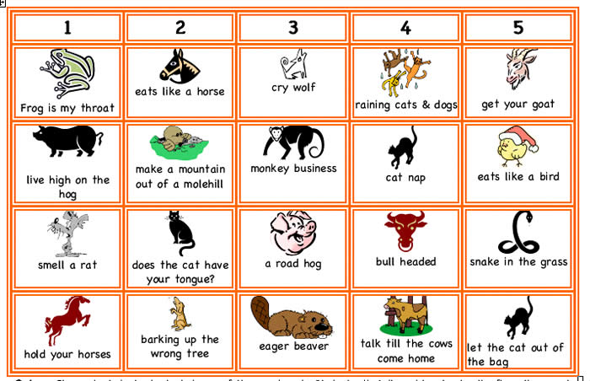
http://www.google.co.in/search?hl=en&site=imghp&tbm=isch&source=hp&biw=1024&bih=677&q=idioms+worksheets&oq=idioms&gs_l=img.1

D. 3 Phrases
Phrases are a group of words that occur in the same order and function as a grammatical and conceptual unit. These are not complete sentences. While idioms have a figurative meaning, all phrases need not be idiomatic but can convey the literal meaning.
Examples from the text
In the end – adverbial phrase modifying the whole sentence
queuing to see the millionaire – gerund phrase
the authenticity of our displays – noun phrase
to find out – infinitive phrase
progressing along an upward-spiralling ramp – adjectival phrase
D. 3. 1 For practice
  - Find five more phrases from the text above and specify what types they are.
  - Rearrange the following words to get five phrases taken from the text and form five more meaningful phrases of your own.
dams, Over, areas, big, minute-to-minute, years, the, refugees, war , fifty, to access, displaced, of, unacknowledged, information, last, by, the, drought-prone
c. Fill in appropriate words of your choice to make meaningful phrases.
a ____, ____ night,
night ___ ____ ____ _____,
___ sing and ___,
the lost ring ____ in the ____

D. 4 Appreciation Creative Writing
Some questions to think about
What is being ‘creative’ according to you?
Do you feel creative writing is a pure outpouring of an author’s imagination?
What according to you are the essential elements of creative writing?
Characteristics of creative writing depend
on the genre the writing belongs to
the purpose of the writer
the personality of the writer
The impact on the reader
is determined by how well the author has handled the linguistic and stylistic features how relevant he is to his reader
To better appreciate a work of creative writing
The reader must know the historic and social conditions of the age the work describes
H/She must be familiar with the kind of language or style the writer uses
H/She must understand the characters the writer creates
More importantly, the reader should have a feel for the tone of the author
TEXT 4
The Greater Common Good (An Excerpt)
Over the last fifty years India has spent ` 80,000 crores on the irrigation sector alone. Yet there are more drought-prone areas and more flood-prone areas today than there were in 1947. Despite the disturbing evidence of irrigation disasters, dam-induced floods and rapid disenchantment with the Green Revolution (declining yields, degraded land), the government has not commissioned a post-project evaluation of a single one of its 3,600 dams to gauge whether or not it has achieved what it set out to achieve, whether or not the (always phenomenal) costs were justified, or even what the costs actually were.
The Government of India has detailed figures for how many million tonnes of foodgrain or edible oils the country produces and how much more we produce now than we did in 1947. It can tell you how much bauxite is mined in a year or what the total surface area of the National Highways adds up to. It’s possible to access minute-to-minute information about the stock exchange or the value of the rupee in the world market. We know how many cricket matches we’ve lost on a Friday in Sharjah. It’s not hard to find out how many graduates India produced, or how many men had vasectomies in any given year. But the Government of India does not have a figure for the number of people that have been displaced by dams or sacrificed in other ways at the altars of ‘National Progress’. Isn’t this astounding? How can you measure Progress if you don’t know what it costs and who paid for it? How can the ‘market’ put a price on things—food, clothes, electricity, running water—when it doesn’t take into account the real cost of production?
According to a detailed study of 54 Large Dams done by the Indian Institute of Public Administration, the average number of people displaced by a Large Dam is 44,182. Admittedly, 54 dams out of 3,300 is not a big enough sample. But since it’s all we have, let’s try and do some rough arithmetic. A first draft. To err on the side of caution, let’s halve the number of people. Or, let’s err on the side of abundant caution and take an average of just 10,000 people per Large Dam. It’s an improbably low figure, I know, but ...never mind. Whip out your calculators. 3,300 x 10,000 = 33 million. That’s what it works out to. Thirty-three million people. Displaced by big dams alone in the last fifty years. What about those that have been displaced by the thousands of other Development Projects? At a private lecture, N.C. Saxena, Secretary to the Planning Commission, said he thought the number was in the region of 50 million (of which 40 million were displaced by dams). We daren’t say so, because it isn’t official. It isn’t official because we daren’t say so. You have to murmur it for fear of being accused of hyperbole. You have to whisper it to yourself, because it really does sound unbelievable. It can’t be, I’ve been telling myself. I must have got the zeroes muddled. It can’t be true. I barely have the courage to say it aloud. To run the risk of sounding like a ‘sixties hippie dropping acid (“It’s the System, man!”), or a paranoid schizophrenic with a persecution complex. But it is the System, man. What else can it be?
Fifty million people.
Go on, Government, quibble. Bargain. Beat it down. Say something.
I feel like someone who’s just stumbled on a mass grave.
Fifty million is more than the population of Gujarat. Almost three times the population of Australia. More than three times the number of refugees that Partition created in India. Ten times the number of Palestinian refugees. The Western world today is convulsed over the future of one million people who have fled from Kosovo.
A huge percentage of the displaced are tribal people (57.6 per cent in the case of the Sardar Sarovar Dam). Include Dalits and the figure becomes obscene. According to the Commissioner for Scheduled Castes and Tribes, it’s about 60 per cent. If you consider that tribal people account for only eight per cent, and Dalits fifteen per cent, of India’s population, it opens up a whole other dimension to the story. The ethnic ‘otherness’ of their victims takes some of the pressure off the Nation Builders. It’s like having an expense account. Someone else pays the bills. People from another country. Another world. India’s poorest people are subsidising the lifestyles of her richest.
Did I hear someone say something about the world’s biggest democracy?
What has happened to all these millions of people? Where are they now? How do they earn a living? Nobody really knows. (Last month’s papers had an account of how tribal people displaced by the Nagarjunasagar Dam Project are selling their babies to foreign adoption agencies. The Government intervened and put the babies in two public hospitals where six babies died of neglect.) When it comes to Rehabilitation, the Government’s priorities are clear. India does not have a National Rehabilitation Policy. According to the Land Acquisition Act of 1894 (amended in 1984), the Government is not legally bound to provide a displaced person anything but a cash compensation. Imagine that. A cash compensation, to be paid by an Indian government official to an illiterate tribal man (the women get nothing) in a land where even the postman demands a tip for a delivery! Most tribal people have no formal title to their land and therefore cannot claim compensation anyway. Most tribal people, or let’s say most small farmers, have as much use for money as a Supreme Court judge has for a bag of fertilizer.
The millions of displaced people don’t exist anymore. When history is written they won’t be in it. Not even as statistics. Some of them have subsequently been displaced three and four times—a dam, an artillery proof range, another dam, a uranium mine, a power project. Once they start rolling, there’s no resting place. The great majority is eventually absorbed into slums on the periphery of our great cities, where it coalesces into an immense pool of cheap construction labour (that builds more projects that displace more people). True, they’re not being annihilated or taken to gas chambers, but I can warrant that the quality of their accommodation is worse than in any concentration camp of the Third Reich. They’re not captive, but they re-define the meaning of liberty.
And still the nightmare doesn’t end. They continue to be uprooted even from their hellish hovels by government bulldozers that fan out on clean-up missions whenever elections are comfortingly far away and the urban rich get twitchy about hygiene. In cities like Delhi, they run the risk of being shot by the police for shitting in public places—like three slum-dwellers were, not more than two years ago.
In the French Canadian wars of the 1770s, Lord Amherst exterminated most of Canada’s Native Indians by offering them blankets infested with the small-pox virus. Two centuries on, we of the Real India have found less obvious ways of achieving similar ends.
The millions of displaced people in India are nothing but refugees of an unacknowledged war. And we, like the citizens of White America and French Canada and Hitler’s Germany, are condoning it by looking away. Why? Because we’re told that it’s being done for the sake of the Greater Common Good. That it’s being done in the name of Progress, in the name of National Interest (which, of course, is paramount). Therefore gladly, unquestioningly, almost gratefully, we believe what we’re told. We believe that it benefits us to believe.
Arundhati Roy
Read the above article and note how the author transforms a journalistic writing into a forceful oratorical piece. A few of the techniques through which this is achieved are:
Inclusive, at times informal conversational tone – Use of plural personal pronouns ‘we’,’I’ and second person pronoun ‘you’; Only to indicate the insignificance of the neglected ones does she use ‘they’; ‘But it is the System, man.’
Repeated use of rhetorical questions (for which the answers are obvious and the questions don’t really need an answer) -- Isn’t this astounding? “Did I hear someone say something about the world’s biggest democracy?’
Use of imperatives to convey the urgency – ‘Go on, Government, quibble. Bargain. Beat it down. Say something’
Use of italics for foregrounding the information and at times to convey a sense of incredulity -- post-project evaluation of a single one of its 3,600 dams; It can’t be true; Fifty million people
Repeated use of contrastive connectives like ‘yet’, ‘despite’ and ‘but’ to show the shocking contrast between projection and reality –
Over the last fifty years India has spent 80,000 crores on the irrigation sector alone. Yet there are more drought-prone areas and more flood-prone areas today than there were in 1947.
True, they’re not being annihilated or taken to gas chambers, but I can warrant that the quality of their accommodation is worse than in any concentration camp of the Third Reich. They’re not captive, but they re-define the meaning of liberty.
D. 4.1 For Practice
a. For discussion – “Greater Common Good”
- What according to you is the purpose of Arundhati Roy in writing this article?
- What kind of journalistic article is this? How does she strengthen her argument?
- Comment on the tone of the author.
b. For discussion – “Visiting the Last
Millionaire”
- What genre does this story belong to? What tells us so?
- Which line tells us that “discrimination” continues even in the far future?
- Attempt an interpretation of the last line of the story “A thousand avenged.”
c. For Discussion – Greater Common Good” and “Visiting the Last Millionaire”
- Do you find any difference in the views of both the writers with regard to ‘technology’?
- What are their opinions with regard to human society?
- Point out the difference if any with regard to their use of personal pronoun ‘we’.
- Compare and contrast the tone of both the writers through their respective writing.
Reading comprehension for additional practice
I. Read the following passage and answer the questions given at the end
Masterstroke
BOOK Sunil Gavaskar reserves his best for Straight Drive
Sunil Gavaskar has been as meticulous with his media work as he was with his batting. Nothing could distract him from constructing his innings or penning his thoughts. He rarely missed a resolve to bat long in the middle; and never missed his fortnightly column. “I love writing. Perhaps even more than I loved batting”, reveals the master in the preface.
On tours, it was a privilege to interact with Gavaskar, who was variously addressed as SMG or Sunny or Sunny bhai. When he spoke on cricket, it was priceless education. When he wrote, it was a worthy assessment by a man most qualified.
He never took his batting easy and never took his media assignments for granted. In the press box he would finish his column, always neatly handwritten on an A4 sheet, even as the last ball of the day was bowled.

Birthday gift
Straight Drive, published by Rupa on the occasion of his 61st birthday, is a tribute to Gavaskar the writer. It is a collection of 61 of the 600-odd columns he has contributed from the time he wrote his first on March 30, 1988. Not surprisingly, the debut column was on a badminton tournament. Badminton has been very close to Gavaskar’s heart. If he had not played cricket, he would have made waves as a badminton star.The columns that form the book have been judiciously selected by Gavaskar’s parents as a birthday gift to their dear son.
“I write from the heart; very, very seldom with the head and that’s why I get into controversies. What I have curbed is the instinct to write a book after ‘One-day Wonders’. My parents wanted me to bring out another book. So, here it is. All the columns have been selected by my dear father,” says Gavaskar.
Straight Drive includes Gavaskar’s tributes to some of his friends and well-loved sportsmen. Vijay Manjrekar, Eknath Solkar, Ramakant Desai, M. L. Jaisimha, G. R. Visvanath, Kapil Dev, Prakash Padukone, and P. Gopichand find special mention. There is also a column dedicated to Pumkaka (Pramod Pandit), who was an early influence on Gavaskar’s cricket.
The India cap
Gavaskar has always been very obsessive, and rightly too, about the India cap. In a column he says: “It is about time our Board differentiated between an India cap for One-Day International and for Tests.” I have seen a livid Gavaskar when he spotted spectators sporting an India T-shirt or a cap. He wrote in 1999: “Did you know that you do not have to be an India player to get the India shirt and India cap? All you have to be is a pretty face, and give the Indian player a smileand maybe an idea or two by acting coy, and you will get the Indian shirt off him in a jiffy”.
Once he politely told a former Test cricketer’s son to take off the India cap he had worn to the breakfast table. On another occasion, he took a journalist to task for wearing an India T-shirt on a flight in Australia. “The late Manjrekar once forced an official to remove the India tie he was wearing because he had not played for India”, writes Gavaskar.
There is a superb column from 3 August 1990 where Gavaskar lavishes praise on Richie Benaud and Geoffrey Boycott for their work in the commentary box. Gavaskar also pens his thoughts on rash driving in India, a chapter on the tragic accident of hockey star Jugraj Singh, and on various aspects of the game.
At one point he also writes “Vishy (Visvanath) was the best batsman of my generation”. He never stopped tired of saying “I would walk miles to wach Padukone or Vishy in action.”
Straight Drive is, indeed, Gavaskar at his best with the pen.
VIJAY LOKAPALLY The Hindu, Metroplus, 11 August 2009, p.1
a. Read the following questions and answer them in two or three sentences.
- How many articles as columns has Sunil Gavaskar written so far and how many have been published in Straight Drive?
- Who is the publisher, what is the occasion of publication and who has selected the articles for publication in Straight Drive?
- Who are the other cricketers he pays a tribute to? Is Gavaskar only interested in cricket? Justify your answer.
- What are your impressions about Gavaskar after reading the passage?
- Can you explain why the book has been named Straight Drive and the review titled “Master stroke”?
b. Match the words in Column A with their meaning in Column B
 | A | B
 | meticulous | showing good sense
 | penning | statement showing your admiration / respect for someone
 | Resolve | acting carelessly
 | assessment | paying attention to details
 | Judiciously | Determination
 | Tribute | writing down
 | rash | Evaluation
c. Guess the meaning of the following phrases and write them in sentences of your own.
- acting coy
- in a jiffy
- in action
- close to one’s heart
- made waves
- take to task

d. Give the other forms of the words given below and name them. An example has been given.
Dedicate – dedication (noun), dedicated (adjective), dedicatedly (adverb)
- distract
- surprisingly
- influence
- differentiate
- tragic
UNIT V
RESEARCH

Grammar and Vocabulary
ANALOGIES
Using parallel cases to reason out is called analogy.
Analogies prove nothing, that is true," wrote Sigmund Freud, "but they can make one feel more at home.
An analogy is a comparison between two different things in order to highlight some point of similarity.
Webster's New World College Dictionary states:
Analogy – noun, pl. analogies
- similarity in some respects between things otherwise unlike; partial resemblance
- the likening of one thing to another on the basis of some similarity between the two
- Biol. similarity in function between parts dissimilar in origin and structure, as the wing of a bird and that of an insect

- Linguis. the process by which words, constructions, or pronunciations conform to the pattern of other, often unrelated, ones: “energize” is formed from “energy” by analogy with “apologize” from “apology”; Old English “handa” became “hands” on analogy with other plurals in -s
- Logic an inference from certain admitted resemblances between two or more things to a probable further similarity between them
Origin: ME & OFr analogie < L analogia < Gr, proportion < analogos, in due ratio < ana-, according to + logos, word, reckoning: see logic
TEXT 1
Analogy and Technical Terms
Science writer Claudia Kalb relies on the computer to explain how our brains process memories.
Some basic facts about memory are clear. Your short-term memory is like the RAM on a computer: it records the information in front of you right now. Some of what you experience seems to evaporate--like words that go missing when you turn off your computer without hitting SAVE. But other short-term memories go through a molecular process called consolidation: they're downloaded onto the hard drive. These long-term memories, filled with past loves and losses and fears, stay dormant until you call them up.
("To Pluck a Rooted Sorrow," Newsweek, April 27, 2009)
Does this mean that human memory functions exactly like a computer in all ways? Certainly not. By its nature, an analogy offers a simplified view of an idea or process--an illustration rather than a detailed examination.
In writing a comparison and contrast paragraph we can say how Chennai is quite unlike Mumbai in history, climate, and predominant life-styles, but like it in being a seaport and a city proud of its own colleges.
That isn't the way an analogy works. In an analogy you yoke together two unlike things (eye and camera, the task of navigating a spacecraft and the task of sinking a putt), and all you care about is their major similarities. It is different from a metaphor as it does not claim complete identification ,it only brings similarities to the fore.
The best analogies are often brief though talented writers do display their skills through extended analogies.
Examples of extended analogies:
- Pupils are more like oysters than sausages. The job of teaching is not to stuff them and then seal them up, but to help them open and reveal the riches within. There are pearls in each of us, if only we knew how to cultivate them with ardor and persistence.
(Sydney J. Harris, "What True Education Should Do," 1964)
- Think of Wikipedia's community of volunteer editors as a family of bunnies left to roam freely over an abundant green prairie. In early, fat times, their numbers grow geometrically. More bunnies consume more resources, though, and at some point, the prairie becomes depleted, and the population crashes.
Instead of prairie grasses, Wikipedia's natural resource is an emotion. "There's the rush of joy that you get the first time you make an edit to Wikipedia, and you realize that 330 million people are seeing it live," says Sue Gardner, Wikimedia Foundation's executive director. In Wikipedia's early days, every new addition to the site had a roughly equal chance of surviving editors' scrutiny. Over time, though, a class system emerged; now revisions made by infrequent contributors are much likelier to be undone by élite Wikipedians. Chi also notes the rise of wiki-lawyering: for your edits to stick, you've got to learn to cite the complex laws of Wikipedia in arguments with other editors. Together, these changes have created a community not very hospitable to newcomers. Chi says, "People begin to wonder, 'Why should I contribute anymore?'"--and suddenly, like rabbits out of food, Wikipedia's population stops growing.
(Farhad Manjoo, "Where Wikipedia Ends." Time, Sep. 28, 2009)
- The "great Argentine footballer, Diego Maradona, is not usually associated with the theory of monetary policy," Mervyn King explained to an audience in the City of London two years ago. But the player's performance for Argentina against England in the 1986 World Cup perfectly summarized modern central banking, the Bank of England's sport-loving governor added.
Maradona's infamous "hand of God" goal, which should have been disallowed, reflected old-fashioned central banking, Mr King said. It was full of mystique and "he was lucky to get away with it." But the second goal, where Maradona beat five players before scoring, even though he ran in a straight line, was an example of modern practice. "How can you beat five players by running in a straight line? The answer is that the English defenders reacted to what they expected Maradona to do. Monetary policy works in a similar way. Market interest rates react to what the central bank is expected to do.
"(Chris Giles, "Alone Among Governors," Financial Times. ep. 8-9, 2007)
A.1 For Practice
Attempt writing a paragraph which is an extended analogy similar to the examples given earlier.
A.2. Analogies play an important part in Competitive exams such as GRE, CAT, GMAT and so on….
Analogy questions are usually of the following types:
Type 1.
These consists of two words that have a certain relationship to each other, followed by five lettered pairs of related words. The pair bearing the same relationship is the right answer. There are seven primary types of relationships used in our analogies: function, degree, lack, characteristic, type/kind, part to whole, and definition.
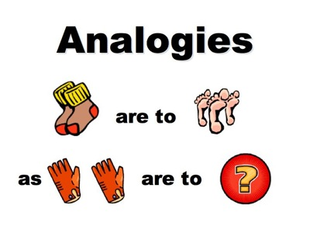
A.2.1 For Practice
Examples:
FOOTBALL : GRIDIRON
a. wrestling:mat
b. court : tennis
c. bowling : floor
d. rugby : arena
e. baseball : diamond
Ans : E
Note: 1.The analogy is based on the shapes of the playfield
EXPURGATE : PASSAGE
a. abridge : text
b. filter : water
c. irritate : wound
d. burn : book
e. cancel : plan
Ans:B
Here the analogy is based on the meaning “remove from”.
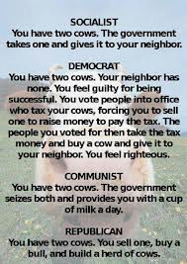
A1 For Practice
Choose the best answer
a. APIARY : BEE
1. museum : painting
2. dam : water
3. arboretum : tree
4. forum : speech
5. planetarium : star
b.SAND PAPER : ABRASIVE
1. gasoline : refined
2. grativity : irritant
3. polish : floors
4. acrylic : emulsion
5. oil : lubricant.
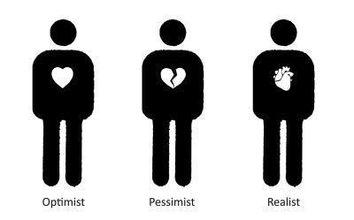
c.DIAPHANOUS : CACOPHONOUS
1. translucent : transparent
2. transparent : noisy
3. sheer : opaque
4. harmonious : discordant
5. twofold : multiple.
d.INFANCY : SENILITY
1. january : October
2. incipient : critical
3. day : night
4. conclusion : climax
5. dawn : dusk.
e.RIG : CONTEST
1. solve : conundrum
2. predict : race
3. repudiate : thesis
4. gerrymander : district
5. incriminate : evidence
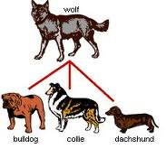
f. COAX : BLANDISHMENTS
1. amuse : platitudes
2. compel : threats
3. deter : tidings
4. batter : insults
5. exercise : antics
g. FILTER : IMPURITY
1. expurgate : obscenity
2. whitewash : infraction
3. testify : perjury
4. perform : penance
5. vacuum : carpet
h. INTRANSIGENT : FLEXIBILITY
1. transient : mobility
2. disinterested : partisanship
3. dissimilar : variation
4. progresssive : transition
5. ineluctable : modality
i.DAMPEN : RESTRAIN
1. stagnate : flow
2. purify : liquefy
3. dilate : expand
4. melt : disband
5. stabilize : instill
j.ARCHIVE : RECORDS
1. box : shoes
2. locker : uniform
3. arsenal : arms
4. pantry : bread
5. arsenide : death
Answers a.3 b.5 c.2 d.5 e.4 f.2 g.1 h.2 i.3 j.3
Tips to crack GRE Analogy test:
- Try using the two capitalized words in a sentence to see if they are similar
- A good way to figure out the relationship in a given question is to make
up a sentence that describes the relationship between the first two words. Then, try to use the same sentence to find out which of the answer choices completes the same relationship with the third word.
e.g. Yard is to inch as quart is to — a. gallon, b. ounce c. milk d. liquid
- Look for the words that are definitely incorrect. Rule them out straightaway;
- Think about different word meanings for the words;
- If you encounter an unknown word, think back to whether you have heard it spoken in an expression. This might help with the meaning; and,
- Apparent, eye-catching answers may be in there to lead you up the
garden path. Be aware.

B.LISTENING & SPEAKING
Of all the things that people do with speech, perhaps the most important is making the communities within which they live. If you listen and study the speech that reaches your ear, you will hear a rich tapestry with which you and those around you accomplish the day-to-day acts that form your lives. To participate in a community is to understand how to use your voice to affect your life.
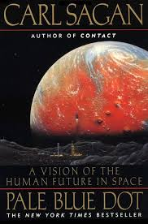
B.1. Presentation Techniques
You have watched the presentation by Carl Sagan titled A Pale Blue Dot and The Inconvenient Truth by Al Gore.
Watch them again and answer the following questions.
1. What impressed you the most?
Which presentation did you like better ? Why?

The best way to enliven and capture the interest of an audience during a seminar or a lecture is to use audio or visual aids. Computer education has made it even easier as this provides us with the techniques combining audio and visual inputs in the form of power point presentations and short films.
However it is not enough to load all the information we have into innumerable slides and attempt to convince the people who have gathered to listen.
The following tips can go a long way in ensuring the success of a presentation.
Stages of Preparation
- Selecting the topic - Know your audience – be sure you know who you are addressing
Choose a topic that will interest them and one that interests you as well!!
- Collecting relevant data – and organising it in proper sequence
- Preparing slides based on data –not too many slides!! Just enough to make sure you do not omit the main points.
- Practicing the presentation – Speech – Voice - Tone, intonation, body language etc.
- Delivery
Slide preparation
- Do not crowd your slides with words –have a maximum of 5 lines - points will do, lengthy sentences should be avoided.
- Use simple, clear fonts and the size should be big enough to be viewed by the last row in the audience.
- Do not use too many colours- three colours can be maintained for the entire presentation.
- Pictures and diagrams should be well chosen-clarity and neatness should be the main criteria.
- Practice your talk along with the power point presentation keeping to allotted time.
Delivery
- Body language is all important –from the moment the speaker walks up to the stage till he leaves.
- Start with a greeting.
- Introduce your topic, you could touch upon the main headings of your presentation.
- Get started with a joke, anecdote, proverb or a question.
- Divide your speech into three parts and highlight the important points of each part, taking the help of the slides, to make sure you do not forget any.
- Close your speech with a good concluding statement.
- Never forget to ask if the audience has any questions to ask.
(Answer those you know and for the others say that you would look into that particular area.)
- Close with a ‘thank you’.

C. Writing
C.1. Writing a Proposal
“What makes a good proposal?” A good proposal stems from a good concept. The best proposals are those to which the reviewers respond, “Of course, I wish I had thought of that!”
The proposal must be written in sufficient detail to allow reviewers to understand:
- what the project hopes to accomplish;
- if the project personnel have the necessary expertise to accomplish the goals and objectives;
- the potential of the project
- the national impact ,if any and cost effectiveness of the project; and
- evaluation and dissemination plans.
One should also remember the following criteria for consideration:
Intellectual Merit
What is the intellectual merit of the proposed activity?
How important is the proposed activity to advancing knowledge and understanding within its own field or across different fields?
Broader Impacts
What are the broader impacts of the proposed activity?
This criterion relates to the extent to which the activity advances discovery and understanding while promoting teaching and learning, how well it broadens participation of underrepresented groups (e.g., based on gender, ethnicity, disability, geography, etc.), the extent to which it enhances the infrastructure for research and education (e.g., facilities, instrumentation, networks, partnerships), the degree to which it plans broad dissemination to enhance scientific and technological understanding, and the benefits of the activity to society.
Writing the Proposal Narrative
A good proposal is always readable, well-organized, grammatically correct, and understandable.
Be explicit in your narrative about how the program will make an improvement.
The narrative should be specific about the proposed activities.
Careful writing should allow you to describe, in the limited space available, enough about your project to give the reviewers a clear idea of exactly what you plan to do and why your plan is a good one.
You must demonstrate in the narrative that you have a broad knowledge of current activities in your field and how this is relevant to your project’s design. This knowledge should include current research.
Including Budget Information
It is helpful to reviewers to see that you have devised a time frame. This will show that you have done adequate planning and are realistic about the program’s implementation.
The budget request should be realistic for the project and reflect the goals of the project. It should request sufficient resources needed to carry out the project, but it should not be excessively high.
When writing up the credentials of faculty for the grant proposal, each biographical sketch should be written with the proposal in mind and should display the unique background of the principal investigator(s) which will be valuable in working on the proposed project.
If your project involves industry, consider having a co-principal investigator representing industry.
Including Evaluation and Dissemination Information
A good evaluation plan appropriate to the scale of the project will provide information as the project is developing and will determine how effectively the project has achieved its goals. The effects of formative evaluation should be described. Also include how you intend to evaluate the final project and how you will determine whether this project met your scientific and pedagogical expectations.
Discuss how you plan to collect and analyze data on the project’s impact

BASIC FORMAT OF THE PROPOSAL

Abstract or Summary of the Proposal
(This is a condensed version of the longer work, and it summarizes and highlights the major points of the report. It included: the subject, scope. purpose, methods, and obtained results of the study, as well as any recommendations and conclusions made.)

Introduction:
(Gives the background and states the purpose of the proposal)
Statement of the Proble
Proposed Solutions
Conclusion
Additional Information:
(i.e. Expense Statements, Cost Savings, Profit and Loss Projections, Equipment, Materials and Personnel Needs, Completion Schedules, Efficiency Studies, Writer's Qualifications, etc.)

Appendices:
(Presentation of charts, graphs, illustrations, etc.)

Works Cited/References

Bibliography
C.2. For Practice
See the following sample of a proposal, ideal for the first year student. Use this a template and prepare a proposal for the first year project.

The Burgeoning of Convenience Stores across
the American Landscape
by Janet Lerner
INTRODUCTION
In a little over two decades we have witnessed the emergence of a new concept in retail buying for the American consumer—the convenience store. The United States government defines convenience stores as “food retailer(s) of limited lines in a freestanding sales area of 3,000 square feet, concentrating on selected fast-moving products” (Directory of Supermarkets, Grocery, and Convenience Store Chains, 1990). To this definition I would add that typically the products on the shelves of convenience stores are priced higher than those carried by their competitors.
RATIONALE FOR MY INVESTIGATION

While spreading across the country like politicians on a campaign trail, convenience stores appear to have maintained a fairly distinctive regional character. Uni-Mart and Sheetz are common names for these stores in central Pennsylvania, but in Iowa we find Casey’s, in Massachusetts Cumberland Farms, and hundreds of other names specific to a state or region. I am intrigued by the rapid growth of convenience stores, which, from my early research, seem to retain a local flavor for such a widespread national phenomenon.
PROCEDURE
Through my library research, I will examine the burgeoning of convenience stores by exploring the answers to questions such as the following:
—How does the rapid growth of convenience stores reflect demographic trends?
—What determines the location of convenience stores? (macro - geography?)
—How have the unrelated markets of food retail and gasoline sales evolved into a common store?
I also plan to interview several key executives at Uni-Mart, including Charles R. Markham, who is the executive vice-president.
REFERENCES
Directory of Supermarkets, Grocery, and Convenience Store Chains. CGS, 1990. This is a comprehensive guide to all major and many minor stores and their data (number of stores, size, brief history, top personnel). It also includes maps that illustrate regional concentrations of stores, and provides an overview of the industry today.
Curtis, C.E. “Mobil Wants To Be Your Milkman.” Forbes. February 13, 1984, pp. 44-45. This article provides a concise but informative discussion of the combining of the food retail and gas industries.
(https://www.e-education.psu.edu/files/styleforstudents)
D. READING
D.1. Referencing Skills for Academic Report Writing
Research as the name indicates involves a ‘re’ ‘searching’ of material available in the concerned area.
How does one collect the material?
What are the resources available?
The internet, media and the library provides most of the input.
How does one record the information gathered?
By using one’s referencing skills.

What is Referencing?
Referencing is a system that allows you to acknowledge the sources of information you use in your writing. If you do not reference your sources, you are plagiarising.
When to provide a reference?
You must provide a reference whenever you quote, paraphrase or summarise someone else’s ideas, theories or data. You must also reference any graphic information you use. Some of the sources you will need to reference include:

- books or chapters in books
- journal or newspaper articles
- conference papers
- films or television programs
- personal communications like emails, interviews or letters
- electronic sources such as web pages, journal articles from online databases, or use net groups

D.2. Writing a detailed project report based on MLA Handbook (Modern Language Association)
General Format of Report
Use at least 1-inch margins at the left, right, top, and bottom of each page. Justify the left margin but not the right. Use a font type and size that is easy to read, such as Times New Roman, 12 pt.

Double space everything, including block quotations, references, titles, and headings. Place your last name and the page number within the top margin of each page, right-justified. Indent ½ inch to begin paragraphs (Refer to Figure 1.).
1 inch 1/2 inch
Wendt 1
Dennis Wendt, Jr.
Professor Faulconer
Phil 350R, Section 1
13 April 2005
Heidegger, Hermeneutic Dialogue,
and Psychotherapy
In 1873 Nietzsche translated a line of ancient Greek text, attributed to Anaximander over 2600 years ago. His translation reads, “Whence things have their coming into being there they must also perish according to necessity; for they must pay a penalty and be judged for their injustice, according to the ordinance of time” (Heidegger 242). Of course, Nietzsche did not actually say this; his

Note: To insert a page header in Microsoft Word, select View, then Header and Footer. This brings up the header box and the Header and Footer toolbar. On the top line of the header box (on any page), right-justify and type your last name followed by 1 space. Then, in the toolbar, click the left-most box with a number sign (#). Then click Close on the toolbar.
Title and Authorship Information
Your name, your instructor’s name, the course number, and the date should be placed at the top-left of the first page, double-spaced, as shown in Figure 1. Center the title on the next double-spaced line, in plain type (not bolded, italicized, underlined, or in a larger font), capitalizing the first letter of all major words. The title may occupy one or two lines, depending on its length. The main text follows on the next double-spaced line, indented ½ inch.
Note: Major words refer to the first word of the title, the first word after a colon, and all other words except articles, coordinating conjunctions, prepositions, and the infinitive to .
In-Text Citation
Each use of information from another source (whether quoted, paraphrased, or summarized) must be properly documented
Whenever possible, cite the source’s author and page number If the author’s name is mentioned in the main text, put the page number in a parenthetical citation at the end of the sentence, after any end quotation marks but before the period
Example: According to Heidegger, it is not “firmly established what we ourselves think with the words ‘being’ and ‘to be’
If the author’s name is not used, then include the author’s surname in the parenthetical citation.
Example: The chatter “‘tranquilizes’ us into thinking that matters are entirely settled and disinclines us to look further” (Inwood 55).
Parenthetical citations vary according to the source, as shown in the examples below. (For each, items need to be cited in parenthetical references only if they are not mentioned in the text.)
2-3 authors: List names in the order they are listed in the source (6.2).
(Westen and Smith 204-24) or (Jones, Callin, and Rundel 14)
4 or more authors: Either list all names or list only the first author’s name followed by et al. Whatever you choose, it should match the works cited entry Walken et al 1131-42).
No author listed: List the first 1-2 words of the title. If the source is an article or chapter, use double quotations; if it is a book, underline
Wendt 8

For Heidegger, however, technological advancement is not the problem; the problem is that we forget to ask the question of being (Pattison 69). The problem with challenging forth, with seeing things as mere resources, is not that it allows for more efficient means to desired ends, but that it tempts us to be satisfied with the chatter’s presumption of finality concerning what things really are. Heidegger warns us to “not allow ourselves to be mesmerized by technology itself and its success” because such can keep us from seeing that it is “an essentially limiting, one-sided, and one-track way of approaching the world” (58, 71).

(“Cancer Therapy” A6) or (Depression 24-68)
Multiple sources by same author: When using more than one source by the same author, you must use the titles (see “No author listed,” above) so the reader knows which source you are citing :
(Heidegger, “Anaximander’s” 19)
Indirect sources: When using a quotation or paraphrase that is a quotation in another source, insert qtd.in
(qtd. in James 34)
2 or more sources in a single reference: Separate 2 or more sources supporting a single claim with semicolons.
(Inwood 55; Heidegger 252; Piper 12)
Page numbers
Page numbers are required for citations of quoted material, as well as summarized or paraphrased ideas from a specific place in a source . If referring to an entire work, or a work without page numbers, then page numbers are not needed—in this case it is preferable to have the author information directly in the text, meaning no parenthetical reference is needed . In some cases, it may be more appropriate to cite a chapter or section number, like ch. 2 .
For many electronic sources, page numbers are not available, but paragraph numbers are provided. If this is the case, then list by paragraph number: par. 5 or pars. 2-3.
If paragraph numbers are not available, then list the section heading, if applicable, like (Conclusion).
When using a reference number or heading other than a page number, separate the reference from the author’s surname with a comma, as in (Jones, ch. 4) or (Parsons, Conclusion).
Quoting in Text
Quote passages exactly as they appear in the original text, using double quotation marks (“ ”) ; however, here are some exceptions.
If additions must be made for clarification, place them in square brackets .
Example: “According to [Jim]”
If words or phrases must be omitted for clarity, use ellipses
Example:“Within the next five years new renovations must be made”
When underlining or italicizing certain words for emphasis include the words “emphasis added”
Example: “it is a value system” (Hall 32, emphasis added)
If a quote is longer than 4 lines, format it as a block quotation .
A block quotation starts on a new line, the entire quotation being indented 1 inch from the left margin, double-spaced, and without quotation marks.
Jensen 13
Works Cited
Davis, Martha and Janet, ed. Body Movement and Nonverbal Communication. Bloomington: Indiana UP, 1982. Print.
Fast, Julius. Body Language. New York: Evans, 1970. Print.
Hall, Edward. The Hidden Dimension. New York: Doubleday, 1966. Print.
Maines, David. “Tactile Relationships in the Subways as Affected by Racial, Sexual, and Crowded Seating Settings.” Journal of Environmental Psychology 2 (1977): 100-8. Print.
The parenthetical citation is placed one space after end punctuation.
When quoting multiple lines of poetry, separate lines with a slash .
Example:“A morning run / In solitude”

Works Cited List
Every cited source must be documented in the works cited list Begin the list on a new page. Label Works Cited on the top line, centered. List references in alphabetical order, double spaced, in hanging indention format (all but the first line of each entry are indented ½ inch from left margin), as shown in Figure 3 .
Note: When 2 or more entries have the exact same author, substitute three hyphens followed by a period (---.) for the author’s name on all but the first entry, alphabetizing by title . When 2 or more entries have the same first author, alphabetize according to the last name of the second author . In addition, when alphabetizing, ignore articles A, An, or The at the beginning of titles with an unknown author.
Works Cited List Entries
For works cited list entries, list the author’s name first, followed by the title. In addition, the medium of publication is needed (print or web) towards the end of the entry. Other needed information varies, depending on the source. Examples for common types of sources are shown below, along with basic guidelines.
Note: For one author, list the surname first, as in Shelley, Mary . For a work with 2 or more authors, list in the order they are credited in the original source. Place the surname first only for the first author: Houp, Kenneth, Thomas Pearsall, and Elizabeth Tebeaux . Indicate editors as shown: Smith, Fred, ed. or Wayne, Henry, and Frank Swenson, eds. If no author is listed, or if the work is anonymous, simply omit author information and put the title first .
Book
Shelley, Mary. Frankenstein. New York: Bantam Books, 1818. Print.
Note: Instead of underlining, titles of books, plays, poems, etc are to be italicized (3.6.2).
Journal article
Bodner, George R. “The Apple Ate My Paper.” College English 46 (1984): 610-11. Print.
Place article titles in quotes. Italicize journal names (see “Book” example), followed by a space, but no punctuation. The volume number (46) comes next*, followed by the publication year in parentheses, as shown. After a colon, list page numbers for the entire article, as shown.
*If the journal is paginated by issue (rather than volume), insert the issue number after the volume number, separated by a period. For example, 38.9 means volume 38, issue 9, paginated by issue.
Magazine article
Moritz, Michael. “A Hard-Core Technoid.” Time 16 Apr. 1984: 62-63. Print.
Do not include volume or issue numbers. For daily/weekly magazines, list the month and date, as shown. For monthlies, list the month. Abbreviate all months except May, June, and July.
Newspaper article*
“Cancer Therapy Brings New Hope.” Salt Lake Tribune 17 Aug. 1996: A6. Print.
Like a magazine article entry (see above), except with the following provisions: First, if a city’s name is not included in the name of a local or regional newspaper, then place the city in brackets, as in Post Register [Idaho Falls]. Second, if an article is printed on 2 or more discontinuous pages, list only the first page followed by a plus sign (+), as in A1+.
This example illustrates how to cite a source when no author is listed. If an author is listed, follow the standard format.
Non periodical internet source
Knox, Brenda. “The Don Quixote Exhibit.” Johns Hopkins University. May 1996. Web. 1 June 2004.
After the title of the article comes the title of the overall website (if applicable), then the name of the institution or organization sponsoring the site, if applicable. The first date listed (May 1996) is the month and year of the last time the website was changed. The next date indicates the day, month, and year of when you accessed the site.
Documentation for Internet articles can be far more complicated than these examples, depending on the type of source. Refer to the Handbook for details.

